Animal Watch
Sit quietly by your window and look outside.

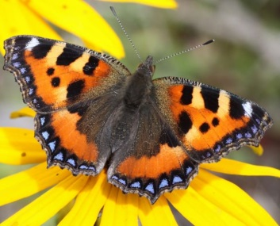
Draw a picture of any animals you can see. It
might be a dog, a cat or insect.

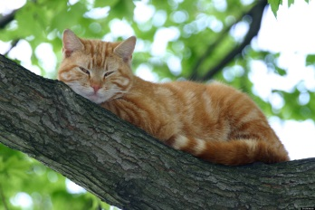

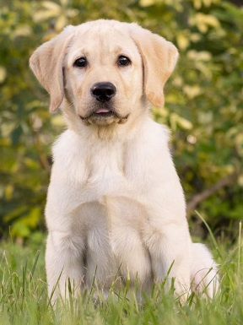
Challenge questions

- Can you name the animal you have seen?
- Are they pets or do they live in the wild?
- Can you describe what the animal is doing?
- Can you find out more information about one of the animals you have seen?

