English Task – Role on the wall
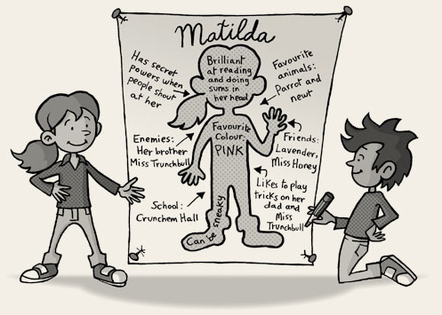
Here is an example of a role on the wall for the character of Matilda in Roald Dahl’s book.

Your task is to create a role on the wall for Lucy in our book, Lob.
1) Draw an outline of Lucy on a big sheet of paper.
2) Write anything that describes her appearance around your drawing.
3) Now concentrate on her personality, character traits and feelings and write them on the inside of her body outline.
4) Make sure you look through the text up to this point to check for as many ideas as possible. Add Lucy’s likes or dislikes to the outside of her body shape.
5) Write a short description of Lucy, using full sentences with conjunctions, such as:
While, although, when, and, but, however, because
Examples:
Although Lucy loves being in London, she always feels excited going to Clunny Cottage.
While her parents are busy working in London, Lucy loves spending her summer holidays with her grandparents.
When Lucy works in the garden with grandad, …

