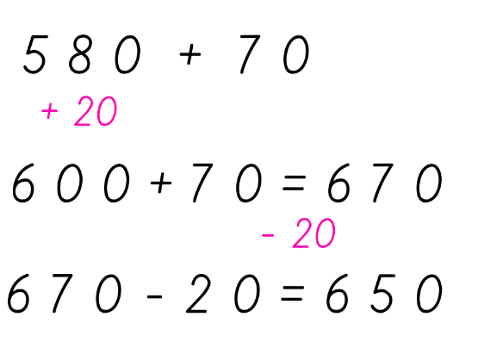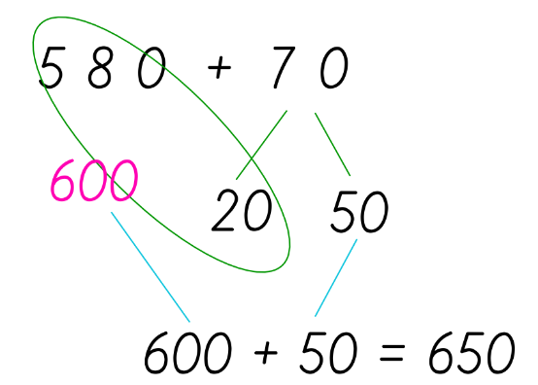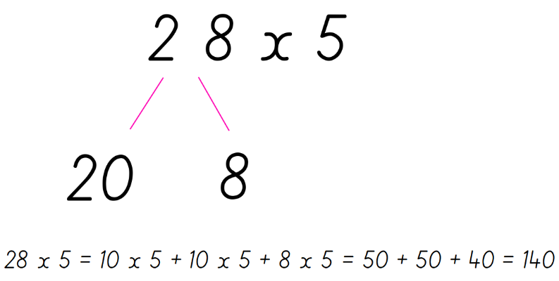

Home Learning Guidance

Maths Key Areas of Learning

Number facts –

Times tables; 2, 3, 4, 5, 6, 8

Skip counting forward and back in multiples of; 10, 20, 25, 100

All bonds to 10, 20, 100 (10 = 3 + 7 etc, 14 + 6 = 20 etc, 100 = 57 + 43)

Multiplication of 2 and 3 digit numbers by 1 digit (please do not teach column method and encourage mental maths by regrouping, as below)

Mental addition and subtraction using regrouping and compensation.

Regrouping Compensation

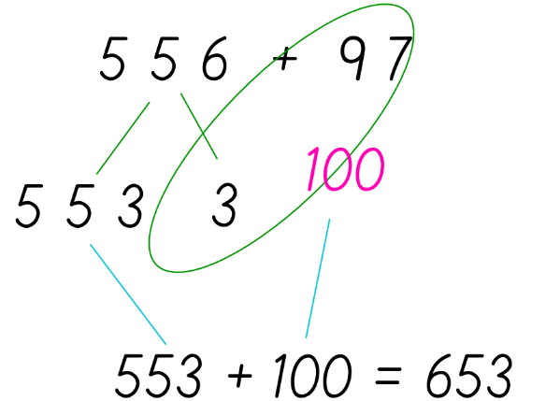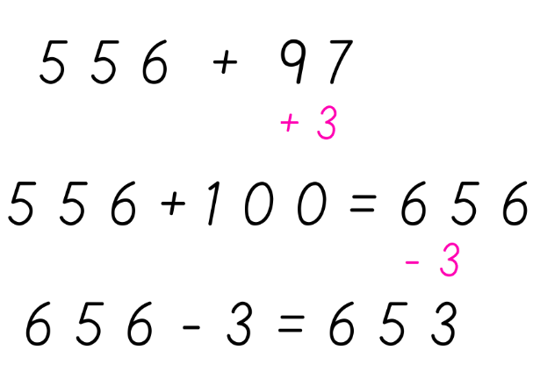

Home Learning Guidance

Handwriting and spelling

I have added the children’s high frequency words to their Home Learning books again. The school’s handwriting policy is in their new reading log, so they can combine the two by writing out their spellings in their best handwriting into their Home Learning books.

Home Learning Guidance

Reading

There is an advised reading schedule on the time table provided. We encourage a wide range of different text including suitable newspaper articles and factual books as well as their fictional story books.

There is guidance in the children’s new reading logs regarding support with reading. There is a common misconception that if children can read the words in their book then they can read. However, it is more crucial that you ask your child questions about what they have read to assess their understanding. Questions are provided in their reading logs.