**Solutions**

**Paper 1**

1. Bounty
2. Lion Bar
3. Mars
4. Double Decker
5. Kit kat chunky
6. Yorkie
7. Mint Aero
8. Boost
9. Snickers
10. Milky Way
11. Fudge
12. Toffee Crisp
13. Cadbury Caramel
14. Turkish Delight
15. Picnic
16. Crunchie

**Paper 2**

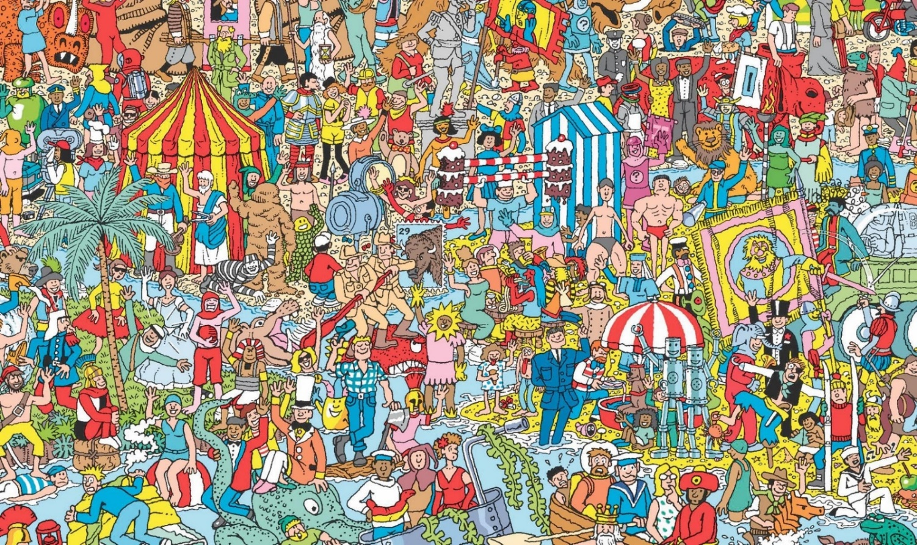

**Paper 3**

Timed task

**Paper 4**

Spelling test:

1. Creature
2. Enough
3. Reception
4. Numb
5. Division
6. Sighed
7. Navigation
8. Thoughtful
9. Offered
10. Muscle
11. Curiously
12. Courage
13. Disagreement
14. Pyramid
15. Excellent
16. Generous
17. Chorus
18. Tongue
19. Accidentally
20. Deceive

**Paper 5**

Art task

**Paper 6**

1. You!

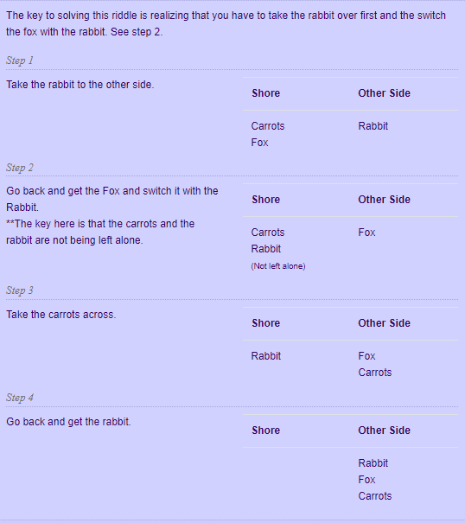

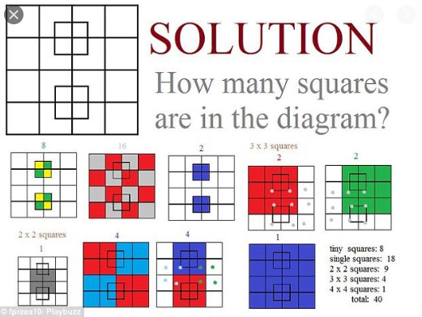



**Paper 6**

1. **Cat in the hat**
2. **The Hungry Caterpillar**
3. **Matilda**
4. **Green Eggs and Ham**
5. **3 Little Pigs**
6. **Alice and Wonderland**
7. **James and the Giant Peach**
8. **Harry Potter**
9. **Charlotte’s Web**
10. **Charlie and the Chocolate Factory**
11. **The Rainbow Fish**
12. **Tiger came to tea**
13. **Black Beauty**
14. **We’re going on a bear hunt**
15. **The lion, the witch and the wardrobe**

**Paper 10**

Secondary schools – different answers

**Paper 11**

Celebration task