Here is a picture from the new book that we are looking at.
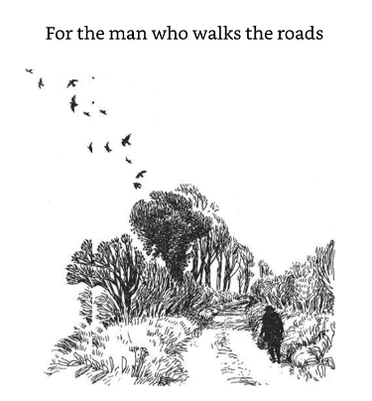
The sentence below is the dedication of the book. Find out what a dedication is and why authors use it.

Now think about these questions and then answer them in your book. If there is somebody with you, discuss your ideas with them. Are their ideas different from yours?
1. What do you notice in the drawing?
2. How does it make you feel?
3. Who, or what, could that figure be?
4. Where might they be going?
5. Where might they have been?
6. Read the dedication. Do the words add anything to your understanding?
7. What might this story be about?

