|  |  |  |  |  |  |
| --- | --- | --- | --- | --- | --- |
| Image result for larks class Year 5 Larks Class  Home Learning activities to choose from  Week commencing 23rd March | | | | | |
|  | **Monday** | **Tuesday** | **Wednesday** | **Thursday** | **Friday** |
| Our morning prayer | Dear Lord  Thank you for this brand new day.  Help us to embrace opportunities for new learning.  Show us how to listen and love.  Support us and our friends.  Guide us to excellence in all that we do today.  Amen | | | | |
| PE | Every morning from **9am-9:30am**, Joe Wicks (aka The Body Coach) will be leading children around the country in a physical activity session! Search Joe Wicks on YouTube to join in. | | | | |
| Reading response | Visit the Newsround website. What is the latest news regarding Coronavirus? | The Titanic Radio Officers  (resource 2 below) | Charles Lightoller, the man who kept surviving  (resource 4 below) | | Titanic investigator task  (resource 5 below) |
| Maths fluency revision | Practise times tables here:  <https://www.transum.org/software/SW/Starter_of_the_day/students/Basic_Multiplication.asp?Level=4> | Practise counting forwards and backwards in halves, | Revise factors here:  <https://uk.ixl.com/math/year-5/identify-factors> | Practise counting forwards and backwards in quarters, | Revise integers:  <https://uk.ixl.com/math/year-5/understanding-integers> |
| Maths revision | Multiplication and division triangles (resource 1 below) | 10-a-day column 1:  division  (resource 3 below) | 10-a-day column 2: division  (resource 3 below) | 10-a-day column 3: multiplication  (resource 3 below) | 10-a-day column 4: multiplication  (resource 3 below) |
| Spellings | To pluralise a word ending in **y** (with no e before it), change the **y** to an **i** before adding **es**. | | | To pluralise a word ending in **ey**, just add **s**. | |
| Pluralise these words:   * city * factory * family * lady * library | Pluralise these words:   * berry * activity * army * baby * laboratory | Pluralise these words:   * memory * gully * body * spy * supply | Pluralise these words:   * journey * monkey * valley * trolley * donkey | Pluralise these words:   * kidney * alley * key * storey * turkey |
| Writing | Create an information poster about the Titanic OR use PowerPoint / Keynote to create a presentation.  Include a heading, sub-headings, plenty of interesting information and a range of images. | | | | |
| History  Geography  RE  Science  Art, Design and Technology | Make your own family tree. The clip below will show you how to lay it out.  <https://www.youtube.com/watch?v=3wdM1Rx0HdI> | Test your memory of South American countries. You can use an Atlas or find a map on Google to help you.  <https://online.seterra.com/en/vgp/3016> | Find out about one of the Festivals which is celebrated by Sikhs, such as Vaisakhi.  <https://www.bbc.co.uk/teach/class-clips-video/religious-studies-ks2-vaisakhi/z6s2t39> | Find the food chains:  <https://www.bbc.co.uk/bitesize/topics/zbnnb9q/articles/zcgbjty> | Make a model or a detailed drawing of one of the vessels we’ve learned about:   * Titanic * HMS Beagle (Darwin) * The Endurance (Shackleton) |
| Daily reading | Read with an adult for at least 20 minutes EVERY DAY.  When you need something new to read, try an e-book:  <https://worldbook.kitaboo.com/reader/worldbook/index.html#!/>  [https://www.oxfordowl.co.uk/for-home/find-a-book/library-page/?view=image&query=&type=book&age_group=Age+9-11&level=&level_select=&book_type=&series=#](https://www.oxfordowl.co.uk/for-home/find-a-book/library-page/?view=image&query=&type=book&age_group=Age+9-11&level=&level_select=&book_type=&series=) | | | | |
| Suggested Brain Breaks and Relaxation | Choose a Peace Out  <https://www.youtube.com/results?search_query=peace+out> | Listen to a MindUp Brain Break (the one we use in school.)  <https://mindup.org.uk/mindup-activities/> | Listen to an Audiobook  (YouTube has a selection for KS2). | Choose a Peace Out  <https://www.youtube.com/results?search_query=peace+out> | Melting with GoNoodle  <https://family.gonoodle.com/activities/melting> |
| Suggested  Physical Activities | Joe Wicks workout (scroll down for kids’ versions)  <https://www.youtube.com/user/thebodycoach1/videos> | Try the Banana Banana Meatball!  <https://family.gonoodle.com/activities/banana-banana-meatball> | Try Cosmic Kids Yoga  <https://www.youtube.com/user/CosmicKidsYoga> | Peanut Butter in a Cup  <https://www.gonoodle.com/good-energy-at-home-kids-games-and-videos/> | Choose a ‘Just Dance kids’ exercise  <https://www.youtube.com/results?search_query=just+dance+kids> |
| A song a day to sing along with | My Lighthouse  <https://www.youtube.com/watch?v=lFBZJGSgyVQ> | Be Bold, Be Strong  <https://www.youtube.com/watch?v=OWqa4Rpq4PE> | Sing Hosanna  <https://www.youtube.com/watch?v=21RHemxzb8U> | Our God is a Great Big God  <https://www.youtube.com/watch?v=-424MpB_pd0> | This is Amazing Grace  <https://www.youtube.com/watch?v=cgsbaBIaoVc> |
| Our School Prayer | Lord of the loving heart, may ours be loving too.  Lord of the gentle hands, may ours be gentle too.  Lord of the willing feet, may ours be willing too.  So may we grow more like you in all we say and do.  Amen | | | | |

**Resource 1: Multiplication and Division triangles**

**For each of the triangles, write the two multiplication facts and the two division facts you know.**

**For example,**

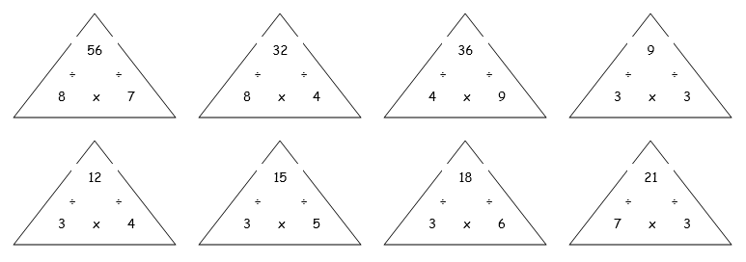**8 X 7 = 56 7 X 8 = 56 56 ÷ 8 = 7 56 ÷ 7 = 8**

**Extension: What other facts do you also know? e.g. 80 X 7 = 560, 0.8 X 7 = 5.6**

**Resource 2: The Titanic’s Radio Officers**

Just 11 years before the Titanic sailed, Guglielmo Marconi had made the first transatlantic radio broadcast. He founded his own company which provided communication equipment. Two of his radio officers were on duty throughout the Titanic’s voyage.

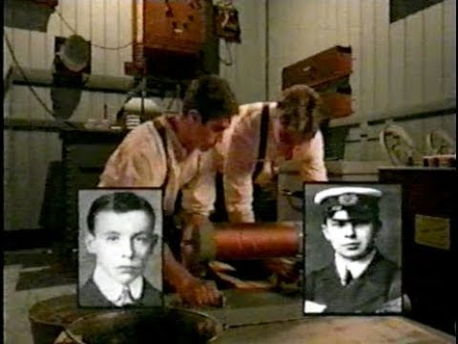

Harold Bride and Jack Phillips had been very busy transmitting messages, not only for the Captain but for passengers too. On the night before the disaster, they are said to have made alterations to the radio equipment to make it work more efficiently. They could not have predicted how useful this would become.

The following day, Bride and Phillips received seven ice warnings from other ships. They felt the judder of the ship as it hit the iceberg but were in disbelief when the captain asked them to transmit a ‘CQD’ message to other ships: this indicated that the Titanic was in distress and required assistance. The two young men worked continuously and were dismayed to discover that the nearest ship was four hours away.

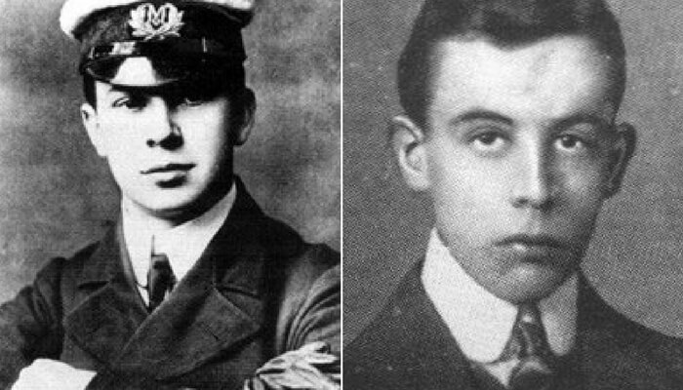

When, at last, the electricity on the ship went out, the two radio officers were forced to abandon their duties. Running out on to the flooded deck, they went their separate ways. Jack Phillips perished in the disaster but it is not known exactly what happened to him. There were reports that he clung to an upturned lifeboat in the water and was overcome by the cold or a wave.

Bride helped fellow passengers to launch one of the final lifeboats but it fell into the water and landed upside down; Bride was underneath it and managed to swim out. Together with 15 other men, he survived the night by clinging to the boat. When the men were finally rescued by the Carpathia, Bride’s feet were badly frostbitten but he assisted the ship’s radio officer as the survivors from the Titanic continued their journey to New York.

1. What is the meaning of ‘Transatlantic’?
2. Find a synonym (alternative word) for ‘alteration’.
3. Define ‘efficiently’.
4. Put the word ‘dismayed’ into a sentence of your own.
5. Find words in the text which mean:

* help
* leave
* without stopping

**Resource 3: 10-a-day Maths Revision**

**Tuesday: Division**

‘Bus stop’ method

1. 245 ÷ 5

2. 368 ÷ 6

3. 752 ÷ 8

4. 332 ÷ 4

5. 5678 ÷ 9

6. 57,851 ÷ 7

7. 2487 ÷ 6

8. 37,554 ÷ 8

9. 316 children are put into teams of 5. How many teams will there be? How many children remain?

10. 87 eggs are shared into boxes of 6. How many full boxes will there be and how many eggs will remain?

**Wednesday: Division**

‘Bus stop’ method

1. 459 ÷ 6

2.756 ÷ 3

3. 656 ÷ 4

4.232 ÷ 12

5. 897 ÷ 9

6.426 ÷ 15

7.894 ÷ 11

8. 90,752÷12

9. £3,762 is shared equally between 8 people, How much will each get and how much will remain?

10. A zoo shares 582kg of meat between 12 animals each month. How many kg will each animal get?

**Thursday: Multiplication**

Use the column method. Check your answers using a calculator.

1. 5679 X 8

2. 4851 X 6

3. 3756 X 9

4. 2558 X 3

5. 1287 X 4

6. 38,775 X 7

7. £56.72 X 9

8. £478 X 9

9. 8 people run a race of 2582m. How far have they run in total?

10. 6 people win 989 in a lottery draw. How much money was won in total?

**Thursday: Multiplication**

Use the column method. Check your answers using a calculator.

1. 6624 X 5

2. 3819 X 7

3. 4612 X 6

4. 6794 X 4

5. 8765 X 11

6. 97, 765 X 12

7. 5642 X 14

8. 3256 X 11

9. A mountain bike costs £657. What is the price of 9 bikes?

10. There are 675 packs of batteries in a factory. Each contains 9 batteries. How many batteries altogether?

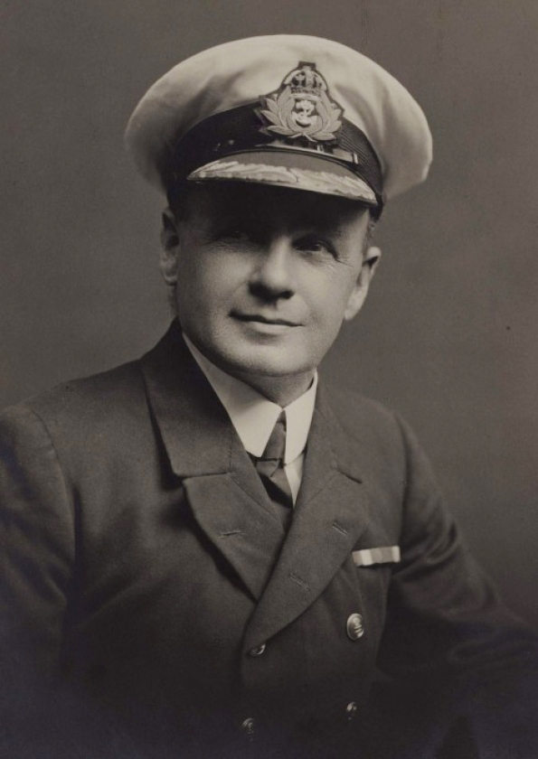**Resource 4: Charles Lightoller, the man who kept surviving**

Charles Lightoller was the most senior crew member to survive the Titanic disaster. What makes his life story so incredible is that he survived a number of other disasters too! **This is a longer text to last more than one reading session. Read the text together with an adult - you could take it in turns to read a sentence or a paragraph each.**

Lightoller was 13 when he joined the navy. His first ship, Holt Hill, was badly damaged in a heavy storm. Lightoller and his colleagues were forced to dock in Brazil, which was a dangerous place to be: war had broken out and there was an epidemic of a potentially fatal illness called small pox.

Soon after setting sail again, the Holt Hill ran aground in the Indian Ocean. Lightoller’s captain was killed in the shipwreck and the rest of the crew were rescued by a passing ship. Lightoller was a keen seaman and continued with his naval duties, even after his next ship was hit by a cyclone and was almost wrecked.

When Lightoller was 21, the coal on his cargo ship caught fire. Lightoller was awarded for his bravery in fighting the fire and saving his ship.

Three years later, on a voyage to Africa, Lightoller caught a serious illness called Malaria. Extraordinarily, he made a full recovery and went on to travel the world successfully on a number of ships.

Lightoller was pleased to become the Titanic’s second officer in 1912. At sunset on 14th April, he noticed how quickly the temperature was falling. He instructed the sailors in the crow’s next to keep a vigilant watch for ice bergs, handed over to the next commanding officer and went to bed. He was woken by the collision.

Still in his pyjamas, Lightoller went up to the deck. When he realised that the Titanic would founder, he returned to put on warmer clothes, including his officer’s jacket. He organised the loading of the lifeboats with women and children first. He ordered them to be lowered using a range of hand signals; it was impossible to hear his words over the noise.

As Titanic tilted forward, Lightoller was tipped into the sea and was pulled under the water. Incredibly, he was blown out of the water by a gush of air and swam to a lifeboat which was floating upside down in the water. He clung to the little boat until the rescue ship arrived at dawn. He helped the passengers up the rope ladders and became the last survivor to be pulled from the sea.

Just two years later, Lightoller was working on the Titanic’s sister ship, the Oceanic, when it ran aground. Once again, Lightoller commanded the evacuation and coordinated the lifeboats as the Oceanic sank.

Towards the end of World War 1, Lightoller captained a torpedo boat called the Falcon. Laying in bed one night, Lightoller felt the Falcon shudder as it collided with another ship. It stayed afloat for six hours before sinking, giving Lightoller time to evacuate his crew safely to the other boat.

As the war ended, Lightoller left the navy. He and his wife opened a guest house and lived a quieter life with their five children and pet chickens.

However, Lightoller was called upon in World War Two to captain a ship used in the evacuation of thousands of British soldiers from France. Lightoller and his crew safely returned more than 150 soldiers to Britain, narrowly escaping German bomb attacks on their journey.

Although two of Lightoller’s sons died fighting in World War two, Lightoller was fortunate to survive yet again. He went on to run a boat yard until he died of an illness at the age of 72.

Charles Lightoller survived at least nine dangerous situations. Can you make a list of these, or highlight them in the text?

e.g.

1. First ship damaged in a heavy storm
2. War and small pox in Brazil

You may also like this short clip about Charles Lightoller:

<https://www.youtube.com/watch?v=7q37EojA6_M>

**Resource 5: Titanic investigator task**

Humans learn from their mistakes. After the Titanic Disaster, investigators were given the task of working out what went wrong to avoid future disasters.

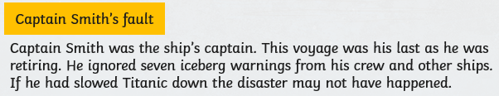Who do you think was at fault? Read the arguments below and write a few sentences to explain what you think caused the disaster.

