|  |  |  |  |  |  |
| --- | --- | --- | --- | --- | --- |
| Image result for larks classYear 5 - Larks Class  Home Learning activities to choose from  Week Commencing 11th May info@scsj.rbkc.sch.uk | | | | | |
|  | Monday | Tuesday | Wednesday | Thursday | Friday |
| Our Opening Prayer | Dear Lord  Thank you for this brand new day.  Help us to embrace opportunities for new learning.  Show us how to listen and love.  Support us and our friends.  Guide us to excellence in all that we do today.  Amen | | | | |
| P.E. | The Body Coach workout  **9am - 9:30am Monday - Friday**  <https://www.youtube.com/results?search_query=joe+wicks+body+coach> | | | | |
| Daily Events | Book Swap open outside school – all welcome!  **11am - 2pm** |  | Listen out for your phone call from Miss Bourne today.  Green phone icon, iPhone 3G Telephone call Computer Icons, phone ... | The World’s Biggest Assembly #3  **10am**  If you missed it, you can watch it here:  <https://www.youtube.com/watch?v=0keXnJkHpn8> | This afternoon (from 2pm), Miss Bourne will be calling the families she couldn’t get through to on Wednesday. |
| Reading Response | The Great Barrier Reef (resource 1 below) | The Northern Lights  (resource 2 below) | Victoria Falls  (resource 3 below) | The Grand Canyon  (resource 4 below) | Mount Everest  (resource 5 below) |
| Maths Fluency | The change game:  <http://fluencychallenge.com/play/play-claw.html> | Comparing decimals:  <http://www.teacherled.com/2015/04/01/compare-decimals/> | Cube nets:  <https://www.nctm.org/Classroom-Resources/Illuminations/Interactives/Cube-Nets/> | ‘The Claw’ decimals:  <http://fluencychallenge.com/play/play-claw.html> | Measuring in centimetres: <https://www.topmarks.co.uk/maths-games/measuring-in-cm> |
| Maths Revision | If you didn’t do last Friday’s session, you should do that first.  <https://www.youtube.com/watch?v=xuEz2ZR8_TI&list=PLQqF8sn28L9xBmQclRrb8YjcM-pzxHjfk&index=16> | <https://www.youtube.com/watch?v=EfGq_TYJHpY&list=PLQqF8sn28L9xBmQclRrb8YjcM-pzxHjfk&index=17> | <https://www.youtube.com/watch?v=R1aLze33udU&list=PLQqF8sn28L9xBmQclRrb8YjcM-pzxHjfk&index=18> | <https://www.youtube.com/watch?v=JBeArLR8Fnk&list=PLQqF8sn28L9xBmQclRrb8YjcM-pzxHjfk&index=19> | <https://www.youtube.com/watch?v=e1RfGtcB1ts&list=PLQqF8sn28L9xBmQclRrb8YjcM-pzxHjfk&index=20> |
| Times Tables  Practice | Play ‘hit the button’ with multiplication / division facts:  <https://www.topmarks.co.uk/maths-games/hit-the-button> | You will need at least 2 dice for this activity. Roll the pair of dice to make a number. Roll them again and multiply the two numbers. | Archery Arithmetic  <https://mathsframe.co.uk/en/resources/resource/399/Archery-Arithmetic-Multiplication> | Practise counting in patterns with somebody else in your house. Take it in turns to say the next number in the sequence.  e.g. 7, 14, 21… | Complete the grids  <https://phet.colorado.edu/sims/html/arithmetic/latest/arithmetic_en.html> |
| Spellings | Spelling frame:  <https://spellingframe.co.uk/> | Coconut vowels:  <https://www.arcademics.com/games/coconuts> | Match the contractions:  <https://www.quia.com/cc/86241.html> | Write these as contractions, using the apostrophe correctly:  cannot  will not  has not  would have  he is  they are | Spelling frame:  <https://spellingframe.co.uk/> |
| Punctuation and Grammar | Verbs and adverbs:  <http://www.scootle.edu.au/ec/viewing/L6187/index.html> | Fronted adverbials:  <https://www.bbc.co.uk/bitesize/topics/zwwp8mn/articles/zp937p3> | Irregular plurals:  <https://uk.ixl.com/ela/year-5/form-and-use-irregular-plurals> | Nouns and pronouns:  <https://uk.ixl.com/ela/year-5/replace-the-noun-with-a-personal-pronoun> | Modal verbs:  <https://uk.ixl.com/ela/year-5/what-does-the-modal-verb-show> |
| Writing | Find out about one animal or plant species that you might find in the Great Barrier Reef. Create a poster, information text or PowerPoint/Keynote presentation about it. | Write a postcard home from a trip to see the Northern Lights, describing the experience. | Create a country profile of South Africa, using your own research. | Choose a picture of the Grand Canyon.  Either:  Write a detailed setting description using the picture  or  Write your own story of an adventure in the Grand Canyon. | You are a mountaineer attempting to climb Everest. Write a diary entry from your journey.  (Your learning about mountain climbing from ‘Touching the Void’ will be very useful for this!) |
| Art | Complete a piece of art work based on at least one of the natural wonders of the world that you have learned about. Depending on the resources you have available at home, you might like to draw, paint, collage or sculpt  – Google Images will be useful for inspiration. | | | | |
| Themed Learning and Science | Test your knowledge of the world:  <https://www.bbc.co.uk/bitesize/topics/zvsfr82/articles/znm7vk7> | Explore the wonders of the natural world (except for the Northern Lights) using Google Earth. The full list is on the map under this document.  <https://www.google.co.uk/intl/en_uk/earth/> | Explore lines of longitude and latitude. Watch the clip and take the quiz:  <https://www.bbc.co.uk/bitesize/topics/zvsfr82/articles/zd4rmfr> | Find out about time zones around the world and play the quiz:  <https://www.bbc.co.uk/bitesize/topics/zvsfr82/articles/zjk46v4> | Mountain geography:  <https://www.bbc.co.uk/bitesize/topics/z849q6f/articles/z4g3qp3> |
| Sharing a book with Miss Bourne (added daily – click on the link on the class page) | **Fiction choice:**  ***Roald Dahl’s Revolting Rhymes*** – The Three Little Pigs call on Little Red Riding Hood for help dealing with a wolf.  **Non-fiction choice: *Harvesting Hope*** – The story of Cesar Chavez, the farmer who stood up for his beliefs | **Fiction choice:**  ***The Great Kapok Tree*** – Rainforest animals desperately persuade a woodcutter to leave their tree alone  **Non-fiction choice:**  ***Albert Einstein*** – The story of the famed genius | **Fiction choice:**  ***Jack and the Baked Beanstalk*** – You know what’s at the top of the beanstalk, but what about the *baked* *bean* stalk?  **Non-fiction choice:**  ***David Livingstone*** – The explorer who didn’t let a lion attack put him off exploring Africa | **Fiction choice:**  ***Anything but mediocre* –** What do you want to be when you grow up?  **Non-fiction choice:**  ***The Pilot Who Crashed Inside a Volcano* –** Remember the Survivors book we read? You had voted for this chapter next. I think it’s the best one yet! | **Fiction choice:**  ***The Lady of the Lake* –** Merlin helps King Arthur to find a new sword in an unexpected place.  **Non-fiction choice:**  ***The Hunt for the Abominable Snowman* –** People have searched for the legendary creature for years. Do you think they’ll ever find a Yeti? |
| Sing Education (Mr. Cadman’s channel) | Have a go at some music lessons:  <https://www.youtube.com/channel/UCr-UQ93J2M2daetW90YKoww/> | | | | |
| Catch up with the News | The Week Junior Magazine for Schools | Welcome  Click on the link below to catch up on the latest news:  <https://magazine.theweekjunior.co.uk/> | | | | |
| Daily reading | Read with an adult for at least 20 minutes EVERY DAY.  When you need something new to read, you could try an e-book:  <https://worldbook.kitaboo.com/reader/worldbook/index.html#!/>  [https://www.oxfordowl.co.uk/for-home/find-a-book/library-page/?view=image&query=&type=book&age_group=Age+9-11&level=&level_select=&book_type=&series=#](https://www.oxfordowl.co.uk/for-home/find-a-book/library-page/?view=image&query=&type=book&age_group=Age+9-11&level=&level_select=&book_type=&series=) | | | | |
| Suggested Brain Breaks and Relaxation | Put on some relaxing music. You might like to do something creative while you’re listening, like drawing or colouring.  <https://www.youtube.com/watch?v=17ILK7mjdVI> | Meditation for Kids  <https://www.youtube.com/watch?v=_mX4JBBIcBk> | Practise the MindUp brain break (the same one as we do in school).  <https://mindup.org.uk/mindup-activities/> | Have a go at some origami  <https://www.youtube.com/watch?v=JlJsU8tspfc> | Lay down comfortably, press play and follow the instructions:  <https://www.youtube.com/watch?v=cDKyRpW-Yuc> |
| Suggested  Physical Activities | One foot passing challenge:  <https://tlg-pe.co.uk/tlgskillsathome/challenges.aspx?code=6> | Speed bounce challenge:  <https://tlg-pe.co.uk/tlgskillsathome/challenges.aspx?code=7> | Bar challenge:  <https://tlg-pe.co.uk/tlgskillsathome/challenges.aspx?code=8> | Choose a ‘Just Dance Kids’ video from YouTube  <https://www.youtube.com/results?search_query=just+dance+kids> | Workout  <https://www.youtube.com/watch?v=L_A_HjHZxfI> |
| A song a day to sing along with | Shine Jesus Shine  <https://www.youtube.com/watch?v=7OIwSQmyCg4> | I the Lord of Sea and Sky <https://www.youtube.com/watch?v=gcL9S5a3weU> | One more step along the world I go <https://www.youtube.com/watch?v=b6czcGvXQcM> | You are Good <https://www.youtube.com/watch?v=eW0UOxwepJQ> | Roses of Success <https://www.youtube.com/watch?v=WOyIJVUaoeg> |
| Our Closing Prayer | Lord of the loving heart, may ours be loving too;  Lord of the gentle hands, may ours be gentle too;  Lord of the willing feet, may ours be willing too;  May we grow more like you in all we say and do.  Amen  May the Lord bless us and keep us;  May his power be ever beside us;  May the Lord look with favour upon us  and give us his peace. | | | | |

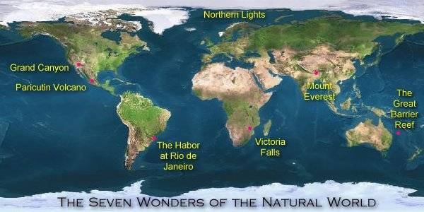**Seven Wonders of the Natural World**

**Resource 1: The Great Barrier Reef**

The Great Barrier Reef is a huge living formation off the East coast of Australia. It is one of the world’s most natural living ecosystems (a group of animals and plants that share the same location). Stretching for more than 2,600 miles, it includes more than 900 islands. It is bigger than the UK and can be seen from outer space!

Scientists know that the reef is millions of years old and made naturally although there is still a lot to discover about how the many species of animals, plants and coral came to be there.

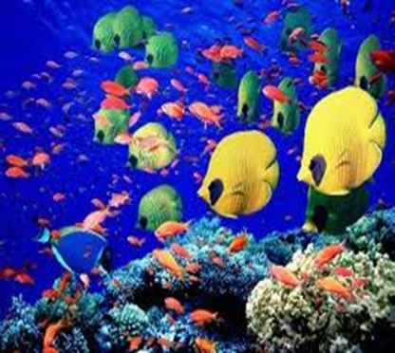More than 360 species of plants have so far been identified. Most of these are coral and sponges. Coral is a unique living species that needs a particular condition to survive: warm, shallow water with a high salt content. Australia’s coast is ideal.

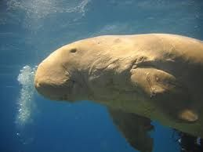A variety of animal species thrive in the reef. Seahorses, sea snakes, sea turtles, dolphins, stingrays and sharks can all be found there. More than 50,000 dugongs (pictured) live in Australian waters, feeding from the plants. They are often hunted by saltwater crocodiles.

For centuries, tribes have fished and found other sources of food there.

The Great Barrier Reef is such a peaceful, natural beauty that local people have always been drawn to it. It remains a popular place for tourists to visit; it is a hotspot for divers keen to feast their eyes on the magnificent sights of a unique place.

Tourism can be damaging and scientists are concerned about the effect on the reef of too many visitors. Coral is very delicate and can be easily destroyed. With so many other plants and animals in the reef relying on it, protecting the reef is vital.

The Great Barrier Reef became a World Heritage site in 1981. This means that the area is protected from any activities which may harm it, such as fishing and touching the coral.

Scientists hope that by allowing the reef to flourish they will be able to explore it for years to come to uncover more of the secrets of the species that live there.

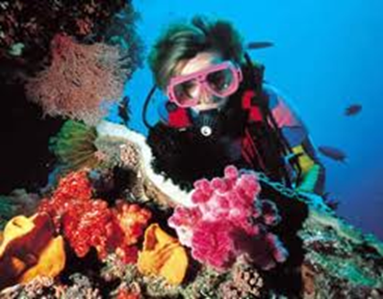

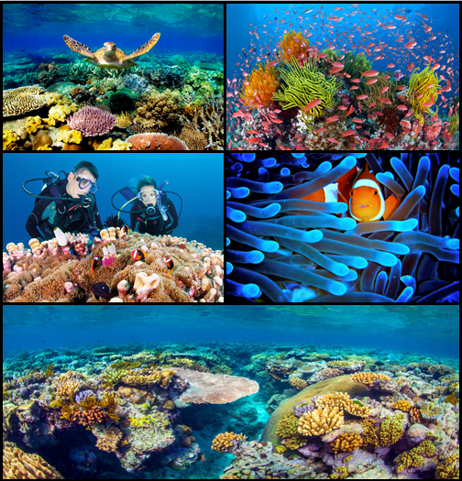

You might also like to watch this clip on the same topic:

<https://www.youtube.com/watch?v=J2BKd5e15Jc>

**Monday’s reading response task:**

Remember to answer the questions in full sentences.

1. In which country is the Great Barrier Reef found?

The Great Barrier Reef is found in…

1. What do scientists already know about the reef?
2. Name some of the animal species found in the reef.
3. Why is it vital to protect the coral?
4. What happened in 1981? What does this mean?

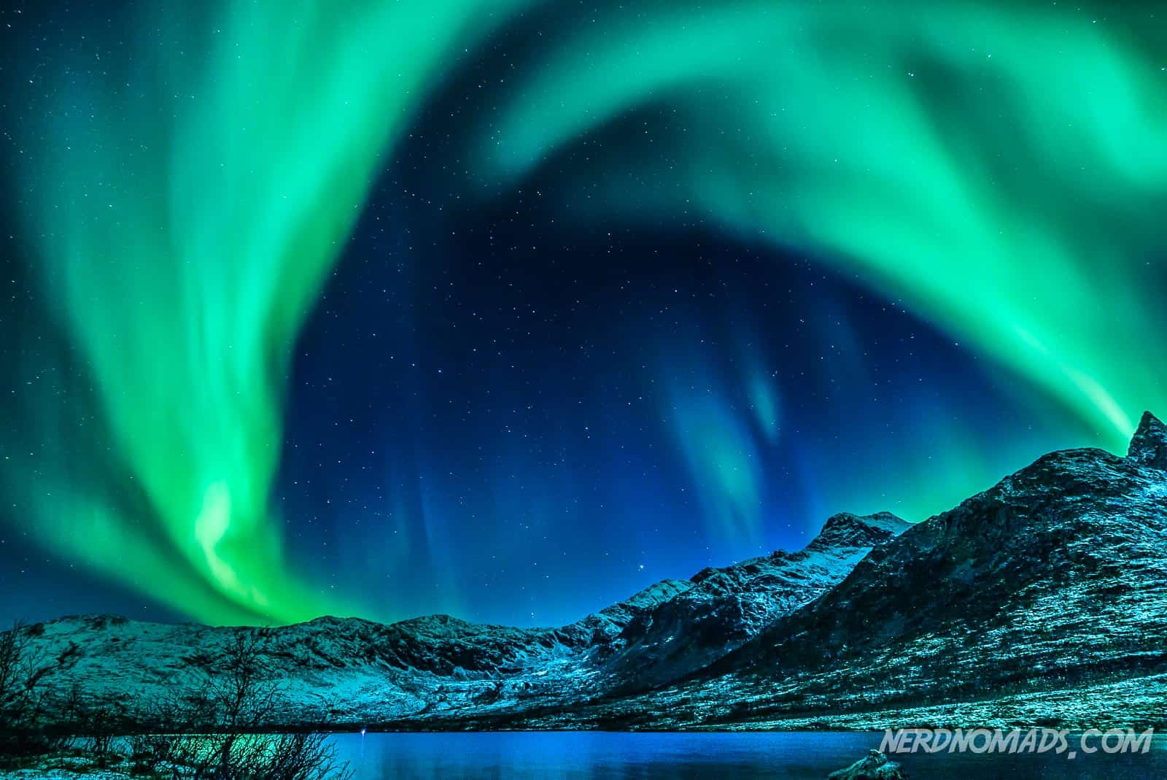**Resource 2: The Northern Lights**

Otherwise known as the Aurora Borealis, the Northern Lights are bright, dancing streams of purple, green, red and yellow which can be seen in the night’s sky. No two auroras will ever look the same; their forms are constantly changing.

Since the beginning of time, people have told stories and legends to explain natural, but mysterious occurrences. The Northern Lights are one example. The Vikings thought that the Northern Lights were caused by the shining weapons of brilliant soldiers. The Innuits believed that they were the souls of animals such as salmon and deer. The Indians said they were the torches of giants living in the north. The Ancient Chinese believed that the lights were the flames of fighting dragons.

In fact, Scientists now know that the Northern Lights are caused by the sun’s charged particles, called solar flares or solar wind, colliding with the gas atoms in the Earth’s atmosphere. This causes the gasses to glow, creating the effect of colourful, moving patterns against the dark background of the night. They are 200 to 300 kilometres above Earth and are large enough to be seen from space!

They can appear at any time but are most likely during the coldest months of the year. They are not just a spectacle for the eyes: The Northern Lights create sounds much like claps and crackles. 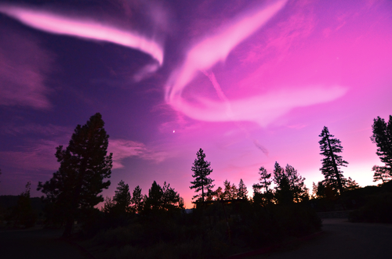

The name ‘Aurora Borealis’ comes from Ancient Greece and Ancient Rome. Aurora was the Roman God of the dawn and Boreas is the Greek word for the north wind.

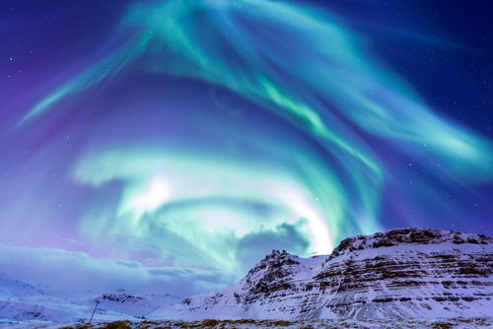The best places in the world to view the Northern Lights are, unsurprisingly, the countries closest to the North Pole, such as Canada, Iceland and Norway. It must be dark to see them. People often travel away from towns and cities to avoid the light pollution which makes them harder to see. The Northern Lights can be unpredictable, especially in the Arctic where the weather changes quickly.

Close to the South Pole, it is possible to see the Southern Lights; however, these are not as easily visible. Earth isn’t the only planet to have auroras; they have been seen on Neptune, Jupiter, Saturn and Uranus too!

You might also like to watch this clip on the same topic:

<https://www.youtube.com/watch?v=fVsONlc3OUY>

**Tuesday’s reading response task:**

Remember to answer the questions in full sentences.

1. What did the Vikings believe about the Northern lights?
2. How far above Earth are the Northern Lights?
3. During which season are the Northern Lights most likely to be seen?
4. Name three of the best countries in the world to see the Northern Lights.
5. Why do people travel away from cities to view the Northern Lights?

**Resource 3: The Victoria Falls**

The Victoria Falls is one of the impressive waterfalls on the planet. It is located along the border between two countries in southern Africa. Can you see which two countries the Falls are between? Use the map below to help you to locate them.

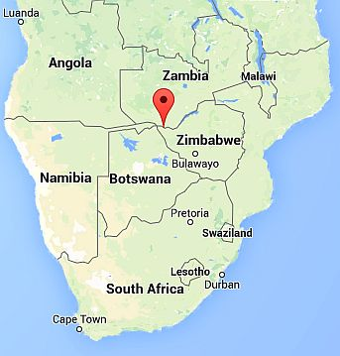

There, the Zambezi River takes a huge plunge, forming a giant ‘sheet’ of falling water. At more than 100 metres high and more than a mile wide, the Victoria Falls are the world’s largest. 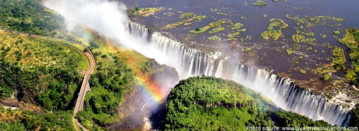

550 million litres of water flow over the falls every single minute, plunging into a pool that is 70 metres deep. Due to the sheer force of the water, the sound can be heard and the mist can be felt from miles away. Humans have been living around the falls for more than 2 million years and ancient tribes people called it ‘Mosi-ao-Tunya’ which means ‘the smoke that thunders’. In 1855, a British explorer called David Livingstone named the site after Queen Victoria, who was Queen of England at the time.

The mist creates a habitat much like a rainforest in the area surrounding the falls. Here, many species of plants and animals that wouldn’t normally survive in the hot, dry African climate are able to thrive. Elephants, rhinoceroses and hippopotamus can be spotted close to the falls while lions, cheetahs and leopards are to be found in the surrounding jungle. Meanwhile, falcons and eagles can been seen overhead, swooping into the water to catch their fish.

Every year, thousands of visitors come to the falls to see this wonder of the natural world and also to take part in adventurous activities. The Victoria Falls Bridge is a particularly popular place for bungee jumping! Thrill-seekers can jump from 364 feet with a rope tied to their ankles and dangle upside down, just above the water.

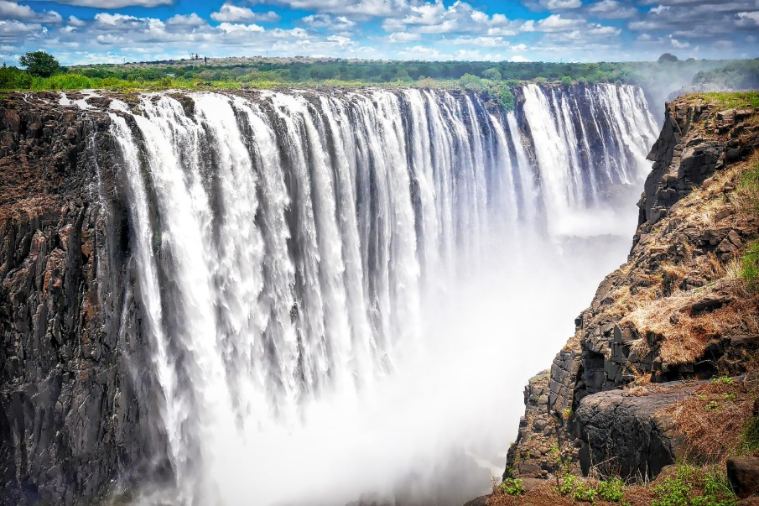In 1983, the falls became part of the Zambezi National Park which means that they are carefully protected from tourism to ensure that they are preserved for future generations to enjoy.

You might also like to watch this clip with impressive pictures of the Falls: <https://www.youtube.com/watch?v=H0LG5rOo_9w>

**Wednesday’s reading response task:**

Remember to answer the questions in full sentences.

1. The Victoria Falls are located on the border of which two African countries?
2. What quantity of water flows over the Victoria Falls every minute?
3. Who named the Victoria Falls after the English Queen at the time?
4. Why are so many plant and animal species able to thrive so close to the falls?
5. What is special about the bungee jumping experience at the Victoria Falls?
6. In the final paragraph, what does ‘preserved’ mean?

**Resource 4: The Grand Canyon**

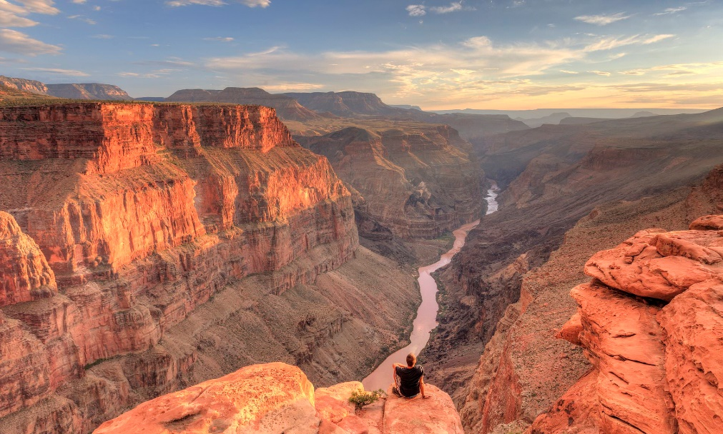

‘Grand’ means great or impressive and a canyon is a very deep valley with step sides. The Grand Canyon, found in the American state of Arizona, is the largest and most famous canyon in the world. It stretches for 277 miles and it is more than 18 miles wide and over a mile deep in some places.

The Colorado River, which runs through the canyon, has formed the landscape. Geologists (scientists who study rocks) believe that this process began more than 17 million years ago. As the river has winds its way across the landscape, it erodes the rocks, cutting into them downwards.

As the crevasses have become deeper, different colours have been visible in the valley’s sides. These are the different colours of more than 40 different kinds of rocks. Some of them are more than 2 billion years old! You might like to watch this clip to show how the canyon was formed: <https://www.pbslearningmedia.org/resource/ess05.sci.ess.earthsys.canyon/the-grand-canyon-how-it-formed/#0>

Approximately three million years ago, a volcano erupted in the canyon. This spread ash and lava, blocking the path of the river and forcing it to carve a new path. The volcanic rocks can still be found in the canyon today.

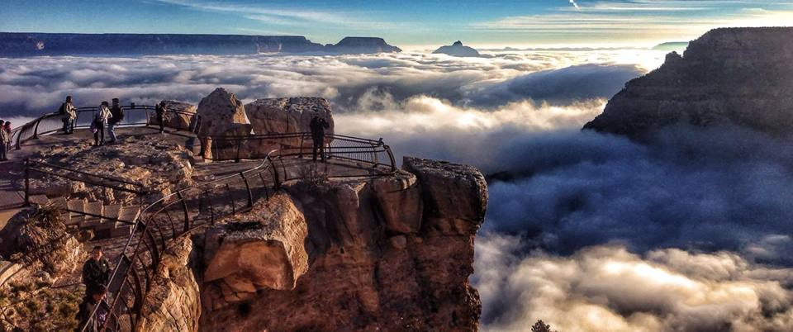

Many species are adapted to thrive in the dry, desert habitat. These include bats, rabbits, deer, raccoons and many reptiles such as lizards. Some of the world’s largest birds swoop overhead. Visitors are reminded to be aware of some of the more dangerous creatures including poisonous snakes, spiders, scorpions and mountain lions.

Every year, more than 4 million people visit the Grand Canyon. People can take trips on boats and rafts along the Colorado River or hike along trails at the top or bottom of the canyon. Some of these trails lead to Phantom Ranch, where hikers can camp for the night.

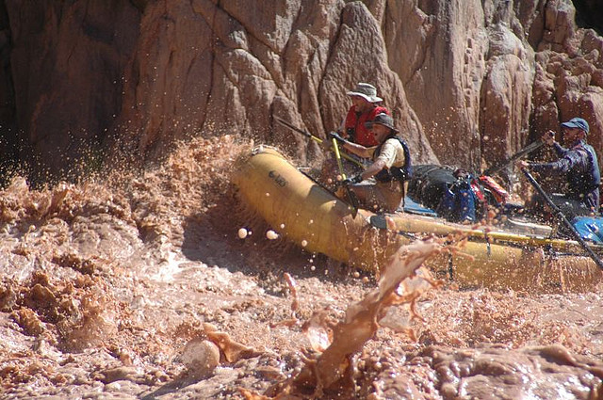

**Thursday’s reading response task:**

Remember to answer the questions in full sentences.

1. A geologist is an expert on which subject?
2. How was the Grand Canyon formed?
3. Why are the valley sides different colours?
4. What was the effect of the volcano?
5. Name two dangerous animals which live in the Grand Canyon National Park.
6. Helicopters are used for two purposes in the Grand Canyon National Park. What are they?

There are spectacular viewpoints which can be accessed by car and others have to be reached on horseback. There are also trains running through parts of the canyon. Helicopter rides over the canyon are a very popular activity; tourists can take in spectacular views from the air. The Grand Canyon National Park also operates its own helicopter rescue service to reach visitors who get into trouble.

You might also like this clip with lots of images of the Grand Canyon:

<https://www.youtube.com/watch?v=ezpqDi42pRM>

**Resource 5: Mount Everest**

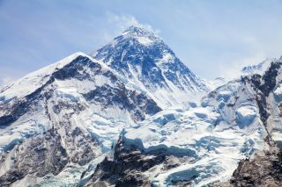Mount Everest is the highest mountain on Earth. It is located in the Himalayan mountain range, on the border between Nepal and Tibet. The very top of Everest is more than 5.5 miles above sea level.

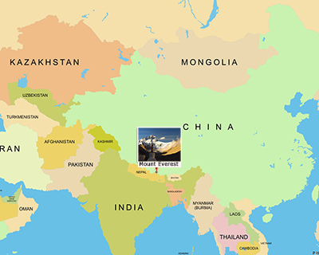

The mountain is known by many different names. The name ‘Everest’ is taken from a British explorer, George Everest, who surveyed and mapped India in the 1800s.

In 1921, people began attempting to climb to the summit of Everest, but each attempt failed. Some explorers have been forced to turn back and several have disappeared altogether.

There are many reasons why climbing Everest is such a great challenge. For half of the year, Everest is inaccessible due to heavy snow and wind. For the other half of the year, high winds and freezing temperatures still create highly dangerous conditions for mountaineers. Heavy snow carries the risk of avalanches and dangerous falls.

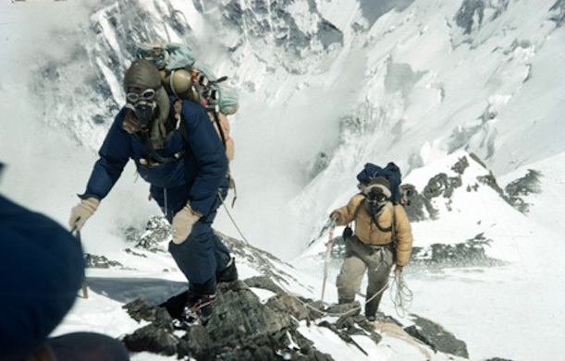Furthermore, the mountain is so high that the air at the top is thinner than the air at the bottom, which can cause altitude sickness; climbers may experience headaches, dizziness, sickness and fatigue. This is because the air is so thin that the heart cannot get enough oxygen to fuel the muscles. These symptoms might not be too dangerous on safe ground near a hospital, but on a dangerous mountain with no way to attract help, they are potentially fatal and can cause climbers to make dangerous mistakes.

In 1953, a team of mountaineers led by Edmund Hillary became the first to reach the summit. They were successful because they tried a previously unused route up the mountain and used supplies which had been set out for them along the route. Delighted at reaching the summit, they took the first ever photographs from the Earth’s highest point and buried some items in the snow to prove that they were there, before beginning their descent.

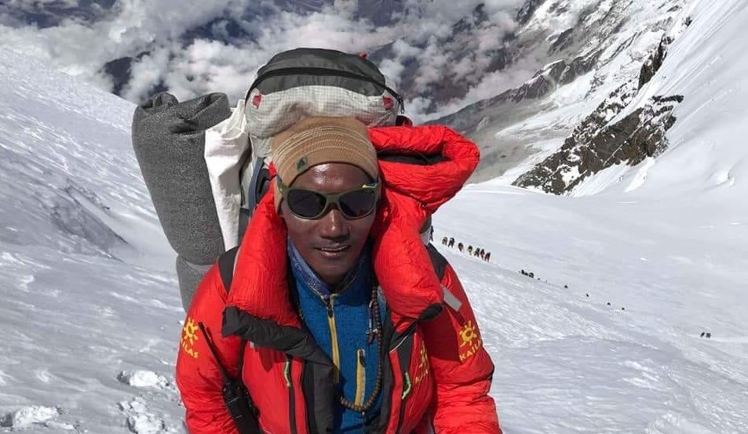In the years since, more than 4,000 climbers have reached the summit. Many of them are assisted by sherpas. These are local mountaineers who guide climbers and help to carry equipment. One Sherpa, Kami Rita, holds the world record for climbing Everest 24 times!

Over the years, the human waste, climbing equipment and general rubbish left by climbers on Everest have begun to mount up. This threatens to contaminate the water sources which climbers use to obtain drinking water. The Chinese and Nepalese governments have organised new initiatives to clean Everest up in order to preserve it.

Today, in order to climb Everest, climbers must pay around £8,000 for a special licence. In 2017, a South African climber was arrested and imprisoned after going on to the mountain without permission. It is vital that the number of visitors to the mountain is controlled in order to reduce the impact on the environment.

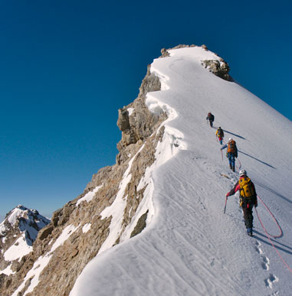

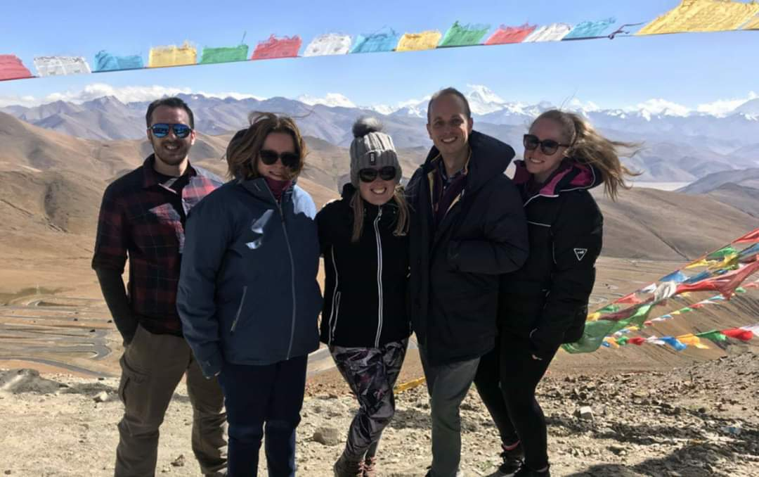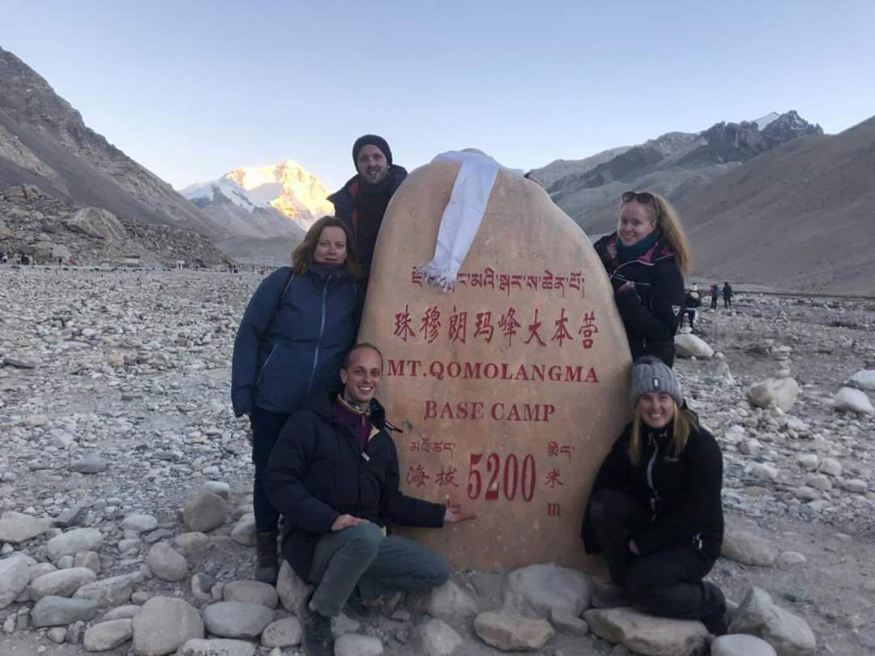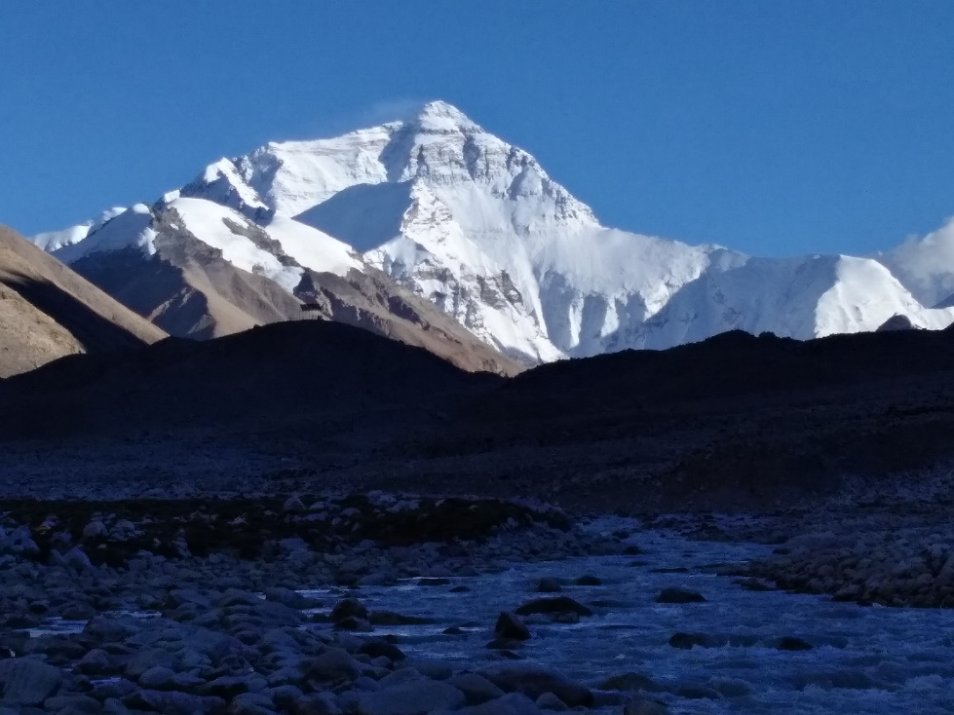**Here are some pictures from Miss Bourne’s trip to Mount Everest in 2018 (you can see Everest in all of the background of all of these).**

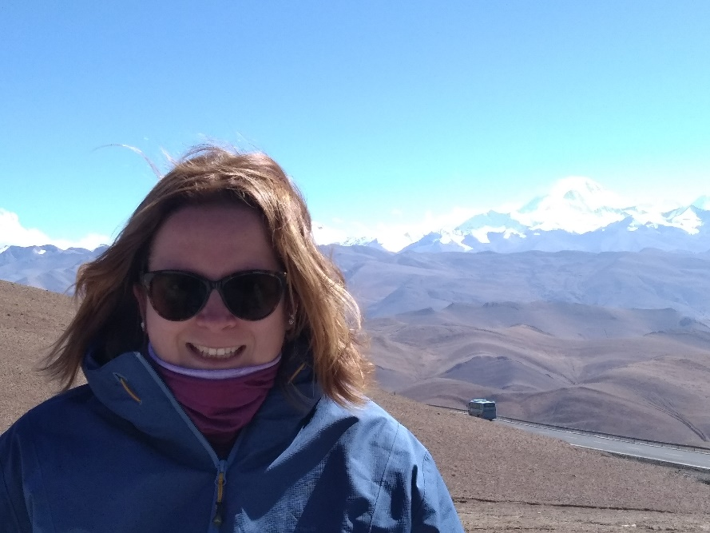

You might also like this clip about Mount Everest. It shows you how it was formed and what it looks like now:

<https://www.youtube.com/watch?v=PDrMH7RwupQ>

**Friday’s reading response task:**

Remember to answer the questions in full sentences.

1. Who was George Everest and what did he do?
2. Give three reasons why climbing Mount Everest is so challenging.
3. What did Edmund Hillary do when he became the first person to reach the summit of Everest?
4. What is the role of a Sherpa?
5. Why are leaders of Nepal and China worried about too many people visiting Mount Everest?