|  |  |  |  |  |  |
| --- | --- | --- | --- | --- | --- |
| Image result for larks classYear 5 - Larks Class  Home Learning activities to choose from  Week Commencing 18th May info@scsj.rbkc.sch.uk | | | | | |
|  | Monday | Tuesday | Wednesday | Thursday | Friday |
| Our Opening Prayer | Dear Lord  Thank you for this brand new day.  Help us to embrace opportunities for new learning.  Show us how to listen and love.  Support us and our friends.  Guide us to excellence in all that we do today.  Amen | | | | |
| P.E. | The Body Coach workout  **9am - 9:30am Monday - Friday**  <https://www.youtube.com/results?search_query=joe+wicks+body+coach> | | | | |
| Mental Health Awareness | This week is Mental Health Awareness Week.  Place2Be are looking for young designers to create kindness cups and certificates.  See the document underneath your home learning grid. | | | | |
| Daily Events |  |  | *Tomorrow*, there will be a world record breaking attempt to hold the largest online art lesson! Join illustrators to find out how to draw characters.  You might prefer to sign up today, at  [www.artworldrecords.com](http://www.artworldrecords.com) | The World’s Biggest Assembly #4  **10am**  Watch it here: [www.tes.com](http://www.tes.com)  World record-breaking art lesson  **4pm**  [www.artworldrecords.com](http://www.artworldrecords.com) | On Saturday 23rd May, Charlie Mackesy (the artist who drew the illustrations for our staff video) will be hosting a ‘draw along session’ at 3pm. Find out more here: <https://www.royalalberthall.com/tickets/events/2020/royal-albert-home-charlie-mackesy/>  Next week is half-term; have a fabulous break!    **HAPPY BIRTHDAY to EDEN - our extremely caring, hard-working and creative future Egyptologist - who will celebrate her birthday next week! *from everyone at SCSJ*** |
| Reading Response | Visit the Newsround website and choose an article that interests you. Record three facts you have learned from it. Not sure which one to choose? Use this one: <https://www.bbc.co.uk/newsround/52393241> | Walt Disney Biography Part 1 (resource 2 below) | Walt Disney Biography Part 2 (resource 4 below) | Film-making techniques (resource 7 below) | The Disney Company Today (resource 10 below) |
| Maths Fluency | Negative numbers – play the quiz:  <https://www.bbc.co.uk/bitesize/topics/znwj6sg/articles/zxthnbk> | Learn the Roman Numerals song. Can you keep up with the actions?  <https://www.youtube.com/watch?v=z1UmAgekzbs> | Make a number line which counts in quarters, starting on 1 and ending in 10.  e.g. 1, 1 ¼ , 1 ½ … | Number Ninja  <https://www.abcya.com/games/number_ninja_factors> | Square and cubed numbers: <https://www.bbc.co.uk/bitesize/topics/zyhs7p3/articles/z2ndsrd> |
| Maths Revision | Adjusting addends to make calculation easier:  <https://www.youtube.com/watch?v=uxRuA8ZhHMA&list=PLQqF8sn28L9z1W52kmapUxEwbLiaFs5oM&index=2&t=0s> | Addition of larger numbers:  <https://www.youtube.com/watch?v=fetTcAFpbZc&list=PLQqF8sn28L9z1W52kmapUxEwbLiaFs5oM&index=2> | Calculations with decimal fractions:  <https://www.youtube.com/watch?v=7HX--0EN6sg&list=PLQqF8sn28L9z1W52kmapUxEwbLiaFs5oM&index=3> | Balancing equations:  <https://www.youtube.com/watch?v=7ThtjPdIibs&list=PLQqF8sn28L9z1W52kmapUxEwbLiaFs5oM&index=4> | Follow the instructions to play game three (you might like to do games 1 and 2 as a warm-up). If you don’t have a die, you could draw from 1-9 playing cards or use a number generator app.  <https://nrich.maths.org/10072> |
| Times Tables  Practice | Teach someone at home to play Stickyfingers like we do at school and see if you can beat them! | Log in to your Times Tables Rockstars account. Email Miss Bourne if you need your password (address above). | Shuffle a deck of playing cards and take out the jacks and the jokers. Queen= 11 and King=12.  Split the deck into two piles and turn over the top card on each. Multiply the numbers on the cards together. You could compete with somebody else: the first person to say the answer wins a point. | Practise your times tables here:  <https://www.timestables.co.uk/multiplication-tables-check/> | Try the fast maths challenge like we do in school. You will need to draw out an 11x11 grid (or you can print the sheet at the end of this document, if you have a printer). Don’t forget your stopwatch. Can you beat our class record of 2 mins 22 seconds?  Make sure you use the numbers 1 - 12 at least once. |
| Spellings | Using the suffix –ation - watch the clip and complete the task below it:  <https://www.bbc.co.uk/bitesize/topics/zqqsw6f/articles/zcb8k7h> | Using the suffix –ous - watch the clip and complete the task below it:  <https://www.bbc.co.uk/bitesize/topics/zqqsw6f/articles/zqcpv9q> | Using the suffix –fer - watch the clip and complete the task below it:  <https://www.bbc.co.uk/bitesize/topics/zqqsw6f/articles/zcsyjty> | Words ending in –cious and –tious:  <https://www.bbc.co.uk/bitesize/topics/zt62mnb/articles/zp7dk7h> | Spelling the ‘shun’ sound:  <https://www.bbc.co.uk/bitesize/topics/zt62mnb/articles/zyv4qhv> |
| Punctuation and Grammar | Punctuation speed game:  <https://www.turtlediary.com/game/identify-correct-punctuation.html> | Passive verbs:  <https://www.bbc.co.uk/bitesize/topics/zwwp8mn/articles/zsx2b82> | Revise colons:  <https://www.helpfulgames.com/subjects/english/correct-punctuation.html> | Watch the clip and write three sentences of your own using a colon. If you don’t know what to write them about, make your first sentence about foods, your second about someone at home and your third sentence about school.  <https://www.youtube.com/watch?v=ymgszCIoHbA> | Using bullet points:  <https://www.bbc.co.uk/bitesize/topics/zvwwxnb/articles/z2yydxs> |
| Writing | Choose a favourite Disney film of your own (see the list in resource 1 for ideas). Write a synopsis to summarise the story from beginning to end. | Choose a character from a Disney film that you know well OR do today’s theme task first and use one of your own characters instead.  Write a detailed character description. See Miss B.’s example (resource 3 below). | Choose a setting photograph from a Disney movie to describe. You might have ideas of your own; if not, choose one from the photographs (resource 5 below).  Miss Bourne has written a model text for you to look at (resource 6 below). | You are going to write a story of your own today. You can either choose a Disney story that you know well, or write a story for the characters you created in your themed learning this week.  It may be helpful to create a story map before you begin writing, to help you to organise your ideas. You might like to present it in paragraphs or as a graphic novel (example in resource 8). | |
| Themed Learning and Science | Learn how to draw Disney characters. Have a go and send us your pictures!  <https://www.youtube.com/results?search_query=how+to+draw+disney+characters> | Design and create two characters in the style of Disney (you could draw, model or make puppets). They could be animals or humans, goodies or baddies. | Create a setting for the characters you created yesterday – for example, would they be found in the desert, under the sea or in the rainforest? The only limit is your imagination. Draw or make a setting as a backdrop for your characters. | Make a play script of scene involving your two characters (see Miss Bourne’s example in resource 9 below). | Use scratch to create an animation of your play script.  <https://scratch.mit.edu/> |
| Sharing a book with Miss Bourne (added daily – click on the link on the class page) | **Fiction Choice:**  ***Revolting Rhymes* –** Cinderella ditches her Prince after he chops off the ugly sisters’ heads!  **Non-Fiction Choice:**  ***Martin Luther King*** – The man who dreamed of equality | **Fiction Choice: *The Silver Arrow*** – The story of Robin Hood and the Sheriff  **Non-Fiction Choice:**  ***The Bermuda Triangle*** – The stretch of the Atlantic Ocean where ships, planes and people are said to have mysteriously disappeared… | **Fiction Choice:**  ***The Lost World of Atlantis*** – The Greek myth that became a Disney film  **Non-Fiction Choice:**  ***The Real Pocahontas*** – The life of the woman who inspired the Disney film | **Fiction Choice:**  ***Beowulf and the Grendel*** – The tale of the noblest and greatest warrior  **Non-Fiction Choice:**  ***The Four-legged Ambulance*** – The true story of the donkey who helped to save lives in World War 1 | **Fiction Choice: *Coyote Steals the Sun and Moon*** – The ancient American myth  **Non-Fiction Choice:**  ***Who Was Grace Darling?*** – The young rescuer who risked her life to save shipwrecked sailors |
| Sing Education (Mr. Cadman’s channel) | Have a go at some music lessons:  <https://www.youtube.com/channel/UCr-UQ93J2M2daetW90YKoww/> | | | | |
| The Week Junior | The Week Junior Magazine for Schools | Welcome  Catch up on this week’s news:  <https://magazine.theweekjunior.co.uk/> | | | | |
| Daily Reading | Read with an adult for at least 20 minutes EVERY DAY.  When you need something new to read, you could try an e-book:  <https://worldbook.kitaboo.com/reader/worldbook/index.html#!/>  [https://www.oxfordowl.co.uk/for-home/find-a-book/library-page/?view=image&query=&type=book&age_group=Age+9-11&level=&level_select=&book_type=&series=#](https://www.oxfordowl.co.uk/for-home/find-a-book/library-page/?view=image&query=&type=book&age_group=Age+9-11&level=&level_select=&book_type=&series=) | | | | |
| Suggested Brain Breaks and Relaxation | Choose a Peace Out  <https://www.youtube.com/results?search_query=peace+out> | Listen to a MindUp Brain Break (the one we use in school.) <https://mindup.org.uk/mindup-activities/> | Try a Disney dance tutorial such as this one:  <https://www.youtube.com/watch?v=Avf5QyUY1Bo&t=301s> | Sketch the view from your bedroom window, adding every detail you can see. | Listen to a MindUp Brain Break (the one we use in school.) <https://mindup.org.uk/mindup-activities/> |
| Suggested  Physical Activities | Choose a ‘Just Dance kids’ exercise  <https://www.youtube.com/results?search_query=just+dance+kids> | Try the Banana Banana Meatball!  <https://family.gonoodle.com/activities/banana-banana-meatball> | Try Cosmic Kids Yoga  <https://www.youtube.com/user/CosmicKidsYoga> | Peanut Butter in a Cup  <https://www.gonoodle.com/good-energy-at-home-kids-games-and-videos/> | Choose a ‘Just Dance kids’ exercise  <https://www.youtube.com/results?search_query=just+dance+kids> |
| A song a day to sing along with | My Lighthouse  <https://www.youtube.com/watch?v=lFBZJGSgyVQ> | Be Bold, Be Strong  <https://www.youtube.com/watch?v=OWqa4Rpq4PE> | Give Me Oil In My Lamp  <https://www.youtube.com/watch?v=21RHemxzb8U> | Our God Is A Great Big God  <https://www.youtube.com/watch?v=-424MpB_pd0> | This Is Amazing Grace  <https://www.youtube.com/watch?v=cgsbaBIaoVc> |
| Our Closing Prayer | Lord of the loving heart, may ours be loving too;  Lord of the gentle hands, may ours be gentle too;  Lord of the willing feet, may ours be willing too;  May we grow more like you in all we say and do.  Amen  May the Lord bless us and keep us;  May his power be ever beside us;  May the Lord look with favour upon us  and give us his peace. | | | | |

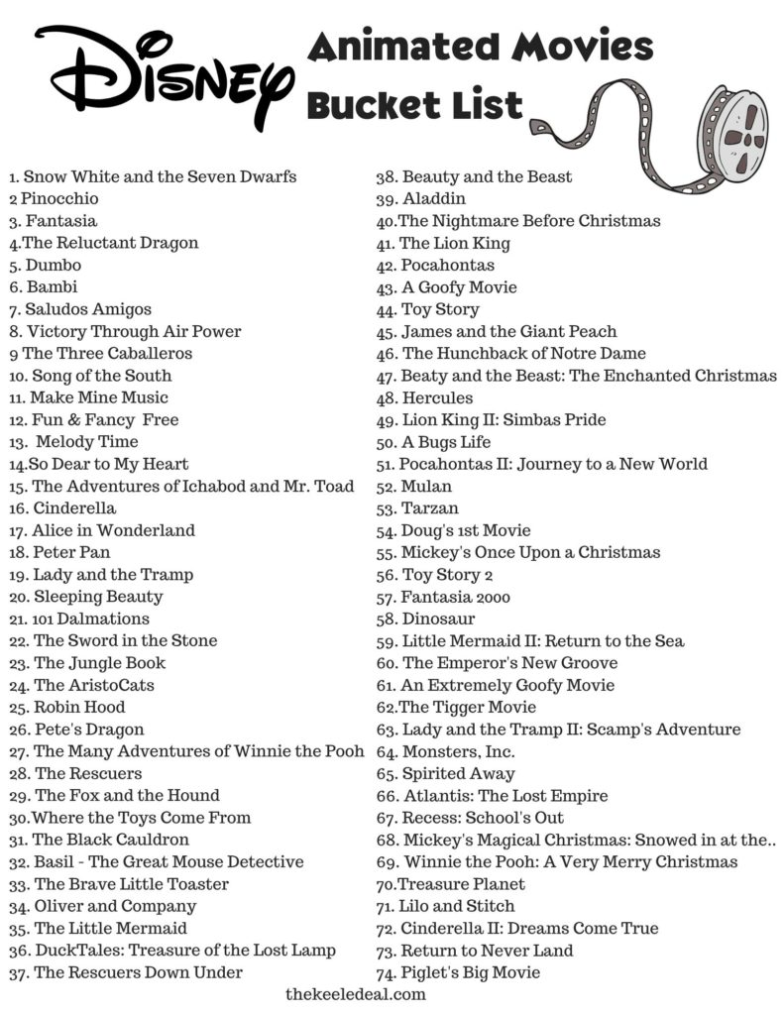**Resource 1: Disney film list**

[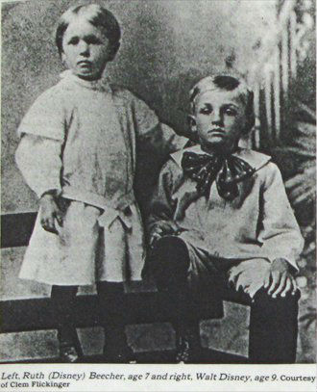](https://www.google.com/url?sa=i&url=https://touringplans.com/blog/2014/12/05/walt-disney-humble-beginnings-man-started/&psig=AOvVaw3EhGi4edGBpfjNdfET7cqv&ust=1589918957597000&source=images&cd=vfe&ved=0CAIQjRxqFwoTCOjn1PWbvukCFQAAAAAdAAAAABAQ)**Resource 2: Walt Disney Biography part 1**

At Walt Disney’s school in Missouri, USA, he was known as the class clown; he would do anything for attention. He once bought a field mouse into the classroom, scaring his teacher and classmates. Little did he know that it would one day be another mouse that would make him famous!

Walt loved growing up in the countryside with his four siblings. Around the family farm were weeping willows and endless fruit trees. Walt watched in **awe** as rabbits, squirrels, foxes and raccoons scurried around the giant pond. He loved riding horses and even the family’s pigs, even though he often fell off and ended up lying in the mud! After school he would fish and swim. In winter time, the frozen pond was the perfect place for skating or sledding. At the age of nine, Walt took his first job, as a newspaper delivery boy.

When some travelling actors came to his school to put on a play of Peter Pan, he was **enthralled**. He later got to play Peter Pan in his school’s production. For the flying scenes, Walt’s brother hooked up some wires to lift him into the air. Unfortunately, the wires broke and Walt fell into the surprised crowd. This didn’t **deter** him, however; he was a natural entertainer.

[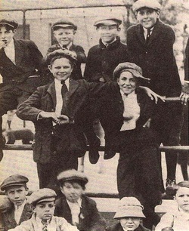](https://www.google.com/url?sa=i&url=https://amanwithadream.weebly.com/childhood.html&psig=AOvVaw3EhGi4edGBpfjNdfET7cqv&ust=1589918957597000&source=images&cd=vfe&ved=0CAIQjRxqFwoTCOjn1PWbvukCFQAAAAAdAAAAABAJ)Walt and his best friend (who was also named Walt) loved to dress up and act. They once won some money in a comedy competition. His favourite hobby, however, was drawing. His favourite possession was a box of crayons given to him by his aunt and he was **rarely** seen without a pencil in his hand. He’d pass the time drawing characters in the corners of his books. When he flipped the pages, the animals appeared to move. He had created his very first cartoons. Soon, the local hairdressing salon displayed his pictures on the walls to entertain their customers.

As soon as Walt as old enough to leave school, he took night classes at art school and bought his first camera. He and a friend made short films together. However, they weren’t always successful. At their first production, they were booed off the stage!

During World War 1, Walt was asked to drive ambulances to help **wounded** soldiers. During his spare time, he would draw cartoons to cheer them up.

[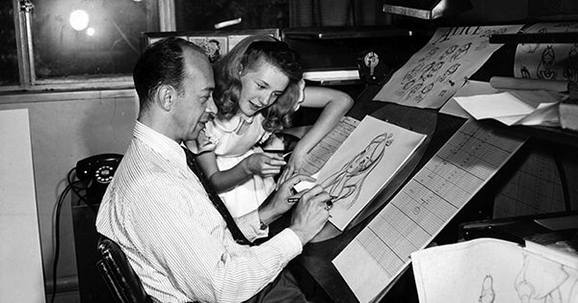](https://www.google.com/url?sa=i&url=https://englishbookgeorgia.com/blogebg/on-this-day-1951-walt-disneys-animated-film-alice-in-wonderland-premieres-in-london/&psig=AOvVaw3qn3re9utTC449ezngjDAV&ust=1589919110048000&source=images&cd=vfe&ved=0CAIQjRxqFwoTCKi0pbucvukCFQAAAAAdAAAAABAD)Eventually, in 1920, he found a job creating animations: making pictures move across the screen. Audiences were amazed by the new technology. Walt spent hours in the library discovering new cartoon invention techniques. Then, he set up a studio behind his house.

Animation takes a long time. Every evening, Walt would draw cartoon characters in different positions and film them. It once took eighteen different drawings just to show a character moving his arm. Walt never let hard work stop him. He called his cartoons ‘Laugh-0-Grams’. They were silent, funny and lasted only a few minutes. Some were based on fairy tales but Walt would change the story to make it better. Soon, theatres were buying his cartoons and Walt had enough money to start a small company.

He couldn’t do all of the drawing by himself so he employed other talented artists to help. They loved working together, designing characters, making up jokes and playing with their cameras. Their first job was animating for the film *Alice in Wonderland*.

[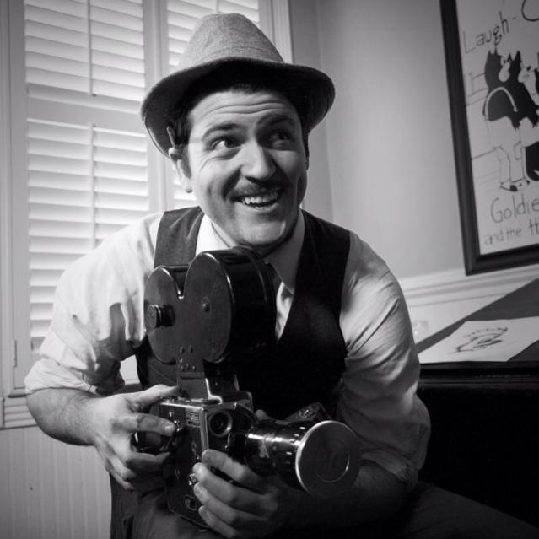](https://www.google.com/url?sa=i&url=https://isaiahstratton.wordpress.com/2014/01/07/as-dreamers-do-a-film-about-the-young-years-of-walt-disney/&psig=AOvVaw3QNImr5wiVd9oyuSc1Od8B&ust=1589919256233000&source=images&cd=vfe&ved=0CAIQjRxqFwoTCJjhoYKdvukCFQAAAAAdAAAAABAD)Walt knew that if he wanted to make it in show business, he needed to move. He packed up everything he owned and headed for the Hollywood film studios.

**Tuesday’s reading response task:**

Look at the words in **bold** in the text.

Match each of the words to its definition. Use the context to help you to work out what each word means.

put off

injured

almost never

very interested

amazement

**Resource 3: Character Description**

Here is Miss Bourne’s example of a detailed character description. You can choose any Disney character to write about.

If you are struggling to think of one of your own, why not choose one of these suggestions?

* Pinocchio
* Peter Pan
* Robin Hood
* Ariel
* The Beast
* Aladdin
* Woody (from Toy Story)
* Hercules
* Tarzan
* Mickey Mouse

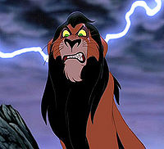

**Uncle Scar from The Lion King**

Scar is not the kind of character that anyone would want as their uncle. He is as dishonest, angry and nasty as any of Disney’s ‘baddie’ characters and he always has a clever but evil plan brewing in his mind.

Scar is a large and strong lion with fur the colour of treacle, a black mane and yellow-green eyes which flash with hatred. He stalks around the savannah, flashing his razor-sharp claws and razor-sharp teeth as a warning to anyone nearby. Even the tone of his voice is threatening.

Scar takes his name from the scar which runs across his left eye. Although the film does not reveal where the scar came from, Scar is likely to have got into some very nasty fights with his enemies.

Scar has always been desperate for power and he dreams of gaining total power over the pride lands by becoming King. Unfortunately for Scar (but fortunately for everyone else), it is Scar’s older brother, Mufasa, who is the rightful heir to the crown. Scar is blinded by jealousy of Mufasa, who is loved and respected by the animals for his kindness and wisdom.

Instead of learning from his brother’s good-naturedness, Scar becomes more and more dishonest and evil. His anger deepens when Mufasa’s son, Simba is born. Now, Scar is third in line to the throne and the only way he can ever become King is by killing Mufasa and Simba. Scar would never hesitate to hurt anyone who gets in his way, even if they are his relatives.

Scar is a very intelligent individual who knows exactly how to trick his young nephew. Simba is too young and innocent to see what is happening and, trusting his uncle, he does not realise the danger.

Throughout the story, Scar shows no positive emotions towards anyone else. He treats his pack of hyena friends badly, shouting his orders rudely and insulting them. He doesn’t even feel guilt or sadness when he kills his own brother; he simply chases away his nephew and hurries to take his brother’s place as ruler.

Although Scar seems strong and aggressive, he is actually a coward: he is more likely to run away from violence than to defend himself. Although he once bullied Simba, he is terrified when Simba returns as a bigger, wiser and stronger adult.

**Resource 4: Walt Disney biography part 2**

At first, life in Hollywood was tough. Nobody would offer Walt a job in animation, so he went back to his original plan of drawing cartoons.

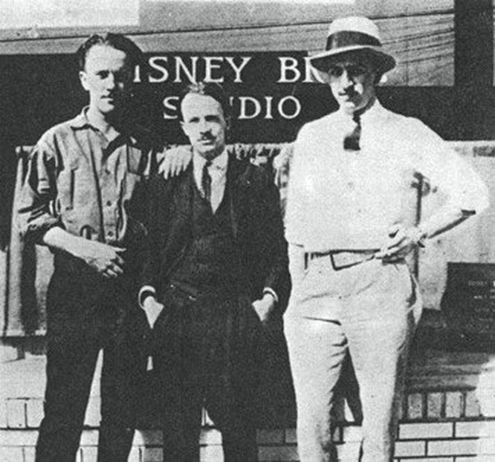His big break came when a woman offered to pay him to create a series of cartoons for her. The woman had seen and loved *Alice in Wonderland* and admired Walt’s talent. Walt’s brother helped him to set up the first Disney Brothers Studio and they borrowed money from their uncle to buy a new camera.

Walt did all of the creative work: designing characters, directing voice actors and putting together the animations. His hard work paid off and the first film was finished earlier than expected. He employed six members of staff to help him, including a friend who was brilliant at creating the drawings. This gave Walt more time to focus on making up stories and directing the filming.

He also employed a young artist called Lillian. She and Walt quickly formed a close relationship and they were soon married.

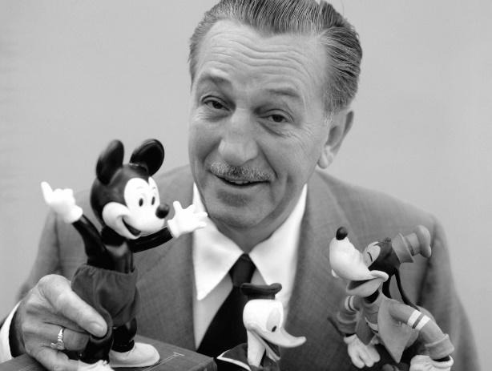Their first cartoons were a huge success and soon they had lots of projects to work on. Walt still wanted to create a character of his own. He worked long hours to get the character right. Lillian chose its name: Mickey Mouse.

Like many films at the time, the first Mickey Mouse cartoon was silent and it was filmed in black and white. A theatre manager had a brilliant idea. He invited children along to his theatre to watch hours and hours of the cartoons. They all became members of the Mickey Mouse Club, which put on games and competitions for its members. Walt went along to see 1,000 fans shouting Mickey’s name and decided to open new clubs across America. Soon, children were buying Mickey Mouse dolls, buttons, pencils, toothbrushes and books and Walt had finally achieved his dream of creating something wonderful.

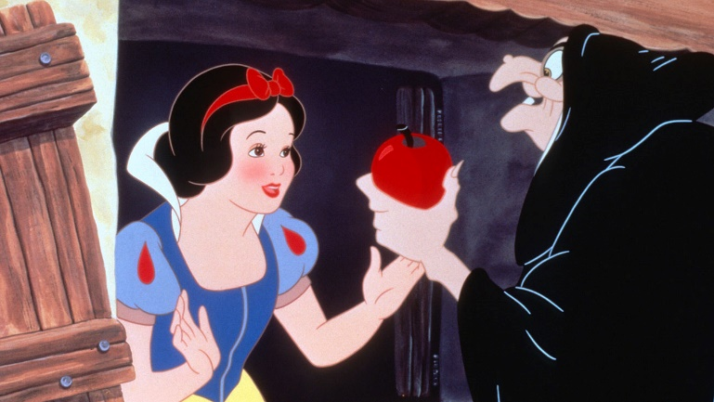By 1930, the first full-colour screens were available and this excited Walt. “At last!” he said. “We can put a rainbow on the screen.” He set about making exciting new colour cartoons, including *The Three Little Pigs*.

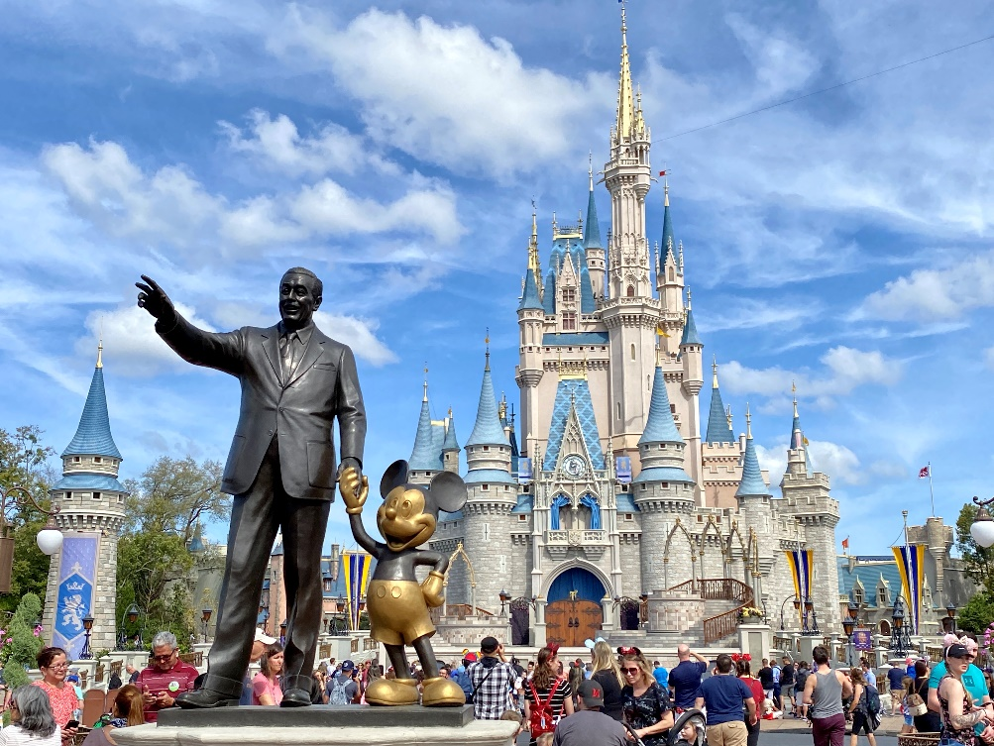

Walt then set out to make the first, full-length movie. It took three years and 250,000 drawings to make *Snow White and the Seven Dwarves*. On the night it opened, Hollywood stars came to the theatre dressed in their finest evening gowns and suits. They gasped at the incredible film and their applause was as loud as thunder. *Fantasia*, *Pinocchio*, *Bambi* and *Dumbo* followed and the Disney brothers began making large amounts of money.

In 1955, Walt opened Disneyland. He wanted to create a fun place where stories came to life. It had rides, shows, costumed characters, its own train and, of course, the Disney Castle. Visitors flocked in their thousands. Walt made all of the staff go to ‘Disney University’ to learn how to make the experience wonderful for the customers!

As time went on, Walt spent less and less time designing characters and enjoyed creating exhibitions instead. He remained creative up until he died. That was more than 60 years ago but Walt Disney is still entertaining people through this books, films, toys and theme parks where millions of families come each year. They are met by a statue of Walt and his beloved Mickey Mouse, which stands proudly in front of the famous fairy tale castle.

**Tuesday’s reading response task:**

Answer the questions in full sentences.

1. Two people helped Walt Disney to set up his studio. Who were they?
2. Name the first new character that Walt Disney created?
3. What happened in the 1930s that changed the way that Walt worked?
4. Name the first full-length movie.
5. How did Walt Disney ensure that staff at Disneyland gave the visitors an exciting experience?

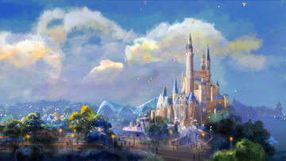**Resource 5: Setting photographs**

Choose a setting from a Disney film to describe. Here are some examples you could pick from:

* Fairy tale castle
* Asian style palace
* Ice palace
* Under the Sea
* 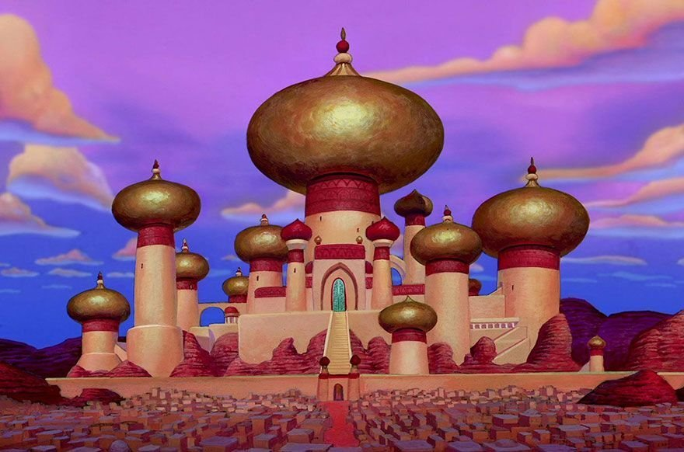Town
* Island
* Cottage in the Woods
* Enchanted forest
* Neverland
* Stormy sea
* Skull rock

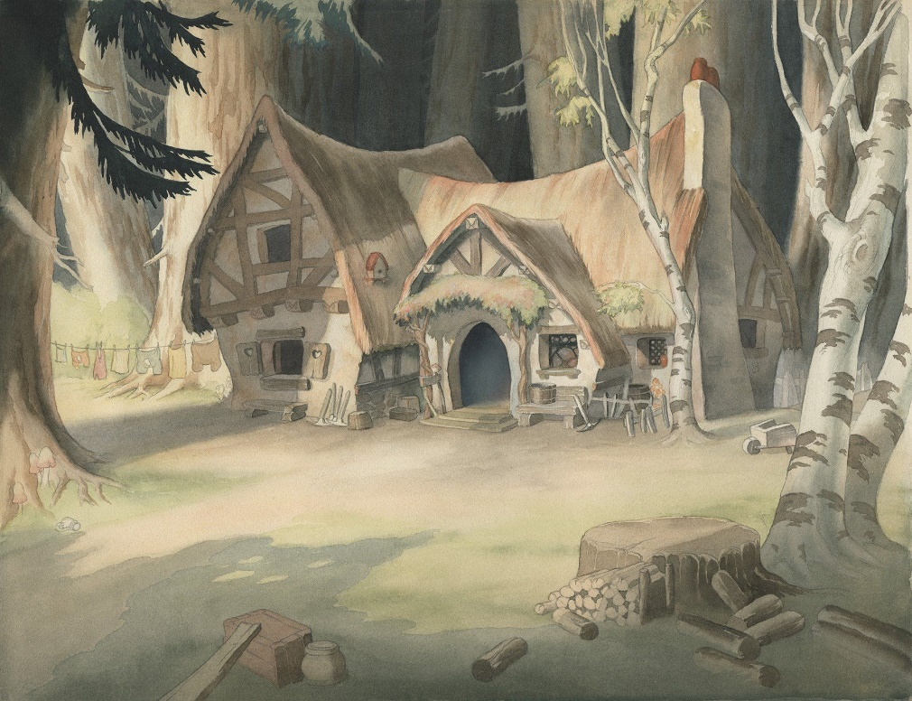

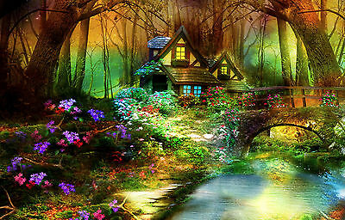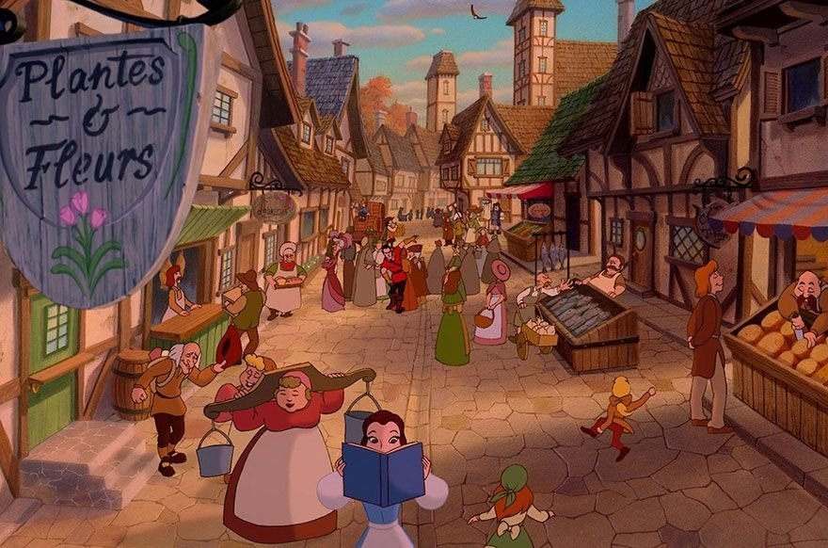

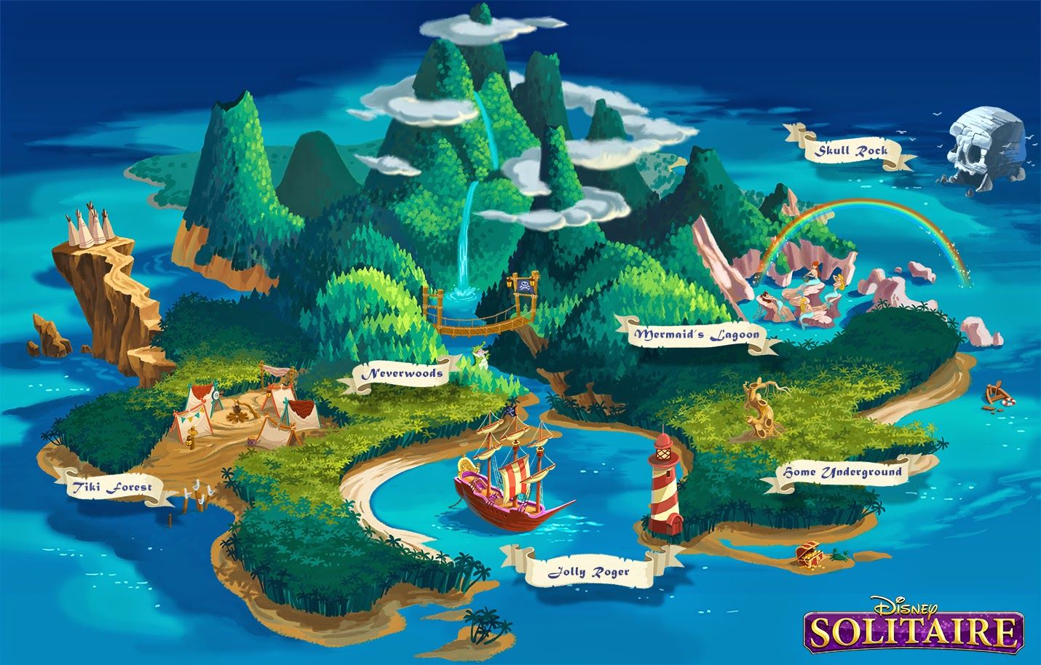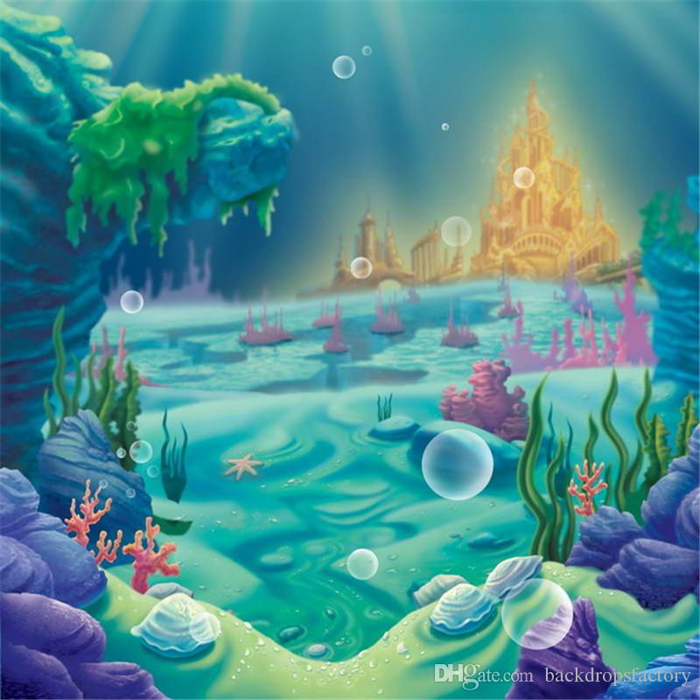

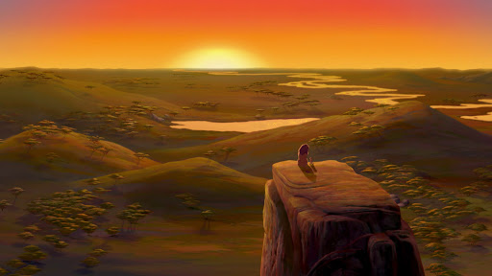

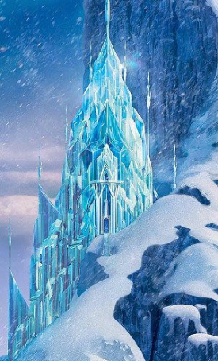

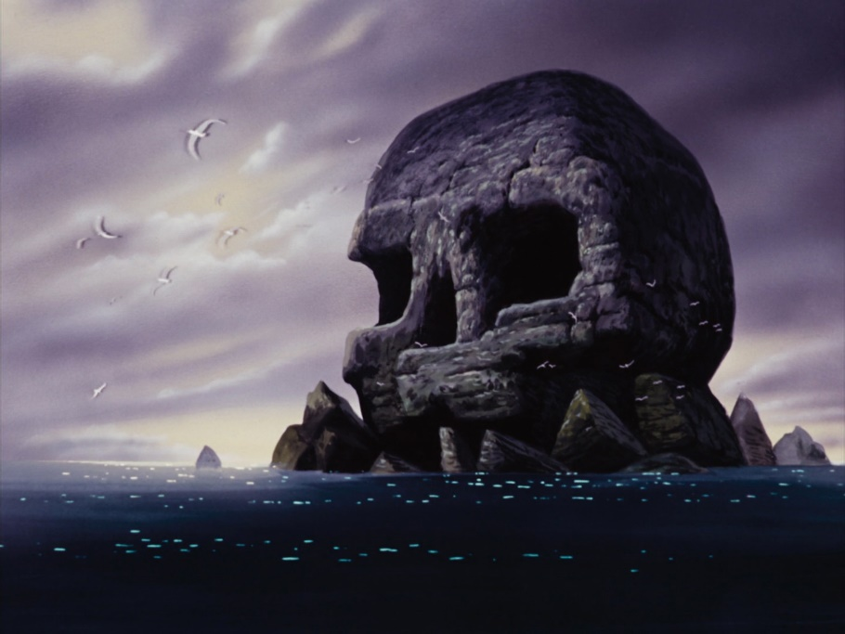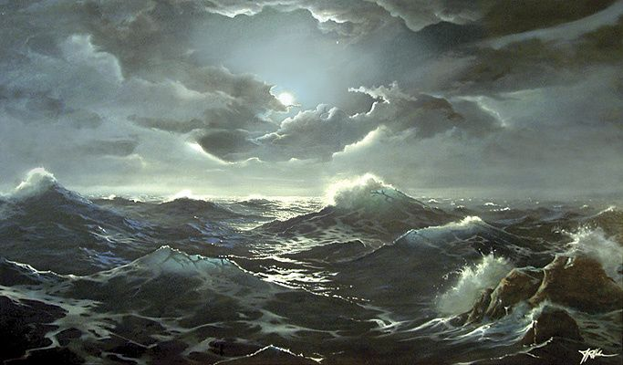

**Resource 6: Setting description example**

Miss Bourne chose this picture for her setting description (it’s on the next page).

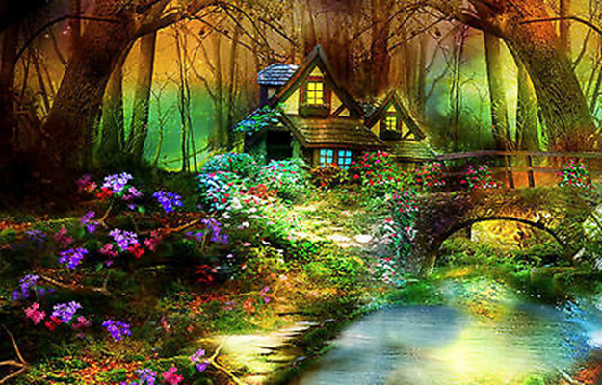

**The Enchanted Forest**

At the heart of the tangled forest, an enchanted clearing can be found. Ancient trees with broad trunks stretch to the sky, creating a protective canopy over the scene. Twisted vines wrap around their branches, as if choking them.

Under the tree canopy stands a cottage. It’s tiny yet beautiful and painted in pale yellow - the colour of buttermilk. Crooked, wooden beams reveal the cottage’s age. Lush, green ivy grows around the front door and creeps up to the slanted, tiled rooves. I wonder what it’s like inside? I imagine it to be a warm and cosy home with a comforting fire place. Lights inside give away the fact that somebody is at home but it’s hard to imagine who might live in such an isolated location.

Lush, green grass surrounds the cottage. The most puzzling of all the sights is the rare and exotic plants which burst with colour; they cannot be found in any other part of the enchanted kingdom.

The stream breaks the carpet of plant life but it takes on a life of its own. Multi-coloured fish dart through the cool, shimmering water while toads jump and play near the banks. Sometimes, passing deer dip their necks into the gently-flowing water for a drink. A rickety bridge of stone and wood straddles the river. I wonder where it leads?

The whole forest hums with animal life. Rabbits hop in and out of their burrows. Insects buzz from flower to flower. High in their trees, birds of prey watch over the scene, as if they are guarding it.

In the half-light between day and night, when the moon changes places with the sun, the forest takes on magical properties. Ribbons of orange, yellow, green and purple light dance between the trees, bathing the scene in a shimmering, mythical glow.

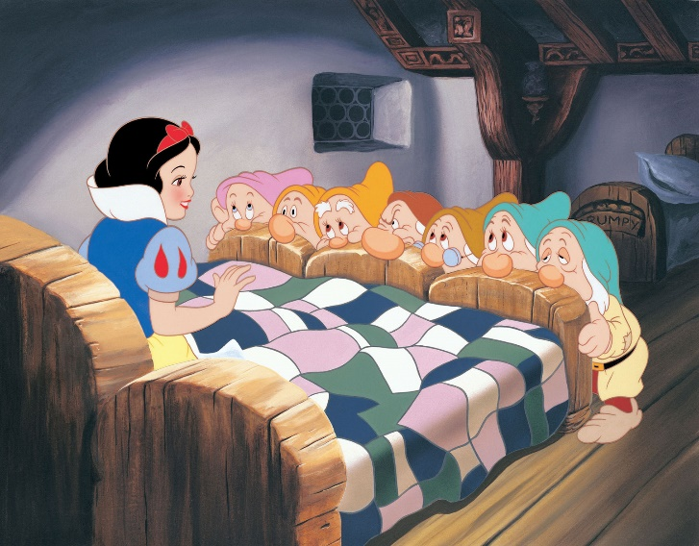**Resource 7: Making Disney films**

When Walt Disney created his first film in 1937 (*Snow White and the Seven Dwarves*) audiences were excited but amazed that it was possible.

It was the first film ever made by cel-animation. Have you ever made a flip-book? You would draw a character on each page of a book, but in a slightly different position. When you flick through the pages quickly, the character appears to move (see an example here: <https://www.youtube.com/watch?v=Y97Rxck89p8>).

Cel-animation uses the same idea. The Disney brothers invited the press into their studio to find out how cel-animations were made.

**Step 1**: The story came first. Many early Disney films were based on traditional fairy tales. Walt and his team of writers developed their own storylines which might be different from the original stories.

**Step 2**: A team of writers drafted the script.

**Step 3**: Studio artists created the first sketches of the characters. Hundreds or thousands of ideas might be sketched before the final one was chosen. In those days, there were no computers to help so each one would be done by hand, using paper and pencil.

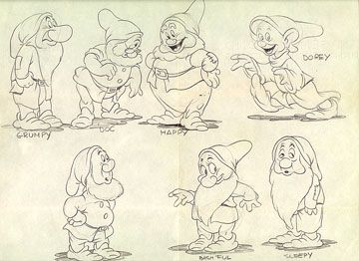

**Step 4**: Artists created story boards, showing the main scenes in the film. Everything the artists did had to be approved by Walt himself.

**Step 5**: The script was edited and improved.

**Step 6**: Musicians were called in and the writers worked with them to create the songs and background music to accompany the film.

**Step 7**: Walt Disney acted out what he wanted the action to look like.

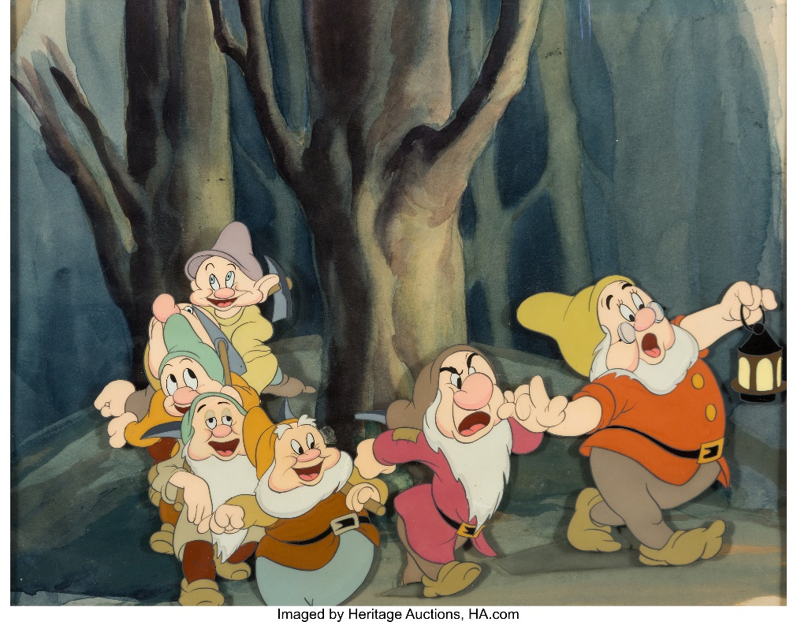**Step 8**: The animators would set to work on the detailed drawings. They would draw each one on tracing paper.

**Step 9**: The drawings went to the camera department where each one was photographed in order. The camera man could then ‘play’ the pictures in sequence to make it appear as if there was movement.

**Step 10**: Once Walt Disney was happy with the film, the drawings were traced on to transparent plastic sheets called cels and these were painted in colour. More than 250,000 of these were made for the *Snow White and the Seven Dwarves* film.

**Step 11**: A separate team of artists created backgrounds using watercolour paints.

**Step 12**: The character cels were positioned over the backgrounds and photographed by the camera team.

**Step 13**: The sound effects were recorded using instruments.

**Step 14**: An orchestra recorded the music.

After three years of patience and perseverance, the film was now ready and crowds gathered excitedly for the premiere (the first showing) in a theatre of the most advanced film ever made.

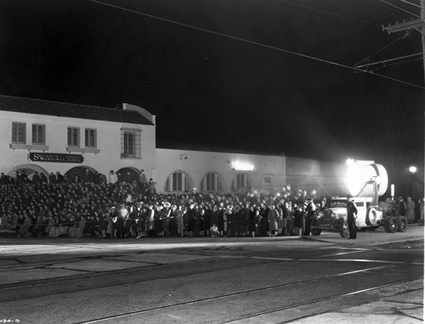

You might also like to watch this clip here. It shows all of these stages.

<http://www.openculture.com/2011/04/how_walt_disney_cartoons_are_made_.html>

**Thursday’s reading response task:**

Remember to answer the questions in full sentences, whether you are writing them or saying them aloud to an adult.

1. What was new and special about the Snow White and the Seven Dwarves film?
2. Why did it take such a long time to create the drawings so that they would be ready to photograph?
3. Why do you think everything that the artists did had to be approved by Walt himself? (see step 4).
4. What is a cel?
5. Why do you think so many people wanted to see the film?

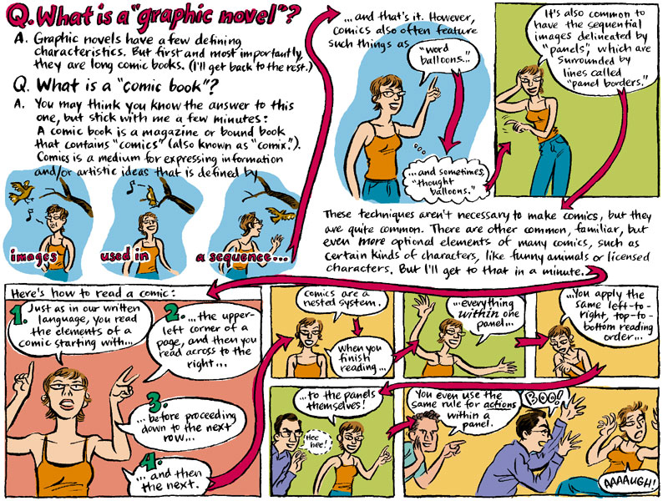**Resource 8: Example of a graphic novel**

**Resource 9: Example of a play script from The Lion King**

As an example of a play script, Miss Bourne has used an extract from The Lion King animation, which can be found here: <https://www.youtube.com/watch?v=AshEWMaXFxY>

*Buzzards circle over Simba’s body. Timone and Pumba charge into them. The buzzards fly away, squawking.*

**PUMBA**: I love bulling the buzzards!

**TIMONE**: [Dusts himself off] Haha! Gets them every time. [laughs]

**PUMBA**: [Stands over Simba, who is sleeping] Uh-oh. Hey, Timone! You’d better come look. I think it’s still alive.

**TIMONE**: [Walks over, rubbing his hands] Eeeeeuuuuu. Alllllllrighty. What have we got here? [Sniffs Simba and lifts up his paw]. Geez, it’s a lion! [Jumps and falls then jumps on to Pumba’s back]. Run, Pumba, move it!

**PUMBA**: Hey, Timone. It’s just a little lion. Look at him. He’s so cute and all alone. Can we keep him?-

**TIMONE**: Pumba, are you nuts? [Pulls on Pumba’s ears]. You’re talking about a lion. Lions eat guys like us.

**PUMBA**: But he’s so little. [Drops Timone on to the ground].

**TIMONE**: But he’s gonna get bigger.

**PUMBA**: Maybe he’ll be on *our* side.

**TIMONE**: (Laughs) Ha! That’s the stupidest thing I ever heard. [Stands up]. Maybe he’ll be… hey… I got it… what if he’s on our side? Y’know, having a lion around might not be such a bad idea. [Jumps on to Pumba’s nose].

**PUMBA**: So, we’re keepin’ him? [Jumps around excitedly].

**TIMONE**: Of course. Who’s the brains in this outfit?

**PUMBA**: Uhhhhhhhm… [Picks up Simba win his horns].

**TIMONE**: My point exactly. Geez, I’m fried, Let’s get out of here and find some shade.

*Pumba canters away with Simba sleeping across his horns and Timone on his head.*

Your task is to write a play script for the characters and setting you have created in your themed lessons this week. If that’s tricky, you could continue Miss Bourne’s Lion King play script instead (I have just done the first half). You will need to watch the second half of the recording, stopping it regularly so that you can record the dialogue.

**Resource 10: The Disney Company today**

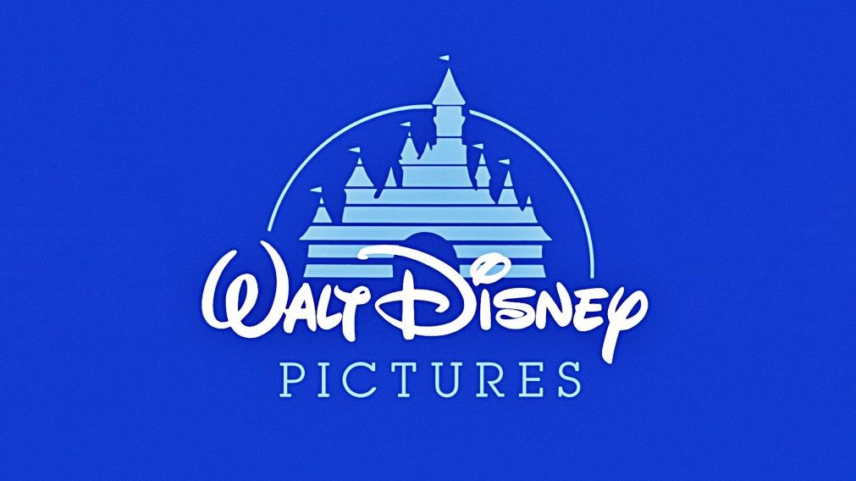

Walt Disney passed away in 1955 and the last film he ever worked on, *The Jungle Book*, was released soon afterwards. 65 years on, his name lives on in the company he started and his famous signature is still used in the company logo.

The Disney Company has bought several smaller film production companies including Pixar and Marvel. It continues to make high-quality family films and sell items based on the stories and characters. Soft toys, action figures, costumes, stationery and props can be purchased from more than 300 Disney stores around the world.

There are now six Disney resorts, including two in the USA and one in Tokyo, Paris, Hong Kong and Shanghai. The small company that Walt Disney began in his tiny studio, using a borrowed camera, is now worth more than $194 billion! The Head Office building in Hollywood is decorated with Walt’s beloved seven dwarves.

Disney is still creating family films to entertain people, but the way that these are made has changed. Computer technology has made the film making process faster than ever and allowed film makers to work in more detail than ever before.

In 1995, the first Toy Story film created almost as much excitement as the first *Snow White and the Seven Dwarves* film did in 1937. It was the first film made entirely using computer animation. Ten years later, the first 3D animation film, *Chicken Little*, was released. 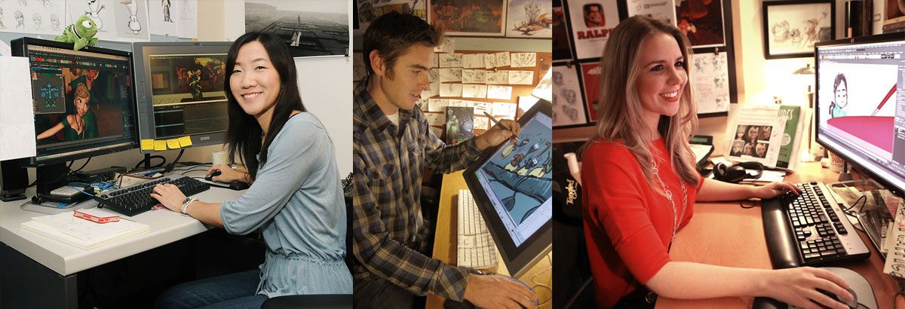

How is the film-making process different today? Like Walt Disney himself, film-makers always begin with a good story. The first drawings for characters and settings are still created on paper by an artist and are then created digitally using drawing software on a computer.

Film scripts and songs are written then voice artists are brought in to record these in a studio. Animation experts add movement to the characters, including the movements of their mouths to fit with the voice actors’ speech.

Instead of drawing each movement by hand (as Walt Disney’s team did in the past) each ‘cel’ can be created on a computer. This makes the process much faster. The lighting department combines all of the different parts including characters, backgrounds and props before the speech, music and sound effects are added.

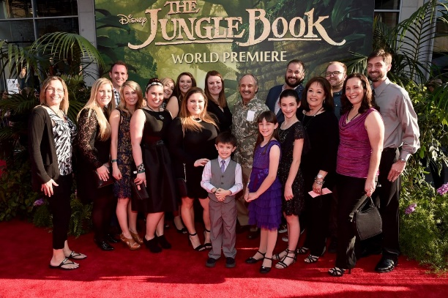The film is ready for its premiere! This is the event when guests – including the voice artists of the film – gather for its first ever showing.

As well as making new films, the Disney Company often makes modern versions of Walt’s classics using the newest technology available. *The* *Jungle Book* and *The Lion King* are examples of films that have had more modern updates in recent years.

You might like to watch some of these clips, showing how some more recent films have been made using modern techniques.

Animating characters in Moana: <https://www.youtube.com/watch?v=vZWIu2-8veE>

Making Tangled: <https://www.youtube.com/watch?v=leatYRK4l8o>

Filming the (new) Jungle Book: <https://www.youtube.com/watch?v=laRkbKVrPb4>

How Toy Story 4 was made: <https://www.youtube.com/watch?v=fT_LdcWFHkA&t=41s>

Making Inside Out: <https://www.youtube.com/watch?v=K-gPD00ksxQ>

**Friday’s reading response task:**

Use the information in the text to create a flowchart showing the stages in the making of an animated film today.