|  |  |  |  |  |  |
| --- | --- | --- | --- | --- | --- |
| Image result for larks classYear 5 - Larks Class  Home Learning activities to choose from  Week Commencing 20th April info@scsj.rbkc.sch.uk | | | | | |
|  | Monday | Tuesday | Wednesday | Thursday | Friday |
| Our School Prayer | Dear Lord  Thank you for this brand new day.  Help us to embrace opportunities for new learning.  Show us how to listen and love.  Support us and our friends.  Guide us to excellence in all that we do today.  Amen | | | | |
| P.E. | **9am - 9:30am Monday-Friday**  The Body Coach workout  <https://www.youtube.com/results?search_query=joe+wicks+body+coach> | | | | |
| Reading Response | A History of Chocolate  (resource 1 below) | | The Cadbury Family  (resource 2 below) | | Fair Trade  (resource 3 below) |
| Maths fluency | Subtract numbers with 5 digits or more:  <https://uk.ixl.com/math/year-5/subtract-numbers-with-five-digits-or-more> | Multiply a 1-digit number by a 3-digit or 4-digit number:  <https://uk.ixl.com/math/year-5/multiply-a-one-digit-number-by-a-three-digit-or-four-digit-number> | Divide larger numbers by a 1-digit number:  <https://uk.ixl.com/math/year-5/divide-larger-numbers-by-a-one-digit-number> | Reading tables:  <https://uk.ixl.com/math/year-5/read-a-table> | Input / output tables:  <https://uk.ixl.com/math/year-5/input-output-tables-with-addition-subtraction-multiplication-and-division> |
| Maths Revision | Watch lesson 1 and complete the activities.  <https://www.youtube.com/watch?v=rJp2Pa5Mqtg&list=PLQqF8sn28L9xBmQclRrb8YjcM-pzxHjfk&index=2&t=0s> | Watch lesson 2 and complete the activities.  <https://www.youtube.com/watch?v=-az4Fv7PmZY&list=PLQqF8sn28L9xBmQclRrb8YjcM-pzxHjfk&index=2> | Watch lesson 3 and complete the activities.  <https://www.youtube.com/watch?v=ryTwlSVg3Vk&list=PLQqF8sn28L9xBmQclRrb8YjcM-pzxHjfk&index=3> | Watch lesson 4 and complete the activities.  <https://www.youtube.com/watch?v=gMV8UnwrFk8&list=PLQqF8sn28L9xBmQclRrb8YjcM-pzxHjfk&index=4> | Watch lesson 5 and complete the activities.  <https://www.youtube.com/watch?v=iH4u_a96NQA&list=PLQqF8sn28L9xBmQclRrb8YjcM-pzxHjfk&index=5> |
| Times Tables Revision | Teach someone at home to play Stickyfingers like we do at school and see if you can beat them! | Log in to your Times Tables Rockstars account. Email Miss Bourne if you need your password (address above). | Shuffle a deck of playing cards and take out the jacks and the jokers. Queen= 11 and King=12.  Split the deck into two piles and turn over the top card on each. Multiply the numbers on the cards together. You could compete with somebody else: the first person to say the answer wins a point. | Practise your times tables here:  <https://www.timestables.co.uk/multiplication-tables-check/> | Try the fast maths challenge like we do in school. You will need to draw out an 11x11 grid (or you can print the sheet at the end of this document, if you have a printer). Don’t forget your stopwatch. Can you beat our class record of 2 mins 22 seconds?  Make sure you use the numbers 1 - 12 at least once. |
| Spellings | Write these words in bubble writing, or use a new colour for each letter, to help you to remember the spellings.   * community * exaggerate * marvellous * restaurant * yacht | Look, cover, write and check:   * competition * excellent * mischievous * rhyme * distance | Put each of Monday’s spellings into a sentence. | Write a definition of each of Tuesday’s spelling words. | Ask somebody at home to test you on the spellings you have learned this week. How many can you get right?  Most of these words are on your yellow Year 5/6 spelling card. |
| Punctuation and Grammar | Is the word a noun?  <https://uk.ixl.com/ela/year-5/which-word-is-a-noun> | Identify the pronouns:  <https://uk.ixl.com/ela/year-5/identify-personal-pronouns> | Complete the sentence with an action verb:  <https://uk.ixl.com/ela/year-5/use-action-verbs> | Use the correct article:  <https://uk.ixl.com/ela/year-5/use-the-correct-article-a-or-an> | What does the adjective tell you?  <https://uk.ixl.com/ela/year-5/does-the-adjective-tell-you-what-kind-or-how-many> |
| Writing | Watch the clip below to learn about how cacao is turned into chocolate. Create a flowchart to show each step in the chocolate making process.  <https://www.youtube.com/watch?v=4vXb8Tt_VCU> | Happy Birthday to Queen Elizabeth: 94 today!  Use your ICT skills to research 10 facts about her. You could find out the answers to questions such as:  What is her full name? Where was she born? Who are her parents? Does she have siblings? Who is her husband? Where does she live? Who are her children and grandchildren? What responsibilities does she have? | 23rd April is St. George’s Day. Enjoy watching the story of St. George below to find out who he was and why today is special in England.  <https://www.youtube.com/watch?v=urosZ3PKFJg>  Create your own cartoon telling the story of St. George. Include pictures and words. | | Think of all the reasons why the chocolate bar you designed (see theme learning) is the best in the world! Make an advertisement for it.  You could make a poster (see resource 4 below for some ideas) or even film yourself making a television advertisement. Think about the persuasive language you could use. **Just for fun:** Cadbury have made some funny TV adverts over the years, with singing gorillas, dancing eyebrows and walking clothes! You might like to look at some of them here: <https://www.youtube.com/results?search_query=cadbury+advert> |
| Themed learning and Science | Find out about the different kinds of teeth that humans have. Teach someone at home the names for their teeth.  <https://www.bbc.co.uk/bitesize/topics/z27kng8/articles/zsp76yc>  <https://www.youtube.com/watch?v=ZE-TtFhZlDw> | Chocolate bar design project:   1. Choose your chocolate (milk, dark, white). 2. Choose two ingredients you’d like to add (e.g. dried fruit, popping candy, marshmallow, nuts, caramel, biscuit etc.)   You might like to survey the people in your house to find out what their ideas are.   1. Choose a name for your new chocolate bar. 2. Design for a wrapper for your chocolate bar. Have a look on Google Images for some ideas. Make it brightly coloured and exciting. 3. Think of a slogan to promote your bar (e.g. Terry’s Chocolate uses ‘Rich, Dark and Perfectly Smooth’). 4. Decide how much your chocolate bar would cost. Have a look at some prices online for some sensible estimates! | | | Have a look at the ‘now and then’ Cadbury pictures (resource 5 below). What clues can you discover about how things have changed over time? Write them down.  e.g. The first Cadbury wrappers were made of paper; now they are made of plastic and foil. |
| Daily Reading | Read with an adult for at least 20 minutes **EVERY DAY**.  When you need something new to read, you could try an e-book:  <https://worldbook.kitaboo.com/reader/worldbook/index.html#!/>  [https://www.oxfordowl.co.uk/for-home/find-a-book/library-page/?view=image&query=&type=book&age_group=Age+9-11&level=&level_select=&book_type=&series=#](https://www.oxfordowl.co.uk/for-home/find-a-book/library-page/?view=image&query=&type=book&age_group=Age+9-11&level=&level_select=&book_type=&series=) | | | | |
| Suggested Brain Breaks and Relaxation | Choose a Peace Out  <https://www.youtube.com/results?search_query=peace+out> | Listen to a MindUp Brain Break (the one we use in school.) <https://mindup.org.uk/mindup-activities/> | Listen to an Audiobook. Audible is offering many free of charge during lockdown.  Miss Bourne’s recommendation of the week: *Charlie and the Chocolate Factory*  <https://www.youtube.com/watch?v=0WIut6D22ms> | Using a pencil, draw around your hand very carefully. Take time to add in every single detail such as your finger nails, knuckles, cuticles and creases in the skin. Look carefully at the different shapes. | Melting with GoNoodle  <https://family.gonoodle.com/activities/melting> |
| Suggested  Physical Activities | Joe Wicks workout (scroll down for kids’ versions)  <https://www.youtube.com/user/thebodycoach1/videos> | Try the Banana Banana Meatball!  <https://family.gonoodle.com/activities/banana-banana-meatball> | Try Cosmic Kids Yoga  <https://www.youtube.com/user/CosmicKidsYoga> | Peanut Butter in a Cup  <https://www.gonoodle.com/good-energy-at-home-kids-games-and-videos/> | Choose a ‘Just Dance kids’ exercise  <https://www.youtube.com/results?search_query=just+dance+kids> |
| A song a day to sing along with | My Lighthouse  <https://www.youtube.com/watch?v=lFBZJGSgyVQ> | Be Bold, Be Strong  <https://www.youtube.com/watch?v=OWqa4Rpq4PE> | Give Me Oil In My Lamp  <https://www.youtube.com/watch?v=21RHemxzb8U> | Our God Is A Great Big God  <https://www.youtube.com/watch?v=-424MpB_pd0> | This Is Amazing Grace  <https://www.youtube.com/watch?v=cgsbaBIaoVc> |
| Our School Prayer | Lord of the loving heart, may ours be loving too;  Lord of the gentle hands, may ours be gentle too;  Lord of the willing feet, may ours be willing too;  May we grow more like you in all we say and do.  Amen | | | | |

**Resource 1: The History of Chocolate**

What’s your favourite chocolate? You’re probably thinking of a delicious sweet treat – perhaps a smooth Dairy Milk button, a chewy Snickers bar or a light and bubbly Aero.

Actually, chocolate has a long history and it didn’t start out as the sweet, solid treat we have today.

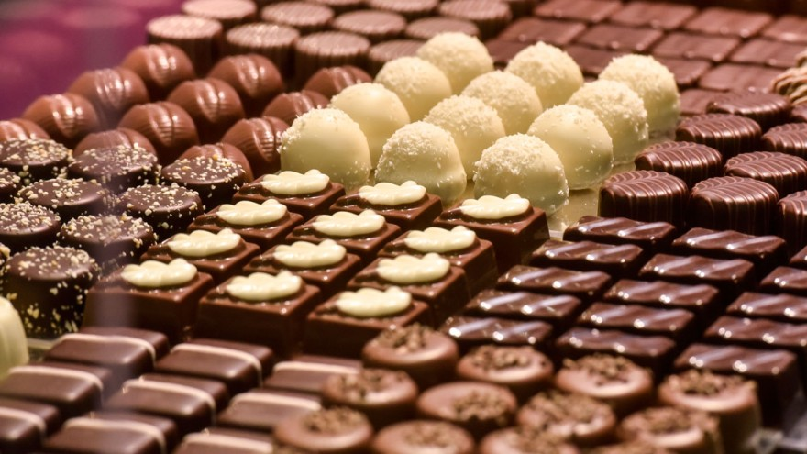

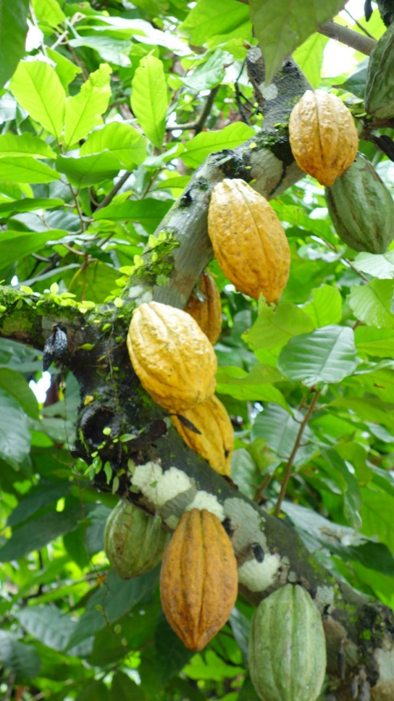The first chocolate came from the cacao trees grown by the Mayan people in Mexico, more than 2400 years ago. The Mayans cut open the large pods which grew on trees to discover cacao beans inside.

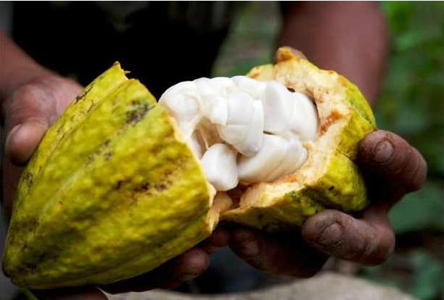They soon began exploring how these could be used for food, drink and medicine. Firstly, they ground up the beans and mixed them with water to create a bitter drink which was used to treat people suffering from a cough.

Cacao beans became very valuable and people used them as a kind of currency: they could buy other food and animals in exchange for cocoa beans. When the Aztecs took over Mexico, they demanded that taxes were paid in cacao beans! Rich Aztecs added flowers, vanilla or honey to the bitter drink to make something delicious and sweet.

The word ‘chocolate’ came from the name of one of the Aztecs’ Gods because people believed that the delicious discovery was a gift from heaven!

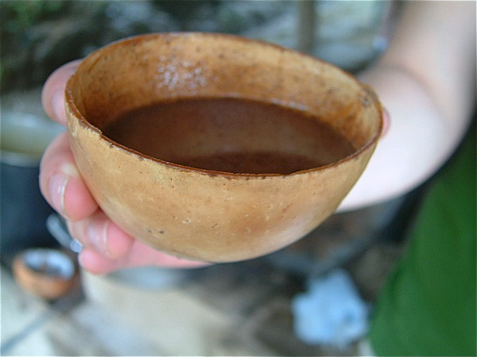

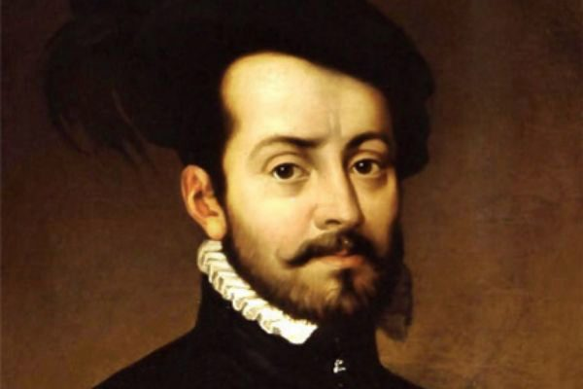

In the 1500s, a Spanish man named Hernan Cortes travelled to South America in search of a fortune. Here, he developed a liking for cacao and began growing it to take back to Spain. The hot cacao drink became popular across Europe. Over time, Europeans experimented with adding sugar and flavours and it became the drink we call ‘hot chocolate’ today.

100 years later, cacao powder was used in London to bake the first ever chocolate cake! Chocolate cookies soon followed.

Up until 1800, cacao was still used mainly to make drinks. A Dutch chemist experimented with adding salts to make a sweet tasting cocoa powder.

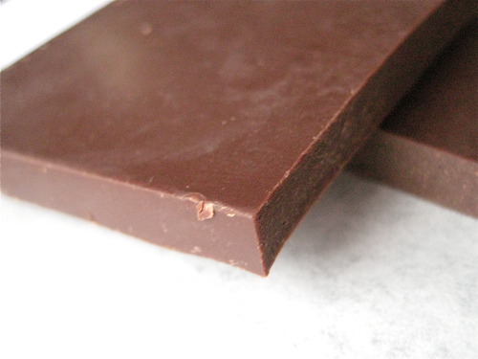Later, Joseph Fry discovered that he could melt cocoa butter and add it back to the powder to create a paste which could be moulded into chocolate bars.

Businessmen saw an opportunity for an exciting new product and companies including Fry’s, Nestle and Hershey’s began turning Fry’s invention into the products we love today.

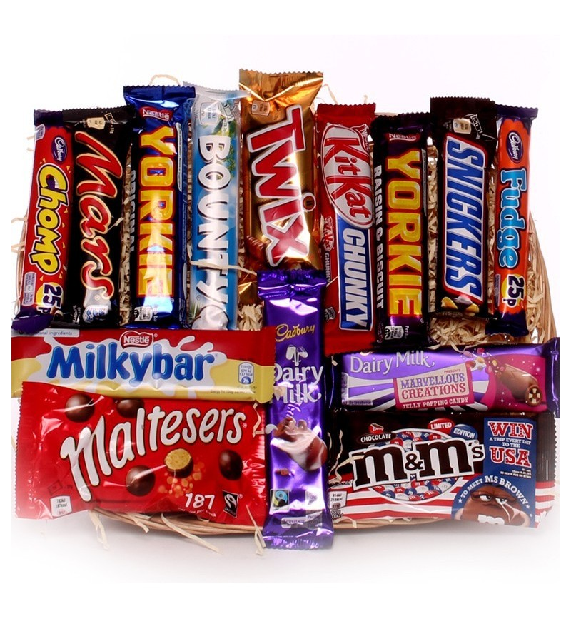

**Monday’s comprehension tasks:**

1. Read the text again and find antonyms for the words below (an antonym has an opposite meaning). There first one has been done for you.

|  |  |
| --- | --- |
| inside | outside |
| liquid |  |
| bitter |  |
| worthless |  |
| unpopular |  |

1. Find three flavourings which the Aztecs added to the cacao drink.
2. Find the name of the man who brought cacao back to Europe.

**Tuesday’s comprehension tasks:**

Read the text again and answer the questions. You could do this orally with an adult or write down your answers. Either way, make sure that you are speaking or writing in full sentences.

1. Who were the first people to use cocoa beans?

*The first people who used cocoa beans were…*

1. The first cacao drink was used to cure a symptom of illness. What was it?

*The first cacao drink was used to…*

1. Name two items the Aztec people could buy in exchange for cocoa beans.
2. Where does the name ‘chocolate’ originate from?
3. Where were the first chocolate cakes and cookies baked?
4. Who invented the first solid chocolate bar?

**Resource 2: The Cadbury Family**

**Wednesday and Thursday’s Reading Response Task:**

You are going to summarise what you have read. Read the text and use it to create a timeline of events in the history of the Cadbury chocolate company.

For example:

1. John Cadbury began selling cocoa products in his drinks shop in Birmingham in 1949.
2. John began experimenting with his own chocolate recipes.
3. John and his brother moved to London.

Have you ever devoured a Double Decker, chewed on a Chomp or bitten into a Boost? Look closely at the packaging on these (and many other chocolate products) and you will notice the world-famous Cadbury logo.

Who were the Cadbury family and how did they create the perfect chocolate recipe to make their products to popular? Read on to find out.

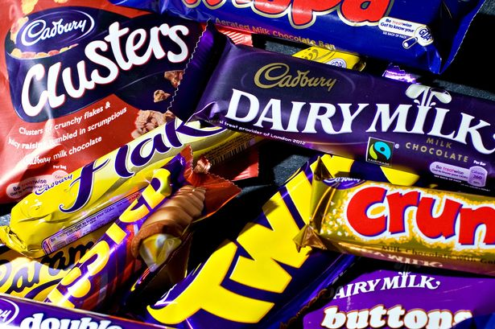

The story began in 1849 in Birmingham, where John Cadbury was the owner of a small shop selling tea and coffee. Noticing that the popularity of cocoa products was spreading across Europe, John Cadbury began selling drinking chocolate to his wealthy customers.

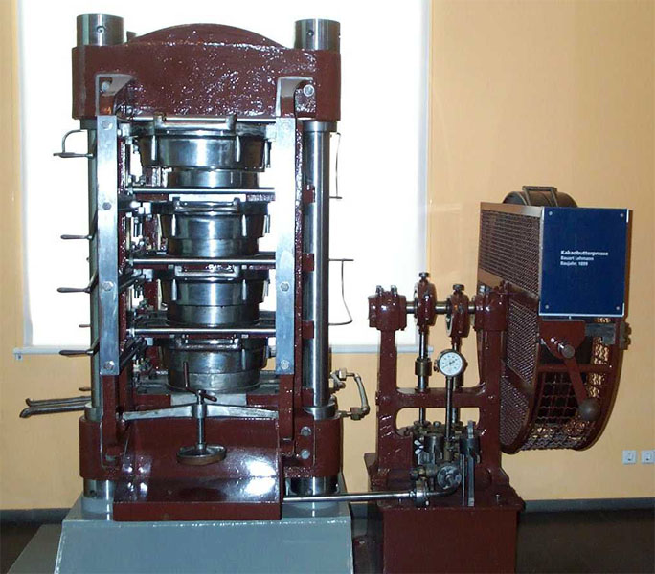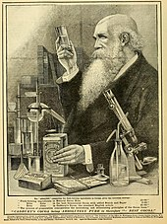The first chocolate bar had just been invented and John began experimenting with his own recipes – he wanted to see if he could make something even better. His products were an instant success so John and his brother moved to London to begin making and selling them to more people. Their customers included Queen Victoria! The demand for the product was so high that the Cadbury brothers had to employ 20 staff to help them.

John’s sons, George and Richard, took over the company in 1861. They worked for very long hours making a small amount of money until they made a change: they bought a cocoa press. This was a machine that separated cocoa butter from cocoa powder to make their chocolate taste better than ever.

This decision set the Cadbury company on the path to becoming one of the most successful chocolate makers of all time. They began making boxes of decorated chocolates in a heart-shaped box. These were particularly popular for Valentine’s Day celebrations.

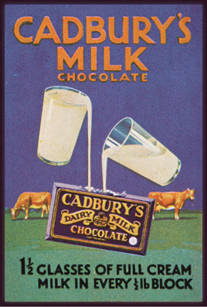The brothers’ second success came in 1875 when they began adding fresh milk to their chocolate to make it smoother, thicker and sweeter.

In the same year, the Cadburys made the first ever chocolate Easter eggs. These were decorated with flowers and marzipan to celebrate Easter time.

As their factory grew and grew to cope with the demand for their products, the Cadbury brothers realised that it was not a nice place for their team to work. It was crowded and dirty and many of their staff did not have a good quality of life. George and Richard wanted to change things for the better so they opened a new factory in the countryside in Bournville (near to Birmingham).

Cadbury was the first company to do this and people thought it was a strange choice. All of the other big companies were in London. However, the move worked perfectly. Their milk could be transported along the canal and they were close to the ports where cocoa was arriving on ships from South America.

The company was stronger than ever and George and Richard bought a large amount of land around their new factory. They built homes for their workers and created a new village with outdoor spaces, swimming pools, football pitches and a running track. Later, they added schools for their workers’ children.

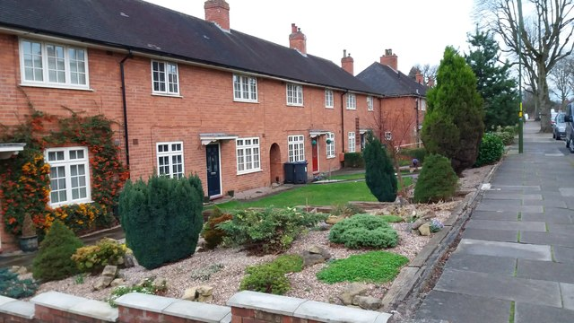

The first Cadbury chocolate bar was sold in 1897. George’s son, who was also called George, added even more milk to the cocoa mixture. The recipe he used has changed very little since then. Have you ever spotted the ‘glass and a half’ of milk in the logo of Dairy Milk products in the shops today? 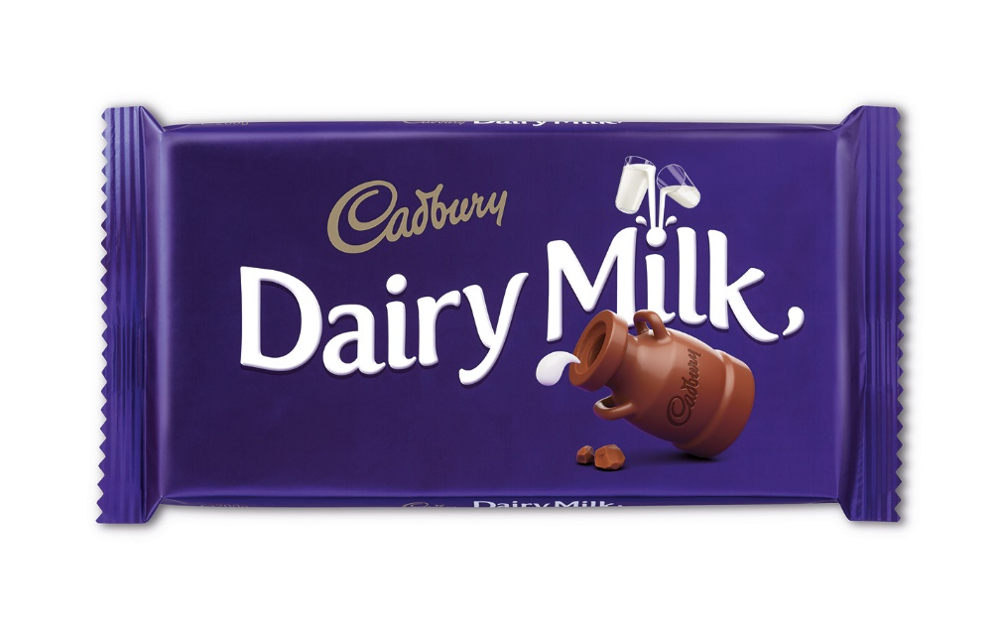

Over the next 30 years, the Cadbury family experimented with adding many new ingredients to their chocolate. The result was many of the products you might recognise such as the Crunchie, Flake and Roses chocolate boxes.

During the World War 2, chocolate production had to stop because milk was rationed. However, the company continued making a milk-free rationing chocolate which was a popular wartime treat.

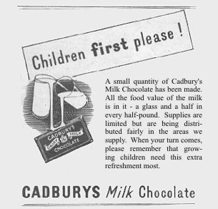

When the war ended, Cadbury added Curly Wurly, Fudge Bars and chocolate biscuits to their range.

In 1955, another new invention was become popular in homes: the television. The first Cadbury advertisement was shown on television that year.

In 1971, the first Cadbury Crème Egg was made. It is still one of the most popular products and the Bournville factory makes over 200 million every year!

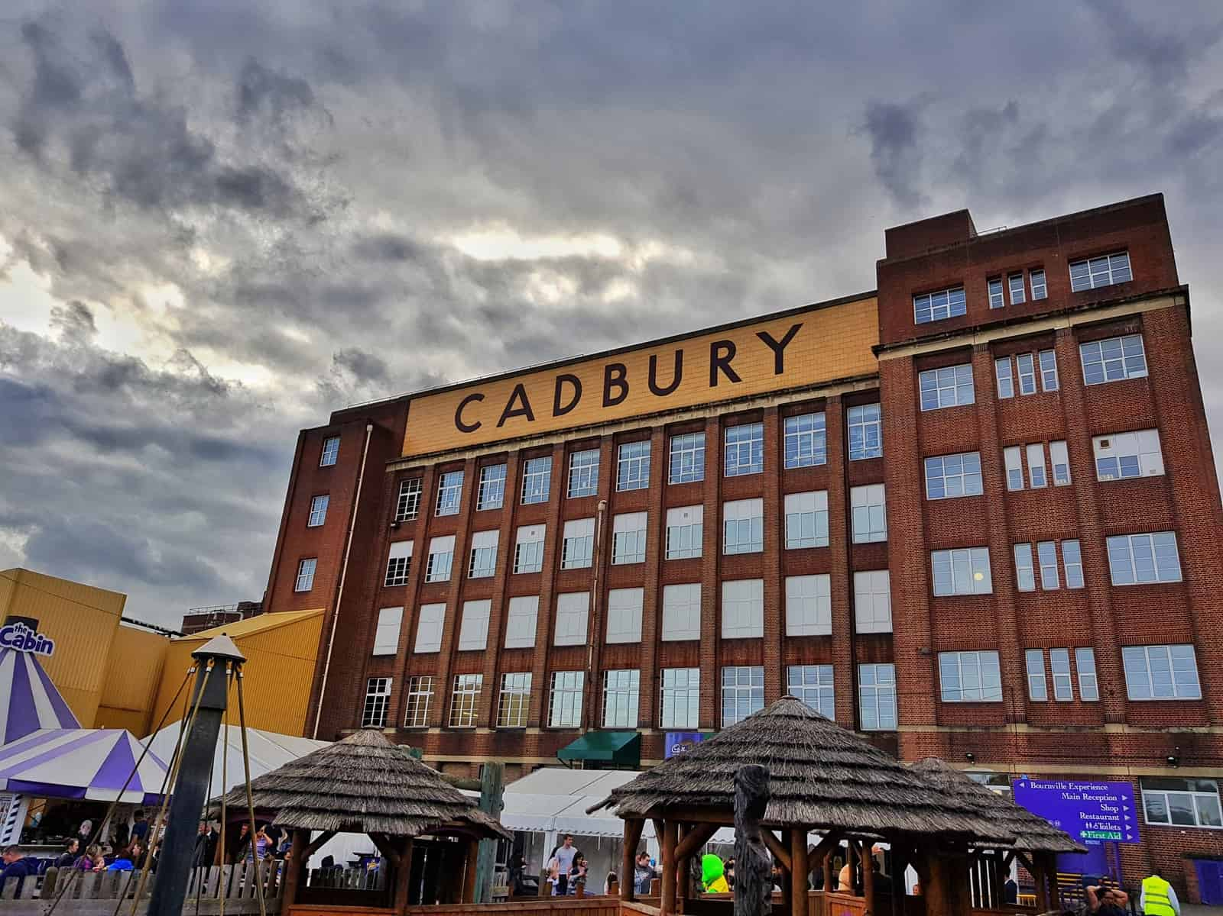In 1990, the Cadbury family opened a museum in Bournville called ‘Cadbury World’. To this day, people can visit the museum and Cadbury factory to see chocolate being made. (You might like to watch this clip: <https://www.youtube.com/watch?v=Uq8jyzppL-Y>)

In the past 30 years, Cadbury have continued to add more and more products to their range. In the UK, almost 1 million are sold every day. The newest products include mini fudge bars and the Tiffin bar.

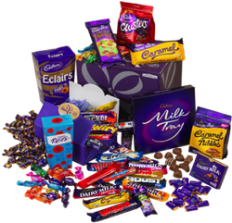The success of Cadbury is a story of 150 years of perseverance, creativity, team work and kindness to others. This shows what you can achieve if you live by our St. Clement and St. James values and rules!

**Resource 3: Fairtrade**

Fair Trade is all about making things fair for the people in developing countries who grow and prepare the plant-based foods, including cocoa beans, which are used in making the food we eat. It is a global movement. In the UK, the Fairtrade Foundation logo can be found on hundreds of products in our supermarkets including fruits, tea, sugar and toiletries.

When you see this logo, you can be sure of two things. Firstly, the ingredients in the product have been grown in a way that doesn’t harm the environment. Secondly, the workers who helped to make the product have been treated well and paid fairly.

The Fairtrade Foundation started because, in the past, companies in richer countries took advantage of workers in poorer countries. They expected people to work long days, to do back-breaking or dangerous work and paid them too little to afford basic necessities such as food and shelter.

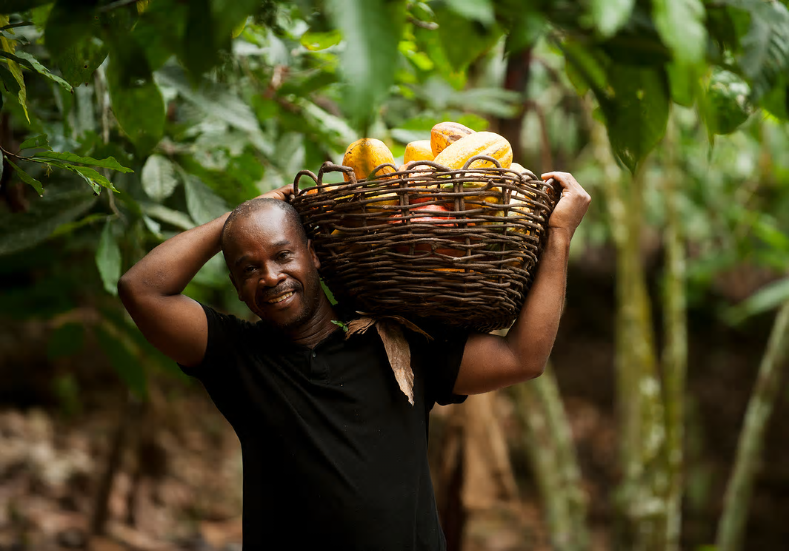

With Fairtrade, farmers are guaranteed a fair price for their cacao beans. This means they can pay for equipment they need to improve their products, grow their business and give jobs to more people. For many people, this is the difference between living in poverty and looking forward to a bright future.

As well as paying fair prices, companies that use the Fairtrade logo contribute to making life better for the people they are trading with. They give money for things like schools, water pumps and health clinics.

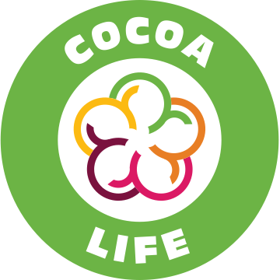Cadbury products used to hold the Fairtrade Foundation logo but you won’t find it on their products any more. This is simply because the company has joined a different Fair trade scheme called Cocoa Life.

As you have learned this week, George Cadbury always believed in looking after his workers. No doubt, he would be very proud of his company today.

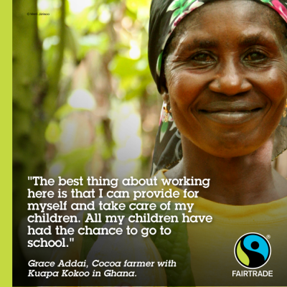

**You might also like to watch this Fair Trade clip about making chocolate production fair for cocoa growers:**

<https://schools.fairtrade.org.uk/resource/the-story-of-chocolate-unwrapping-the-bar/>

**Friday’s comprehension activity:**

Read the Fairtrade text and answer the questions. You could write your responses or tell someone at home your answers orally. Either way, make sure that you are speaking or writing in full sentences.

1. Next time you buy chocolate, how will you know if you are buying a fair trade product?

Next time I buy chocolate, I will know if it is a Fairtrade product because…

1. Why was the Fairtrade Foundation started?
2. What are the advantages of Fairtrade for farmers?
3. Name three other facilities which Fairtrade companies provide for their workers.
4. Why did Cadbury stop using the Fairtrade logo?
5. Do you think that George Cadbury would be proud of his company today? Why / Why not?

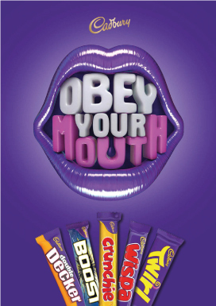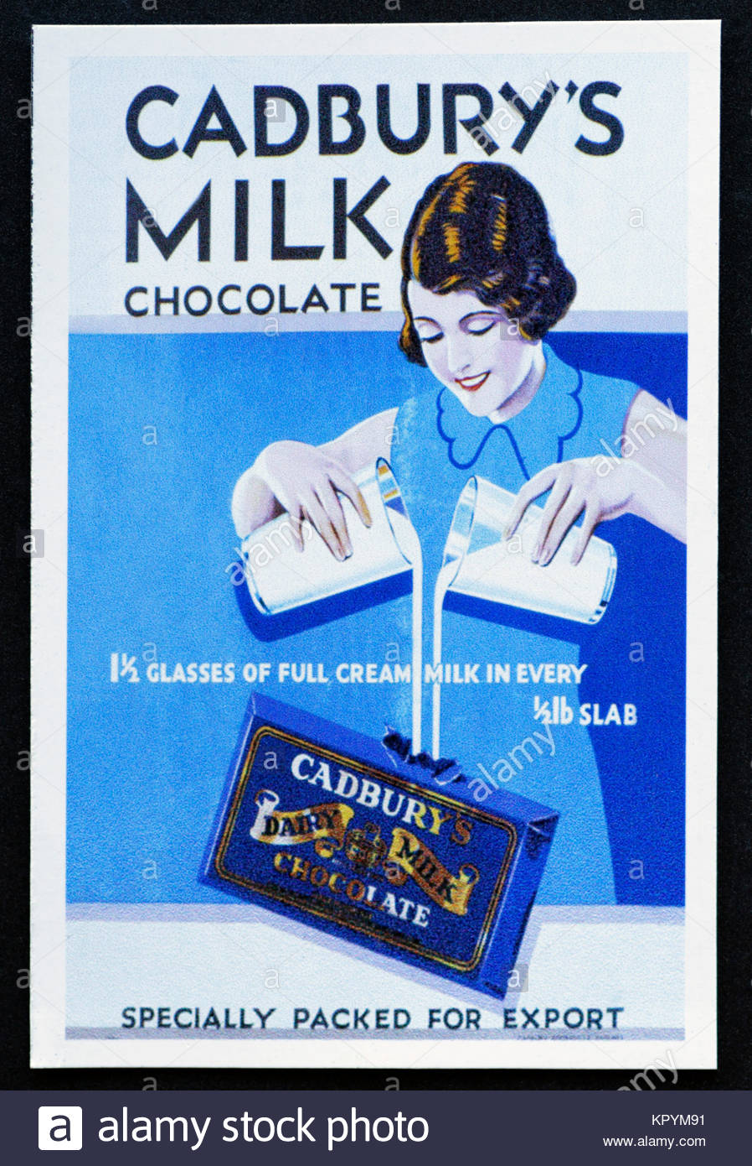**Resource 4: Cadbury Advertisement examples**

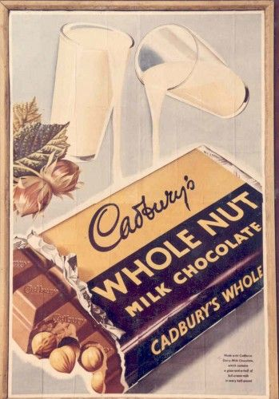

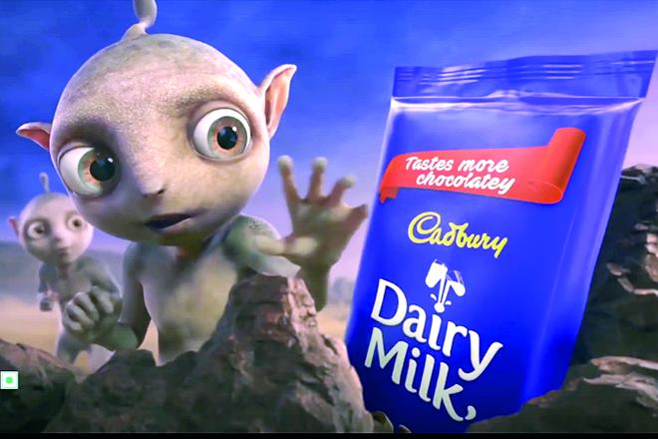

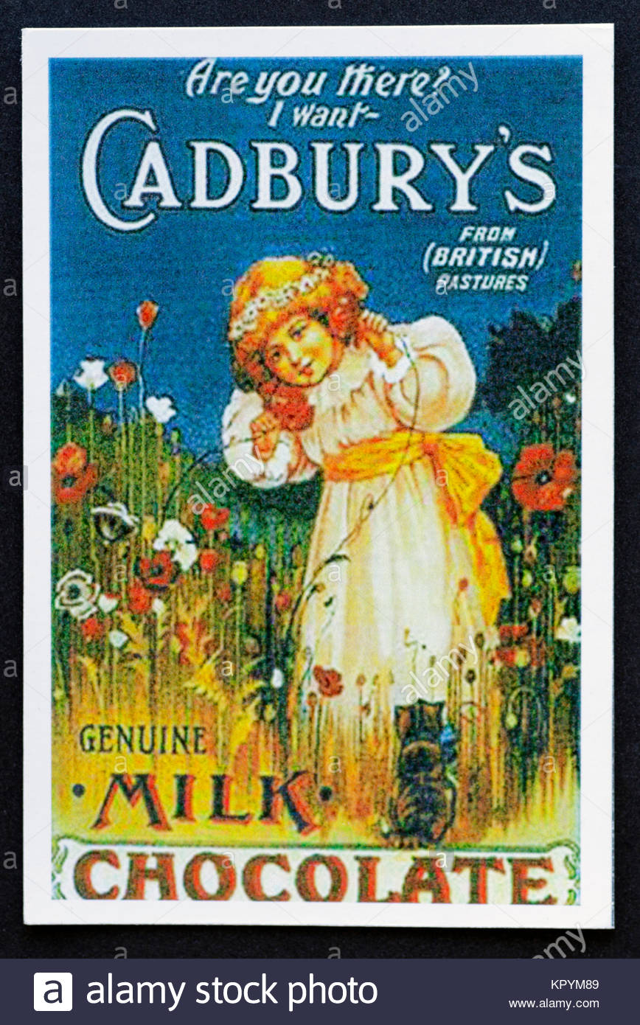

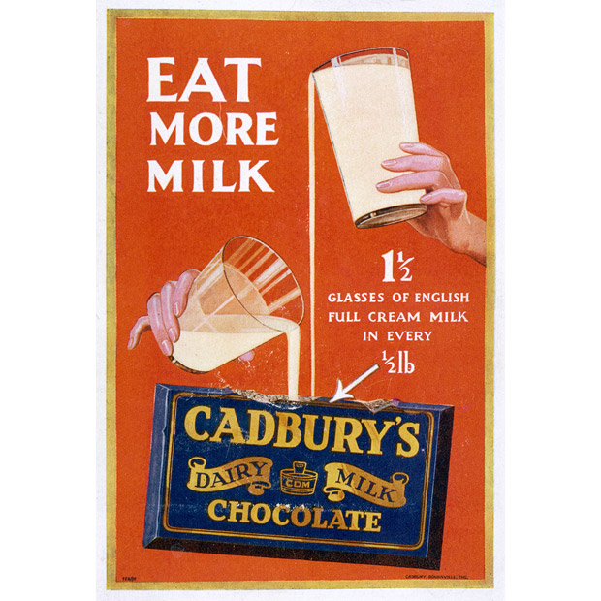

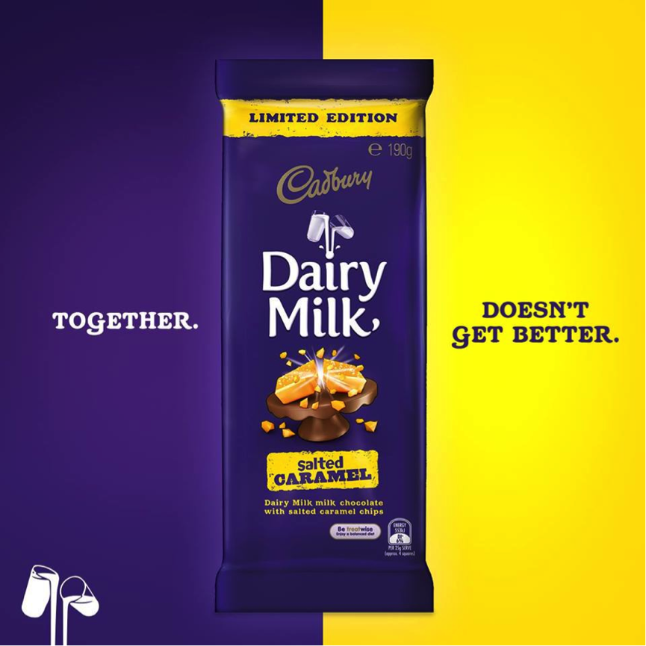

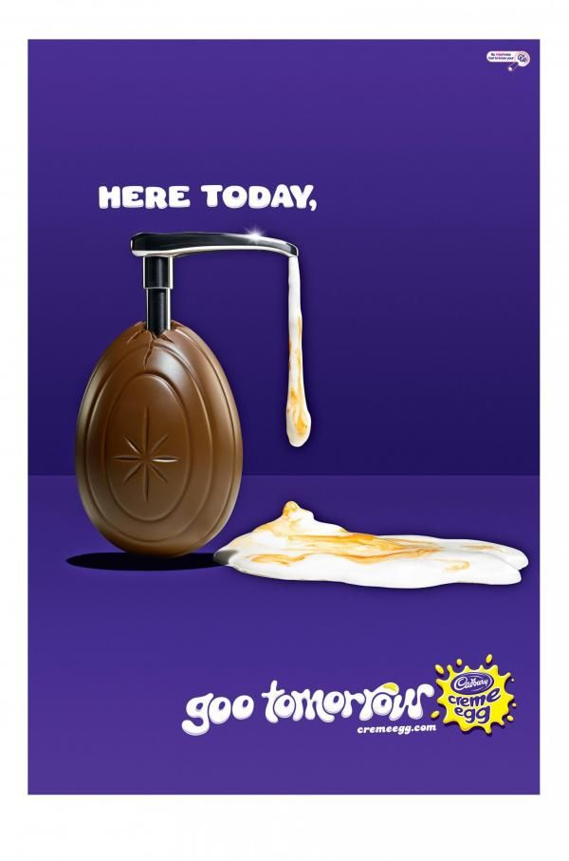

**Resource 5: Cadbury: Then and Now pictures to compare**

1. **Advertisements**

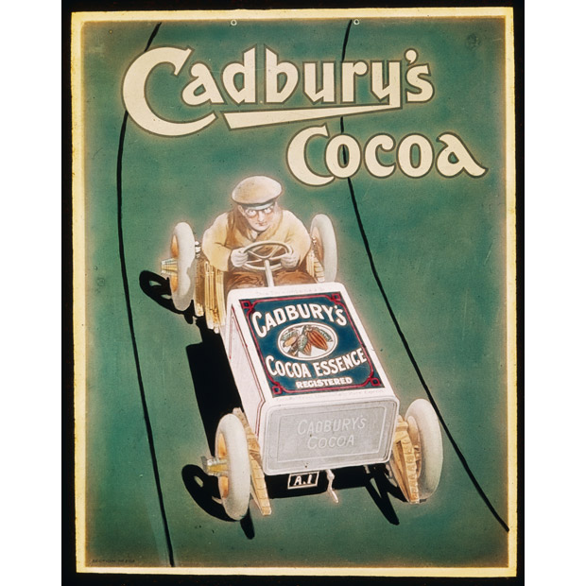

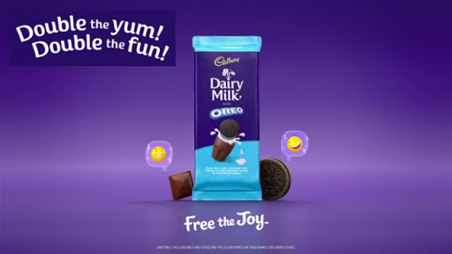

1. **Packaging and materials**

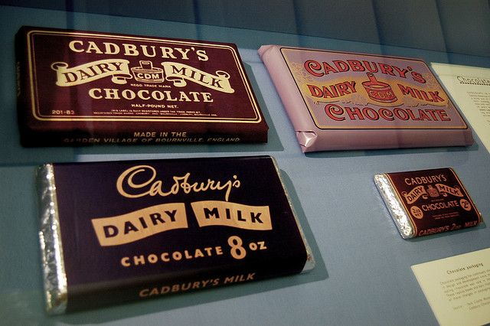

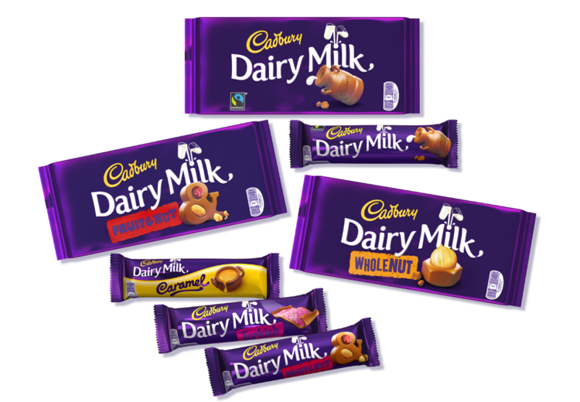

1. **Product range**

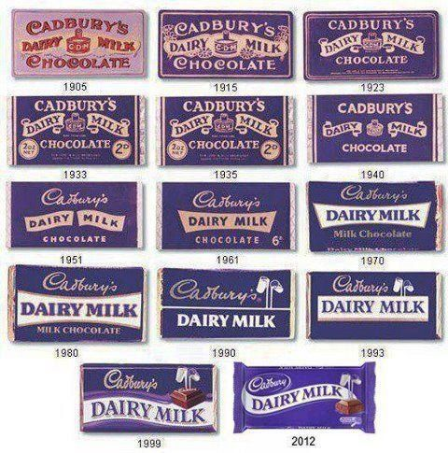

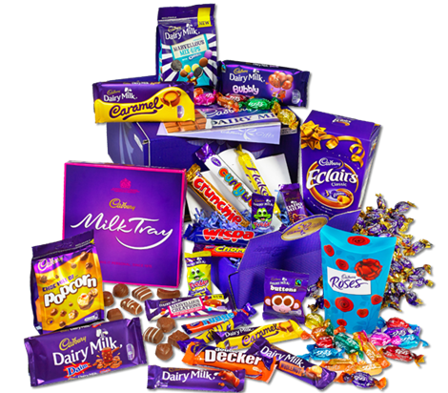

1. 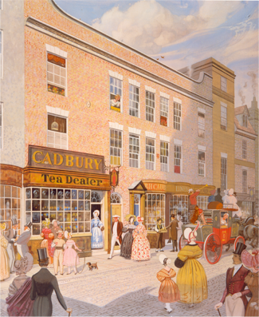**Cadbury’s first shop in Birmingham and Cadbury stores nowadays**

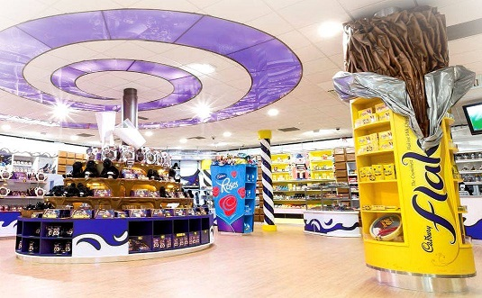

1. **Making chocolate in the factory**

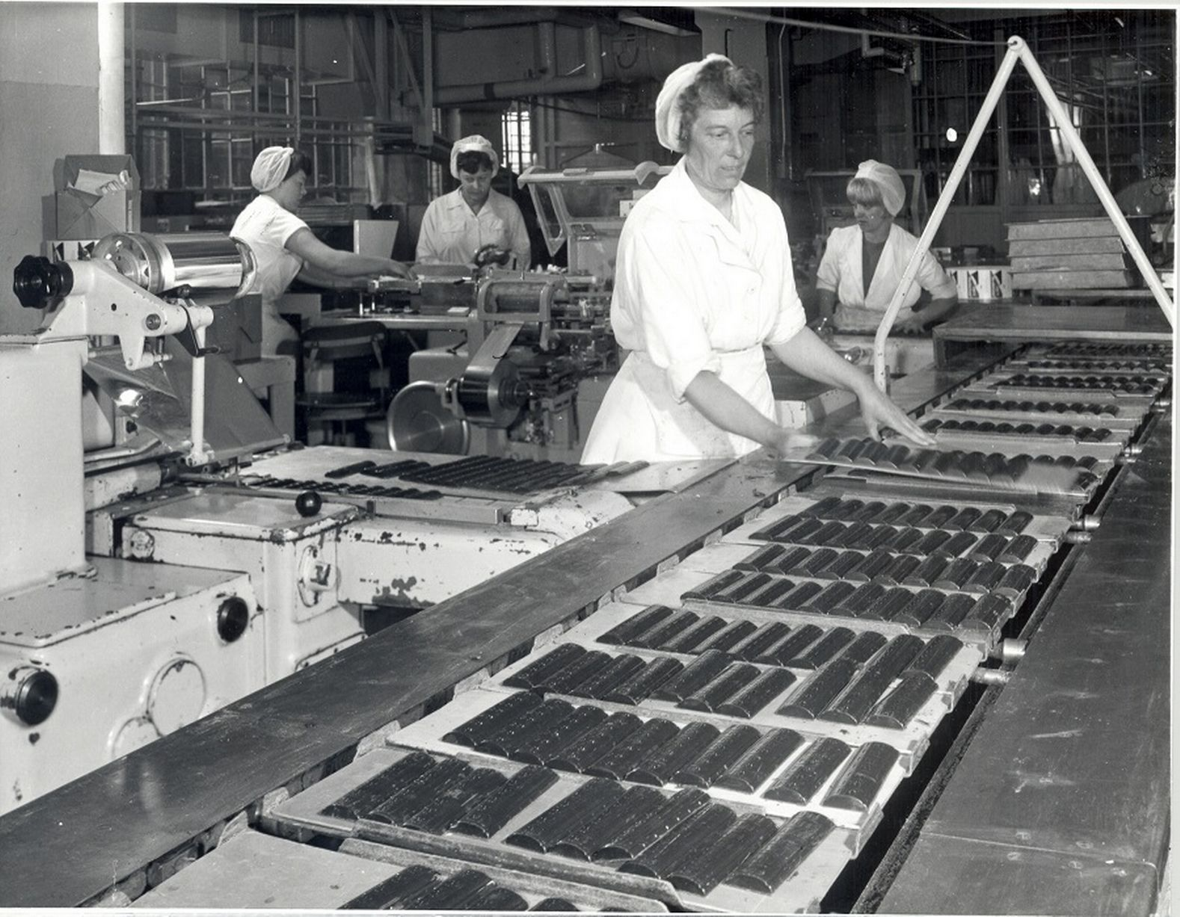

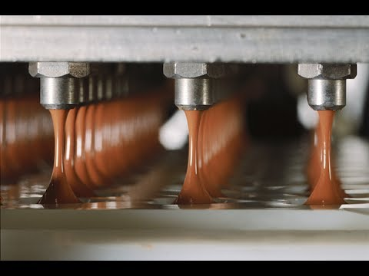

**Fast Maths grid**

|  |  |  |  |  |  |  |  |  |  |  |
| --- | --- | --- | --- | --- | --- | --- | --- | --- | --- | --- |
|  |  |  |  |  |  |  |  |  |  |  |
|  |  |  |  |  |  |  |  |  |  |  |
|  |  |  |  |  |  |  |  |  |  |  |
|  |  |  |  |  |  |  |  |  |  |  |
|  |  |  |  |  |  |  |  |  |  |  |
|  |  |  |  |  |  |  |  |  |  |  |
|  |  |  |  |  |  |  |  |  |  |  |
|  |  |  |  |  |  |  |  |  |  |  |
|  |  |  |  |  |  |  |  |  |  |  |
|  |  |  |  |  |  |  |  |  |  |  |
|  |  |  |  |  |  |  |  |  |  |  |