|  |  |  |  |  |  |  |  |
| --- | --- | --- | --- | --- | --- | --- | --- |
| Image result for larks classYear 5 - Larks Class  Home Learning activities to choose from  Week Commencing 27th April info@scsj.rbkc.sch.uk | | | | | | | |
|  | Monday | Tuesday | Wednesday | | Thursday | Friday | |
| Our Opening Prayer | Dear Lord  Thank you for this brand new day.  Help us to embrace opportunities for new learning.  Show us how to listen and love.  Support us and our friends.  Guide us to excellence in all that we do today.  Amen | | | | | | |
| P.E. | The Body Coach workout  **9am - 9:30am Monday - Friday**  <https://www.youtube.com/results?search_query=joe+wicks+body+coach> | | | | | | |
| Daily events |  | 24 little hats Birthday balloon party  HAPPY BIRTHDAY EZANA, one of our general knowledge experts and times tables superstars, as well as a great friend and footballer!  *from all of us at SCSJ* |  | HAPPY BIRTHDAY TO OUR VERY SPECIAL TA, RITA!  Thank you for everything you do for us all and the kindness you bring to our classroom.  *With love from everyone at SCSJ* | | |  |
| At 10am every Thursday, the Archbishop of Canterbury will be streaming ‘The World’s Biggest Assembly’ for children everywhere.  If you missed today’s, you can watch it here:  <https://www.youtube.com/watch?v=OgdhOstV6iI> | | |
| Reading Response | Medieval Medicine  (resource 1 below)  You might also like this Horrible Histories clip on the same topic:  <https://www.youtube.com/watch?v=9KhCSwY-8Zc> | Medicine in the Early Modern Age  (resource 3 below)  You might also like these Horrible Histories clips on the same topic:  <https://www.youtube.com/watch?v=U2-VFJxWw_I>  <https://www.youtube.com/watch?v=lPzIMyKRIP4> | Victorian Medicine  (resource 6 below)  You might also like this Horrible Histories clip on the same topic:  <https://www.youtube.com/watch?v=OZIMRVpKLFg> | | The NHS  (resource 8 below) | Life as a Paramedic  (resource 10 below)  You might also like this clip on the same topic:  <https://www.bbc.co.uk/bitesize/articles/zk6v2sg> | |
| Maths Fluency | Compare amounts of money  <https://uk.ixl.com/math/year-5/compare-money-amounts> | Choose some activities from Daily 10. Make sure you use Level 5.  <https://www.topmarks.co.uk/maths-games/daily10> | Rocket rounding  <https://www.topmarks.co.uk/maths-games/rocket-rounding> | | Box multiplication  <https://uk.ixl.com/math/year-5/box-multiplication> | Place value and multiplication patterns  <https://uk.ixl.com/math/year-5/multiplication-patterns-over-increasing-place-values> | |
| Maths Revision | Watch lesson 6 and complete the activities:  <https://www.youtube.com/watch?v=UBnTxI5GuBQ> | Watch lesson 7 and complete the activities:  <https://www.youtube.com/watch?v=HdmQ9MHqho4&list=PLQqF8sn28L9xBmQclRrb8YjcM-pzxHjfk&index=8&t=0s> | Watch lesson 8 and complete the activities:  <https://www.youtube.com/watch?v=0Ed3yzP9yy4&list=PLQqF8sn28L9xBmQclRrb8YjcM-pzxHjfk&index=8> | | Watch lesson 9 and complete the activities:  <https://www.youtube.com/watch?v=7VLhm5B3EJs&list=PLQqF8sn28L9xBmQclRrb8YjcM-pzxHjfk&index=9> | Watch lesson 10 and complete the activities:  <https://www.youtube.com/watch?v=gdcHLJ6BYEs&list=PLQqF8sn28L9xBmQclRrb8YjcM-pzxHjfk&index=10> | |
| Times Tables  Practice | Play ‘hit the button’ with multiplication / division facts:  <https://www.topmarks.co.uk/maths-games/hit-the-button> | You will need at least 2 dice for this activity. Roll the pair of dice to make a number. Roll them again and multiply the two numbers. | Archery Arithmetic  <https://mathsframe.co.uk/en/resources/resource/399/Archery-Arithmetic-Multiplication> | | Practise counting in patterns with somebody else in your house. Take it in turns to say the next number in the sequence.  e.g. 7, 14, 21… | Complete the grids  <https://phet.colorado.edu/sims/html/arithmetic/latest/arithmetic_en.html> | |
| Spellings | Adjectives describe a noun. Adverbs describe a verb.  e.g. James was happy. (adjective – describes James)  James cheered happily. (adverb – describes how he’s doing something) | | | | Spooky spellings  <http://www.ictgames.com/mobilePage/spookySpellings/index.html> | Choose Year 5&6 then ‘Hyphens’ <http://www.ictgames.com/mobilePage/lcwc/index.html> | |
| To turn most adjectives into adverbs, add –ly.  cheerful – cheerfully  calm - ?  nice - ?  quiet – ?  rapid – ?  kind – ?  honest - ?  beautiful - ? | To turn adjectives ending in y into adverbs: remove the y and add –ily.  spooky – spookily  lucky - ?  easy – ?  grumpy - ?  hungry - ?  angry - ?  merry - ?  clumsy - ? | Use the two rules you have learned to change these adjectives into adverbs.  creepy – ?  steady – ?  hopeful - ?  nice – ?  disappointing – ?  tidy – ?  dramatic – ?  slight – ?  strong – ?  greedy - ? | |
| Punctuation and Grammar | Find the verbs and adverbs:  <http://www.scootle.edu.au/ec/viewing/L6187/index.html> | Using commas in sentences: watch the clip and try the activity at the bottom of the page.  <https://www.bbc.co.uk/bitesize/topics/zvwwxnb/articles/zc773k7> | Sorting sentence types:  <https://uk.ixl.com/ela/year-4/is-the-sentence-a-statement-question-command-or-exclamation> | | Alphabetical ordering:  <https://uk.ixl.com/ela/year-4/order-alphabetically-based-on-the-first-letter> | Using hyphens and dashes: watch the clip and try the activity at the bottom of the page.  <https://www.bbc.co.uk/bitesize/topics/zvwwxnb/articles/zg8gbk7> | |
| Writing | Create your own poster reminding people to keep small children safe around medicines. See the example below (resource 2). | <https://www.literacyshed.com/the-present.html>  Watch the clip called ‘The Present’. Write a diary from the perspective of the boy, including his thoughts and feelings about the events of the day. Miss Bourne has done a starter (resource 4 below) – use as little or as much of it as you like to write your own diary. | <https://www.youtube.com/watch?v=C8WbrS0O5FE>  Watch the clip. Using what you have learned about the Victorian medicine, write a letter from a patient who has had their leg amputated in a Victorian surgery, to a friend, explaining what the experience was like. Miss Bourne has written a starter. (resource 7 below) | | You should have completed Wednesday’s Reading Response task before doing this one.  In the clip below, Joseph Lister and a more old-fashioned doctor debate how they would treat certain conditions. Make a table to show how their advice differs (see example on the resource 9 below).  <https://www.bbc.co.uk/bitesize/clips/zyps34j> | Look again at the NHS text from yesterday (resource 8). If you were to work in the NHS, which job would you like. You could choose something that’s not on the list. Write a paragraph to explain your choice. | |
| Themed Learning and Science | We’re so fortunate to have medical professionals who help us when we become unwell. It’s really important that we keep our bodies as healthy as possible through our lifestyles. | | You will need to read today’s Reading Response text about Victorian medicine before you to this.  Watch the clip below to find out more about ‘The Great Stink’ of 1858 and the invention of the London sewers.  <https://www.bbc.co.uk/teach/class-clips-video/science-ks2-discovering-the-work-of-Joseph-Bazalgette/zbc2scw> | | Using your ICT skills, research the life of the famous nurse Florence Nightingale and create a fact file.  You might like these clips to inspire you:  <https://www.youtube.com/watch?v=Ho6JC146Z8Y><https://www.youtube.com/watch?v=jONlz7vaMnU>  <https://www.bbc.co.uk/bitesize/topics/zns9nrd/articles/znsct39> | We’ll meet again!  Queen Elizabeth says thank you to our NHS.  (resource 11 below) | |
| Make up your own workout routine of at least 5 minutes (you might like to watch a Joe Wicks one for some ideas). You could write down the moves, draw diagrams or make a video. | Do you remember learning about the Eatwell Plate last term? (see resource 5 below). Design a healthy, balanced dinner for your family.  <https://www.youtube.com/watch?v=Gmh_xMMJ2Pw> |
| Story slot with Miss Bourne (added daily – click on the link on the class page) | **Fiction choice:**  ***I’ll Take You To Mrs. Cole*** – Michael dreads his Mum sending him to scary Mrs. Cole’s house if he’s naughty.  **Non-fiction choice: *Neil Armstrong***– the life story of the first man on the moon | **Fiction choice:**  ***The Fabulous Genie*** – A version of the classic tale of Aladdin  **Non-fiction choice:**  ***Christopher Columbus*** – The story of the European explorer who discovered the Americas | **Fiction choice:**  ***The World’s Best Question*** – A thinking story to wake up your mind  **Non-fiction choice:**  ***The Great Stink***  – The summer that a putrid smell rising from the River Thames horrified the people of London | | **Fiction choice:**  ***The Fantastic Voyage of Sinbad***  – A sailor escapes a desert island, encountering giant snakes, rotting sheep carcases and a city-sized creature known as the Roc.  **Non-fiction choice:**  ***Nelson Mandela*** – the story of the man who won rights for black people in South Africa (links to the World’s Biggest Assembly today) | **Fiction choice:**  ***Revolting Rhymes*** *–*Snow White has a plan to make her dwarves millionaires, while a clever huntsman tricks her wicked stepmother.  **Non-fiction choice:**  ***Incredible Journeys*** – The travel writer and photographer Levison Wood encourages us to see as much of the world as possible. | |
| Sing Education (Mr. Cadman’s channel) | Have a go at some music lessons:  <https://www.youtube.com/channel/UCr-UQ93J2M2daetW90YKoww/> | | | | | | |
| The Week Junior | The Week Junior Magazine for Schools | Welcome  Click here to access this week’s electronic edition:  <https://en.calameo.com/read/006188095256ab5802b0c> | | | | | | |
| Daily reading | Read with an adult for at least 20 minutes **EVERY DAY**.  When you need something new to read, you could try an e-book:  <https://worldbook.kitaboo.com/reader/worldbook/index.html#!/>  [https://www.oxfordowl.co.uk/for-home/find-a-book/library-page/?view=image&query=&type=book&age_group=Age+9-11&level=&level_select=&book_type=&series=#](https://www.oxfordowl.co.uk/for-home/find-a-book/library-page/?view=image&query=&type=book&age_group=Age+9-11&level=&level_select=&book_type=&series=) | | | | | | |
| Suggested Brain Breaks and Relaxation | Put on some relaxing music. You might like to do something creative while you’re listening, like drawing or colouring.  <https://www.youtube.com/watch?v=17ILK7mjdVI> | Meditation for Kids  <https://www.youtube.com/watch?v=_mX4JBBIcBk> | Listen to an Audiobook  Miss B.’s recommendation is ‘Wonder’  <https://www.youtube.com/watch?v=K_xZWu_eILE> | | Have a go at some origami  <https://www.youtube.com/watch?v=JlJsU8tspfc> | Lay down comfortably, press play and follow the instructions:  <https://www.youtube.com/watch?v=cDKyRpW-Yuc> | |
| Suggested  Physical Activities | Try some minion zumba  <https://www.youtube.com/watch?v=FP0wgVhUC9w> | Move and freeze  <https://www.youtube.com/watch?v=388Q44ReOWE> | Beginner workout  <https://www.youtube.com/watch?v=L_A_HjHZxfI> | | Jailhouse rock  <https://www.youtube.com/watch?v=JbxDwaGwi2Q> | Welcome to my gym  <https://www.youtube.com/watch?v=ju8W_SX_wy4> | |
| A song a day to sing along with | Shine Jesus Shine  <https://www.youtube.com/watch?v=7OIwSQmyCg4> | I the Lord of Sea and Sky <https://www.youtube.com/watch?v=gcL9S5a3weU> | One more step along the world I go <https://www.youtube.com/watch?v=b6czcGvXQcM> | | You are Good <https://www.youtube.com/watch?v=eW0UOxwepJQ> | Roses of Success <https://www.youtube.com/watch?v=WOyIJVUaoeg> | |
| Our Closing Prayer | Lord of the loving heart, may ours be loving too;  Lord of the gentle hands, may ours be gentle too;  Lord of the willing feet, may ours be willing too;  May we grow more like you in all we say and do.  Amen | | | | | | |

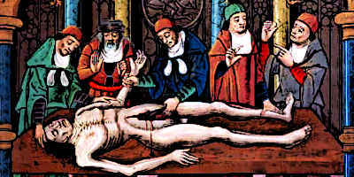**Resource 1: Medieval Medicine (476 BC – 1500 AD)**

Nowadays, we are fortunate to have excellent medical care. If we become ill or injured, there are health centres and hospitals offering treatments and medicines for a range of different ailments. We can even have vaccinations against some of the most common diseases to prevent us from getting them in the first place.

However, this hasn’t always been the case.

The Medieval period was not a good time to be poorly. 1,500 years ago, before medical researchers had discovered everything they know now, people expected to live for around 30-35 years. The average child born in the UK in 2020 can expect to live until the age of 90.

People would die from simple injuries and disease such as fevers and small pox. Doctors of the time had no idea what caused diseases and tried treating most illnesses with herbs.

It was often believed that illnesses were sent by God as a punishment or caused by the stars, planets, bad smells, charms or witches.

Some of the medieval doctors’ herbal remedies did work but there were some that wouldn’t be used today.

For example:

* Posies (fragrant bags containing flowers) were smelled by the patient to ward off diseases.
* A hole would be cut into the skull to relieve headaches and strange behaviour.
* Fireplaces in a patient’s bedroom would be lit to ‘smoke out the disease’.
* 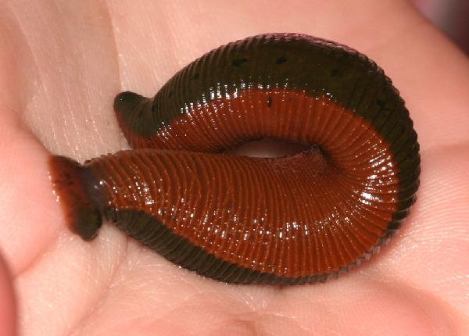Leeches (small creatures a bit like slug) were put on a patient’s body to suck out ‘bad blood’ in the hope of making people better.

There was a lot of progress during medieval times. With so many wars, surgeons had plenty of injured soldiers to practise on.

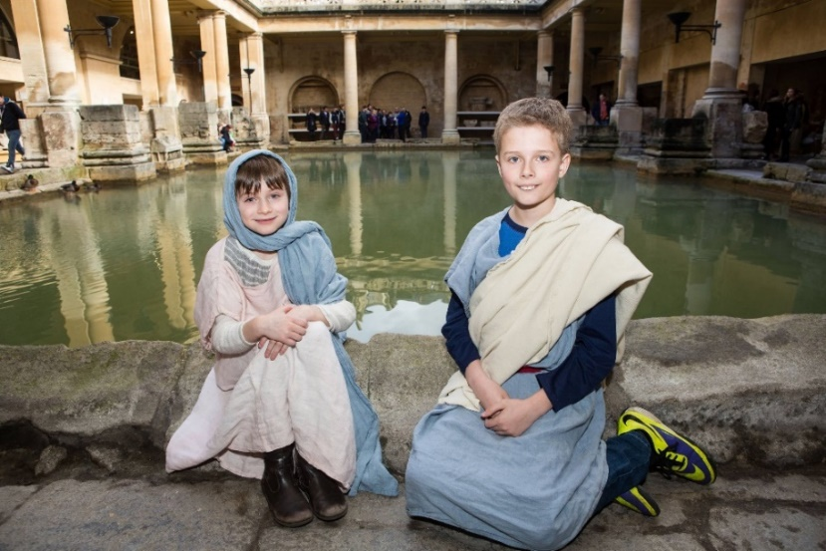Medieval doctors were the first to discover that wine (when put onto the skin) could be used to kill some germs. They also discovered some herbs that could be used to relieve pain (nowadays, you might take Calpol or Paracetamol, with an adult’s permission). Doctors could heal simple wounds and they even developed casts to help broken bones to heal. Some surgeries were performed successfully to heal injuries. However, there was no anaesthetic in those days (medicine used to put people to sleep during an operation) so the patient would be awake the whole time!

The sights and smells of medieval towns would probably have made you feel rather sick. However, people were beginning to realise that keeping clean could improve their health.

The government passed a law forcing people to keep the streets and rivers clean. They encouraged everyone to wash. In those days, people did not have baths or showers in their homes so they would go to a large public bath! It wouldn’t have been as clean as what we’re used to today, but it was a start.

There weren’t sewers or drains or rubbish collections. Town councils paid ‘gong farmers’ to carry away buckets of human waste (that’s right – wee and poo) to cesspits away from the houses.

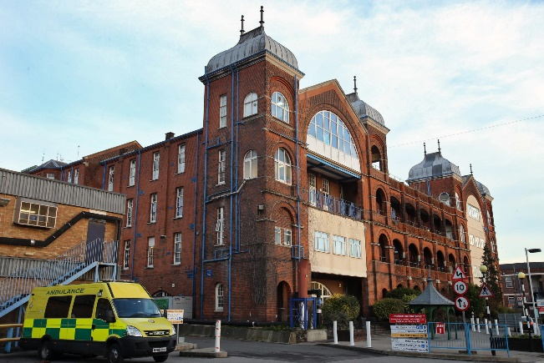It was during the medieval age that a few wealthy buildings were able to have toilets and running water. The first hospital was also built in 1123: St. Bartholomew’s in London is still open today.

Amazingly, it was medieval doctors who first came up with the idea of quarantine! They realised that illnesses could be spread from one person to another and that people could avoid getting ill by keeping their distance.

**Monday’s comprehension task**

Remember to answer in full sentences, whether you’re writing your answers or saying them to someone at home.

1. 1,500 years ago, how long did the average person expect to live for?

*1,500 years ago, the average…*

1. Medieval doctors had six ideas about where illnesses came from. Name three of them.
2. What were leeches used for?
3. What is an anaesthetic used for?
4. How did the government encourage people to keep healthy?
5. Where was the first hospital ever built?

**Resource 2: Safety with medicines – poster example**

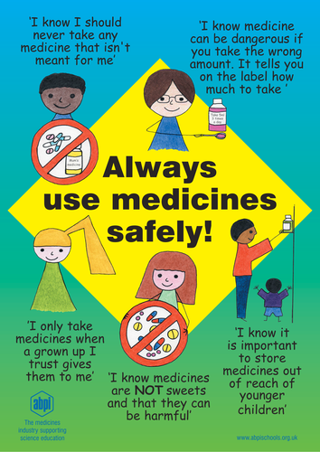

**Resource 3: Medicine in the Early Modern Age (1500 -1800 AD)**

Some major discoveries were about to be made. In 1628, William Harvey discovered the circulation of the blood. He worked out that the heart pumped blood around the body in a closed circuit and noticed arteries and veins carrying it to and from the lungs. How did he make this discovery? He was one of the first doctors to look inside a human body and carry out experiments to test his ideas.

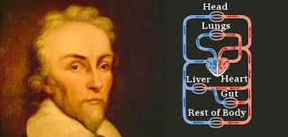

However, doctors still didn’t really know much about germs. They continued to blame diseases on bad smells. Furthermore, seeing a doctor was very expensive so poor people were unable to get help when they were unwell.

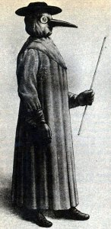Some people would go to ‘quacks’. These were people who weren’t really doctors but they claimed to know how to cure illnesses. Why were they called quacks? They would wear a full body suit with a duck beak shape over their nose and mouth. This was filled with herbs so that they wouldn’t smell the bad smell from their patients and catch the disease from them. Quacks advised touching the king’s skin to cure skin diseases and chewing tobacco to solve any ailment, including snake bites!

Meanwhile, explorers in the Americas were discovering rainforest plants which seemed to have some healing properties. This is still important in the way medicines are made today, but doctors in the early modern age did not know as much as modern scientists about why these worked.

Around the same time, a well-known surgeon began to share his knowledge about how to treat wounds and another invented special tools to make surgery. However, anaesthetic was still a long way in the future.

**Tuesday’s comprehension task**

Remember to answer in full sentences, whether you’re writing your answers or saying them to someone at home.

1. Which discovery was made by William Harvey in 1628?

In 1628, William Harvey discovered…

1. People in the middle ages continued to blame illnesses on one thing. What was it?
2. Why were ‘fake doctors’ known as quacks?
3. How did explorers visiting the Americas help Europeans to improve medicines?
4. What happened in towns and cities during the early modern age?
5. How were Henry VIII’s views about hygiene different from his daughter, Elizabeth’s?

Historians believe that, as towns and cities continued to grow, they became dirtier and messier in the early modern age. Towns were filthy and human waste was thrown out of window to remain on the streets.

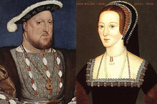

When King Henry VIII came to the throne, things began to improve slightly. He believed in keeping cleaner and sent home any palace staff who were unwell. However, his daughter, Elizabeth, never took more than four baths per year after she became Queen!

People still believed that bad smells caused diseases and they began washing their clothes more often to keep them fresh. This made a positive difference to people’s health, even if their reason for washing clothes was the wrong one.

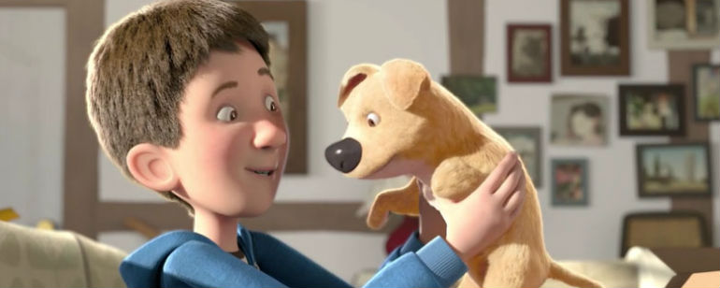**Resource 4: The Present – Miss Bourne’s diary starter**

You can use as little or as much of my starter as you like to begin your own diary entry for Joe on the day that he got his dog.

Dear Diary

My Mum’s constantly nagging me about spending too long gaming. It drives me mad sometimes. I know, I know – she’ll say it’s just because she cares and all that. This morning though, it was irritating me more than ever.

Maybe it was because it was so sunny outside that Mum was particularly annoyed about me being in front of the TV with the blinds down and the lights on. I’ve told her a thousand times: I can’t see the screen properly with the daylight coming in. If I can’t see the screen properly, how am I ever going to make it to Level 14? Luke, my best mate, is catching me up and I can’t let him beat me; I’d never hear the end of it.

The thing is, I prefer being indoors. Ever since my accident, it’s just… easier. Nobody looking or staring. Going out isn’t as much fun when you only have one and a half legs. At least when I’m on the sofa, I don’t have to bother with my crutches. Mum says I shouldn’t lose my sense of fun and adventure just because of my injury but she’s wrong. At least, I thought she was before I got the present.

Over the noise of the game, I didn’t hear her go out but I did notice when she came home and shoved a giant cardboard box in front of my face, just as I was about to enter the dragon’s cave. I think I snarled at Mum a bit. Obviously, I was intrigued by the present but I wasn’t going to let her know that. I resisted the temptation to pause the game until she went upstairs to take a phone call.

When I opened the box I was delighted at first; then I took a closer look and felt angry with my Mum. It was so obvious what she was trying to do. The little puppy was…

**Resource 5: The Eatwell Plate**

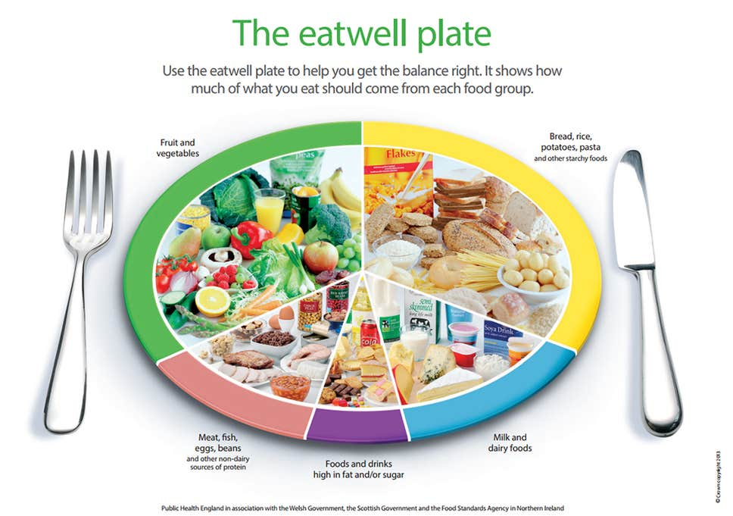

**Resource 6: Victorian Medicine (1819 – 1901 AD)**

The Victorian era was one of discovery and invention. The subject of medicine was no exception. Things were beginning to improve. By 1842, the life expectancy for rich men living in the countryside was 52. For poorer men in cities however, it was still only 15.

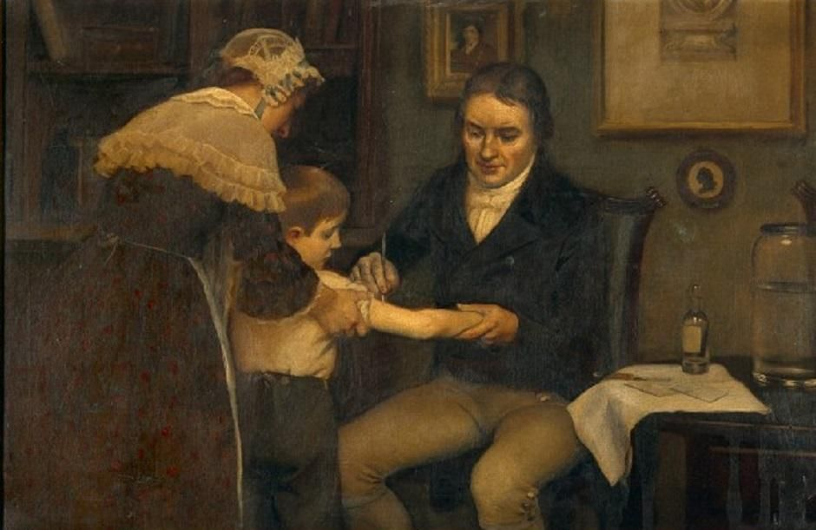It was clear that cities needed to be cleaner. In 1858, ‘The Great Stink’ came over London. The river Thames was so full of human waste that the hot weather caused a putrid smell that drove people out of the city. Huge pumps had to be brought in to drain the sewage.

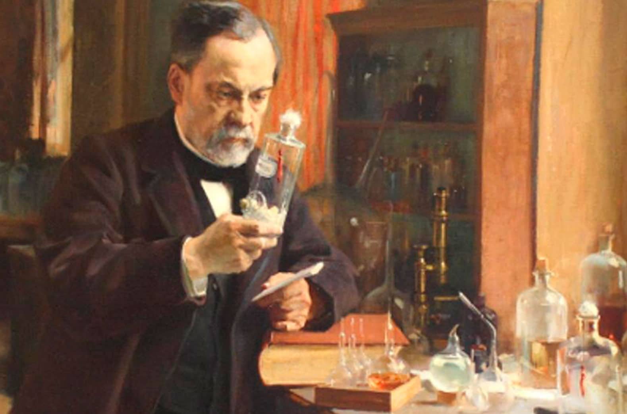The smells were unpleasant, but in 1864, Louis Pasteur proved that it was in fact germs, not smells, which caused diseases. Other scientists built on his ideas to find the germs which caused certain illnesses. With this information, they were on the path to finding cures.

Smallpox was killing thousands of people every year. Edward Jenner believed that there must be a way to stop people getting common diseases and he experimented for years. He injected a small amount of pus from someone who had smallpox into a healthy young boy called James (experimenting on humans is illegal nowadays!). James’ body was able to overcome the small amount of disease. When Jenner then injected small pox into James, he didn’t catch it. His body had already adjusted to fighting smallpox.

By 1840, vaccinations for common illnesses were given free of charge for every baby. Today, all children in the UK are still entitled to free vaccinations against illnesses such as polio; some of these diseases have almost been wiped out of the country because of Jenner’s idea.

One of the greatest successes of Victorian doctors was developing anaesthetics. For the first time, medicine could be given to patients to reduce their pain or make them unconscious during operations.

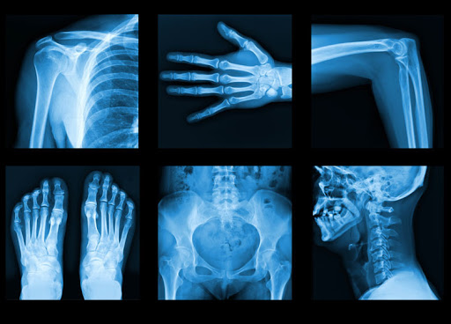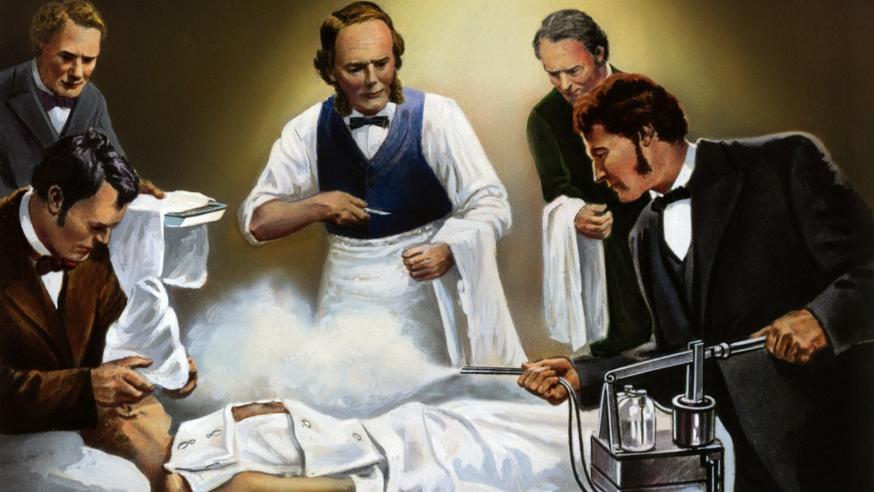

Until 1850, doctors rarely washed their hands. Wounds were left uncovered and bandages might be used several times. After Joseph Lister developed anti-septic to kill germs, the number of patients surviving surgery doubled. Unfortunately, the first recipe he used caused other health problems, but Lister persevered to create a new solution. He worked on new bandages to keep wounds clean and persuaded surgeons to clean the tools used for operations. The chance of surviving an operation was better than ever.

Meanwhile, Florence Nightingale was horrified by the dirty conditions in hospitals. She began training 19,000 nurses, insisting on them keeping hospitals clean and giving patients fresh air. Soon, rubber gloves were being used in hospitals and doctors washed their hands more regularly.

By the time Queen Victoria died in 1901, hygiene standards were saving lives. Furthermore, X-rays had been developed and doctors were able to see inside live patients to help them understand more about the human body.

**Wednesday’s comprehension task**

Remember to answer in full sentences, whether you’re writing your answers or saying them to someone at home.

1. Describe the event which occured in London in 1858.
2. Louis Pasteur discovered that the cause of disease was not bad smells. What is the cause?
3. What was Edward Jenner’s contribution to medical science?
4. Explain what an anaesthetic is.
5. Joseph Lister developed two new things which are useful in preventing infections. What were they?
6. How did the invention of the X-ray machine make doctors’ jobs easier?

**Resource 7: Miss Bourne’ letter starter**

Dear George

I assume that you had not expected to hear from me ever again. I too am amazed to have survived my recent leg amputation. I am pleased to say that it was a success but I hope never have to endure surgery again.

The operating theatre, in the roof of an old church, was a small room, wooden from floor to ceiling. The process was watched by 150 students, all eagerly taking notes and whispering in hushed tones as the surgeon worked.

The surgeon. He was an ordinary-looking man dressed in his everyday clothes. The only thing that was different about him was his dirty apron, which he had obviously worn to work on other patients before me.

He introduced himself to me and explained what would happen.

**Resource 8: The NHS**

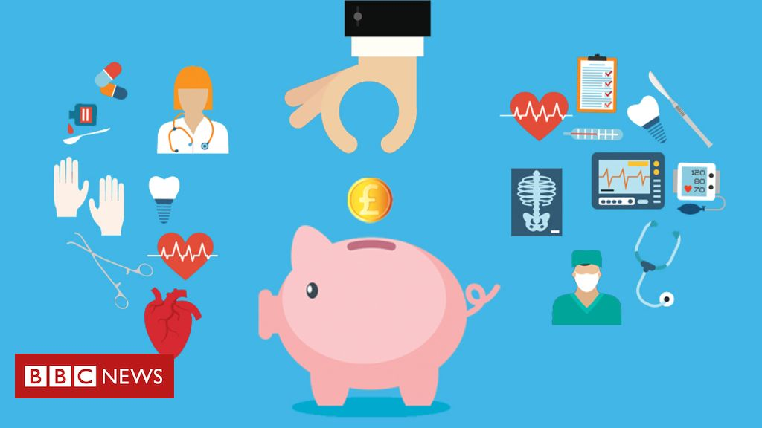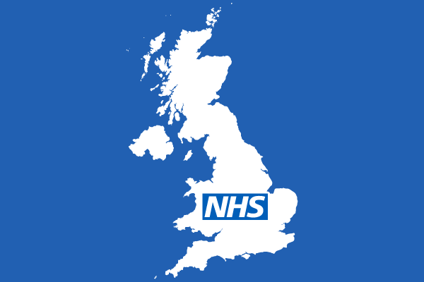Recently, we have heard a great deal about our NHS. Many of us have been thanking NHS staff through the ‘Clap for Carers’ on Thursday evenings. What is the NHS and who are the carers we are celebrating?

Before the NHS was founded, every visit to a hospital or a doctor had to be paid for by the patient. Therefore, only wealthy people could afford treatment. A Welsh politician called Aneurin Bevan was determined to change this and campaigned for a National Health Service (NHS).

He was successful in 1948. Britain was still recovering from World War 2 and many people were poor. The NHS gave everybody an opportunity to receive medical treatment, no matter who they were or how much money they had.

Medical care is expensive. Every person in Britain who goes to work pays tax on their income. This means that not all of the money they earn in their job goes into their bank account. Some of it goes to the government and it is used to pay for services that the country shares, such as schools, roads and medical services. Taxes pay for everything the NHS needs, from equipment to salaries for staff.

1.5 million people work in the NHS. Amazingly, there at least 350 different types of NHS jobs. You are probably familiar with nurses, doctors and dentists, but there are many other professionals you might not know so much about. Here are a few of them:

**Midwives**

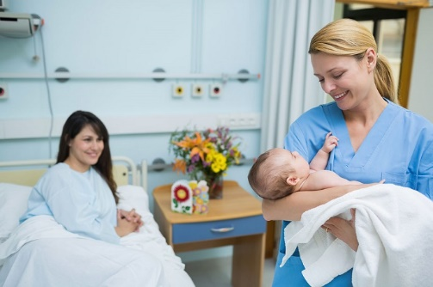A midwife is a specialist nurse who looks after women who are pregnant. It is the job of midwives to help a mother through the pregnancy and be there when the baby is born. Midwives check on new babies regularly to ensure that they are healthy.

**Physiotherapists**

Physiotherapists are there for people who have difficulty in moving due to accidents, illnesses and disabilities. They are experts in movements and exercise to help patients to regain strength. Professional sports players often work with physiotherapists to keep their bodies on top form.

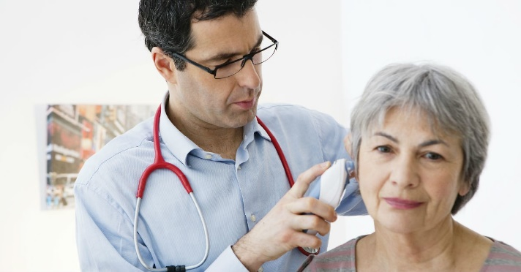**Audiologists**

Audiologists are experts in sound and hearing. They use modern technology to identify and treat difficulties with hearing. They give people with hearing difficulties the opportunity to communicate with others.

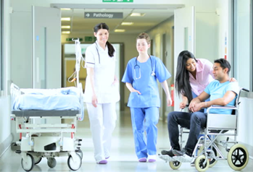**Hospital Porters**

Hospital Porters must have excellent inter-personal skills because a major part of their job is moving patients from one part of the hospital to another, often on wheeled beds or in wheelchairs. They might also move equipment to where it’s needed most in the hospital and help to dispose of medical waste which cannot go in the normal rubbish bins. They sometimes deliver meals to patients’ bedsides, too.

**Pharmacists**

You might think that a pharmacist is a person who sells medicine over the counter but they are very different from other shopkeepers. They are medically trained professionals who can give advice about suitable medicines and how to take them. Pharmacists can give advice on minor ailments and some give vaccinations.

**Radiographers**

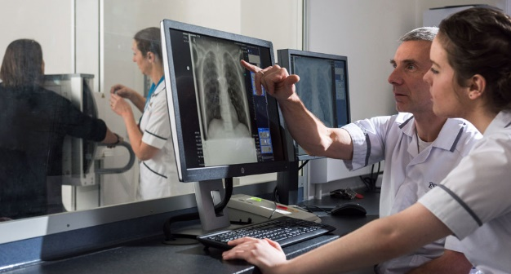Radiographers use X-rays and other scans to assess and diagnose injuries and illnesses. Using the data from these tests, they work closely with the doctors and surgeons to decide on the best treatment for patients. When pregnant women have a scan of their baby, it may be a radiographer who does it.

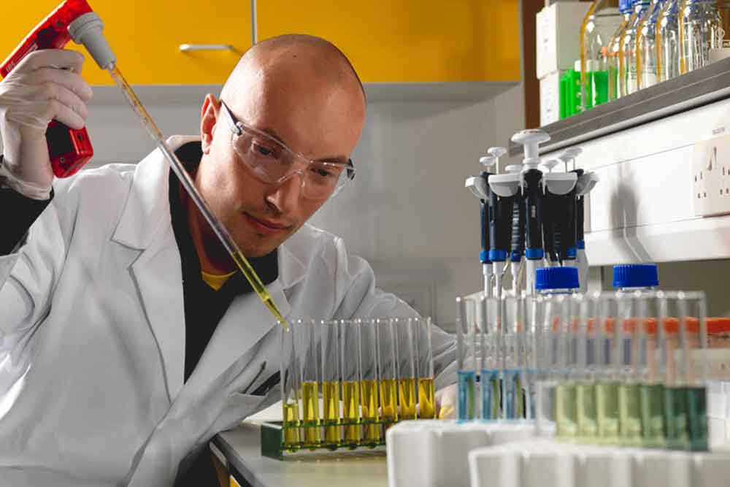**Scientists**

Have you ever had a blood test? The sample of blood taken is delivered to a laboratory where an NHS scientist will test it before informing your doctor of the results.

There are many other scientists in the NHS working on new treatments such as medicines and vaccinations.

**Administrators**

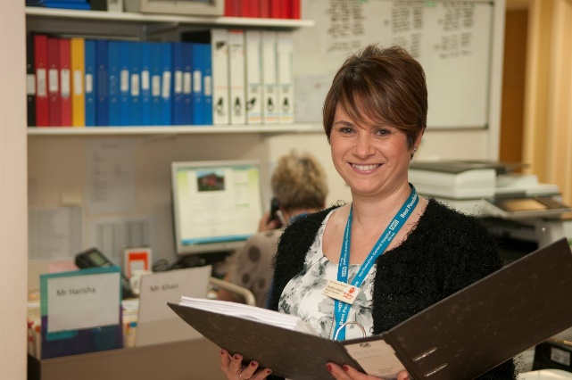A bit like our school, none of these services could run without office staff who keep the NHS running smoothly. Their duties might include managing money, organising staff and working on reception, looking after patients face to face.

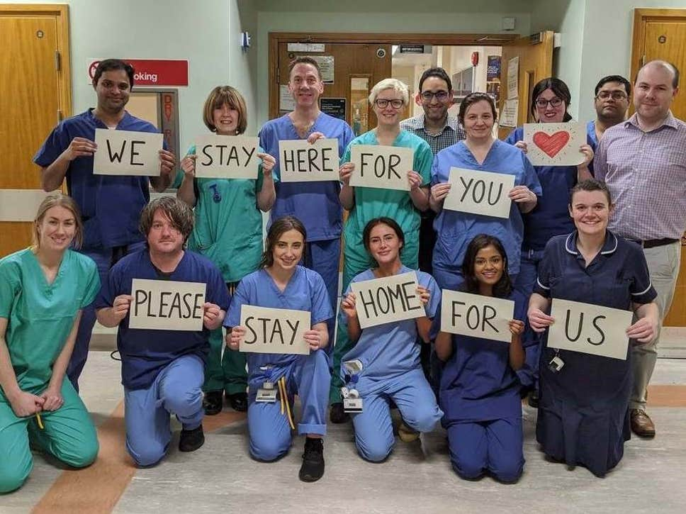If you are clapping for carers tonight, remember you’re cheering for a huge team of people! Many other professionals are still working to keep us in good health while we’re in lockdown – not to mention the cooks, cleaners, transport workers and delivery drivers who are taking care of them too.

**Thursday’s comprehension task**

The text includes information about 8 different NHS professions. For each one, write down one thing that the NHS professional does.

e.g.

*1. A midwife checks on the health of new born babies.*

*2. A physiotherapist…*

**Resource 9: Joseph Lister v. the traditional doctor**

Watch the clip and write down the advice that each of the doctors has for the patient: <https://www.bbc.co.uk/bitesize/clips/zyps34j>

|  |  |  |
| --- | --- | --- |
| **Complaint** | **Joseph Lister’s advice** | **Traditional Doctor’s advice** |
| **I was run over by a carriage and have a broken leg.** |  |  |
| **I have pains in my stomach.** |  |  |

**Resource 10: Life as a Paramedic**

A paramedic is a health care professional who works for the emergency medical services. When someone dials 999 to call for emergency medical help, the paramedics are the first to respond, usually in an ambulance or on a motorbike or even in a helicopter for remote locations.

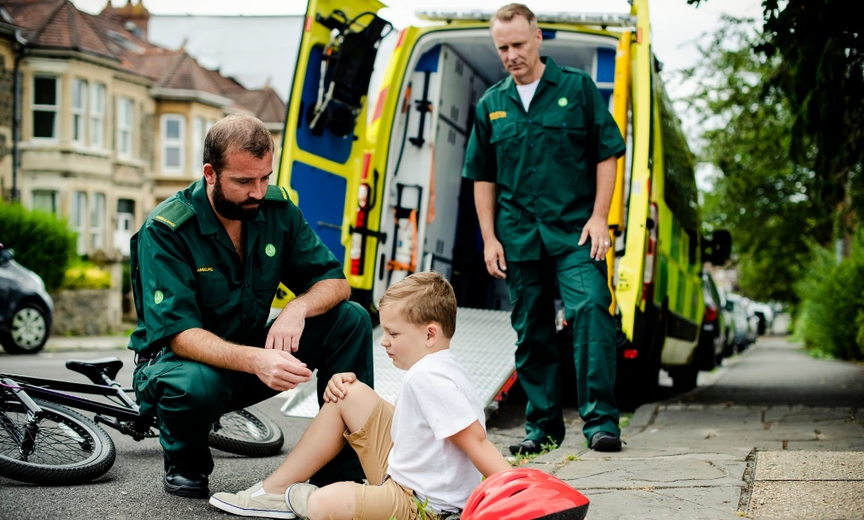

Paramedics use a variety of different techniques to decide what the problem is and whether the patient should be treated at the scene or taken to the Accident and Emergency Department of the nearest hospital.

Most paramedics are not doctors. However, they are well trained in keeping patients as stable and comfortable as possible until the ambulance arrives at the hospital. The sooner the patient gets to the hospital, the sooner specialist doctors and nurses can take over.

The paramedic who is not driving will stay in the back of the ambulance with the patient during the journey to the hospital, checking their ‘vital signs’ such as heart rate and oxygen levels.

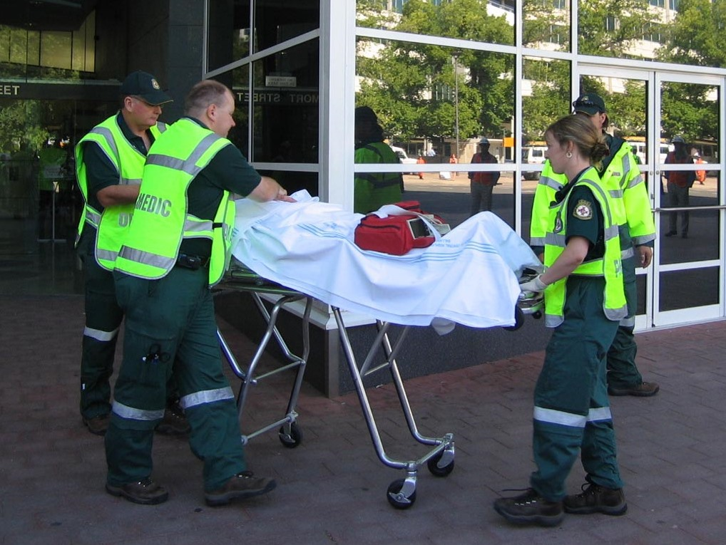

Paramedics must have a driving licence and they receive extra driver training to learn how to drive ambulances safely; paramedics are allowed to break the speed limit and other rules of the road when they are on emergency calls, as long they do it safely.

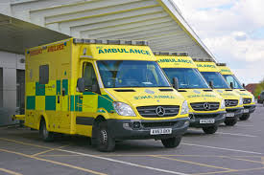

Ambulances are well kitted out with medication and machines such as defibrillators which can be used to start a patient’s heart.

Paramedics wear a distinctive green uniform with a reflective jacket so that they can be seen clearly at night time. People in emergency situations put a lot of trust in paramedics. Their job is very varied: they are used to dealing with different emergency situations every day, with no time to prepare themselves.

There are around 28,000 paramedics working in the UK for the NHS. To qualify, paramedics study medical first aid and take further training before they are able to administer medicines or use certain equipment.

Would you like to be a paramedic?

**Friday’s comprehension task**

Find a word in the text that means the same as each of these:

1. reply
2. a long way from a town
3. most important
4. easily recognised
5. changeable

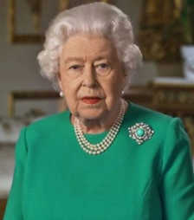**Resource 11: We’ll Meet Again**

Three weeks ago, Queen Elizabeth made a speech to the country about Coronavirus.She reminded people of the song called *We’ll meet again* which people separated from their families in World War Two used to sing.

*“Today, once again, many will feel a painful sense of separation from their loved ones. But now, as then, we know, deep down, that it is the right thing to do. While we have faced challenges before, this one is different. This time we join with all nations across the globe in a common endeavour, using the great advances of science and our instinctive compassion to heal. We will succeed - and that success will belong to every one of us.*

*We should take comfort that while we may have more still to endure, better days will return: we will be with our friends again; we will be with our families again; we will meet again.”*

Here’s the wartime version: <https://www.youtube.com/watch?v=HsM_VmN6ytk>

Here’s the 2020 version: <https://www.youtube.com/watch?v=dTWy9jim7Mw>

**Lyrics**

We’ll meet again; don’t know where, don’t know when

But I know we’ll meet again some sunny day

Keep smiling through just like you always do

‘Til the blue skies drive the dark clouds far away

Will you please say hello to the folks that I know

Tell them I won’t be long

They’ll be happy to know that as you saw me go

I was singing this song