|  |  |  |  |  |  |
| --- | --- | --- | --- | --- | --- |
| Image result for larks classYear 5 - Larks Class  Home Learning activities to choose from  Week Commencing 30th March [pippa.bourne@scsj.rbkc.sch.uk](mailto:pippa.bourne@scsj.rbkc.sch.uk) | | | | | |
|  | Monday | Tuesday | Wednesday | Thursday | Friday |
| Our school prayer | Dear Lord  Thank you for this brand new day.  Help us to embrace opportunities for new learning.  Show us how to listen and love.  Support us and our friends.  Guide us to excellence in all that we do today.  Amen | | | | |
| P.E. | **9am - 9:30am Monday-Friday**  The Body Coach workout  <https://www.youtube.com/results?search_query=joe+wicks+body+coach> | | | | |
| Reading response | Visit the Newsround website. Choose an article that interests you and record three facts you have learned from it. | The Footballers in the Cave: Part 1  (resource 4 below) | The Footballers in the Cave: Part 2  (resource 5 below) | The woman who froze to death and survived  (resource 6 below) | |
| Maths fluency | Positive and negative numbers:  <https://uk.ixl.com/math/year-5/count-on-a-number-line-up-to-100-in-both-directions> | Ordering numbers:  <https://uk.ixl.com/math/year-5/put-numbers-in-order-up-to-1000000> | Adding numbers with 5 or more digits:  <https://uk.ixl.com/math/year-5/add-numbers-with-five-digits-or-more-word-problems> | Column Addition:  <https://uk.ixl.com/math/year-5/addition-with-five-digits-or-more-fill-in-the-missing-digits> | Practise times tables here:  <https://www.transum.org/software/SW/Starter_of_the_day/students/Basic_Multiplication.asp?Level=4> |
| Maths revision | A column-per-day Maths: Addition  (resource 1 below) | A column-per-day Maths: Adding unit fractions  (resource 1 below) | A column-per-day Maths: Adding non-unit fractions (resource 1 below) | A column-per-day Maths: Adding decimals  (resource 1 below) | A column-per-day Maths:  Mixed practice  (resource 1 below) |
| Spellings | To pluralise nouns ending in **f**, change the **f** to a **v** before adding **-es** | | To pluralise nouns ending in **s**, **sh**, **ch**, **x** or **z**, add **-es**. | | |
| Pluralise:   * leaf * elf * loaf * calf * shelf | Pluralise:   * wolf * thief * life * knife * half | Pluralise:   * lunch * branch * witch * finch * bunch | Pluralise:   * gas * bus * marsh * wish * dish | Pluralise:   * fox * box * quiz * flash * princess |
| Grammar and Punctuation | Adjective Detective  <https://www.childrensuniversity.manchester.ac.uk/learning-activities/languages/words/adjective-detective/> | Possessive Apostrophes: Watch the clip then complete the activity below it.  <https://www.bbc.co.uk/bitesize/topics/zvwwxnb/articles/zx9ydxs> | Apostrophes in contractions:  Watch the clip then try the three activities below it.  <https://www.bbc.co.uk/bitesize/topics/zvwwxnb/articles/zcyv4qt> | What is an adverb?  Watch the clip and complete the activity below it.  <https://www.bbc.co.uk/bitesize/topics/zwwp8mn/articles/zgsgxfr> | What is a fronted adverbial?  Watch the clip and complete the activity below it.  <https://www.bbc.co.uk/bitesize/topics/zwwp8mn/articles/zp937p3> |
| Writing | Watch the short animation called ‘The Lighthouse’.  <https://www.literacyshed.com/the-lighthouse.html>  This is a silent film. Write the story in your own words. It may be helpful to pause the film regularly so that you can write each part.  **Miss Bourne has written a story opening; you can borrow this if you like.** (resource 2 below)  Use the word mat to help you to make your writing full of suspense. (resource 3 below) | | Create a survival guide on one of these topics:   * survival in cold climates * survival in the rainforest * survival in the desert * survival on water   You will need to include sections such as:   * finding safe food and water * cold / heat and appropriate clothing * safety around wild animals * getting help   It may help you to think about our visit from the RNLI, or the stories we’ve read this term: Touching the Void; The girl who fell from the sky; Shackleton; The mountaineer who cut off his own arm; The runner who drank his own wee; The man who wrestled a shark and many more... | | |
| Themed learning and Science | If an adult can log in to BBC iPlayer:  Choose some Hero Squad clips to watch.  <https://www.bbc.co.uk/cbbc/shows/hero-squad>  If you were joining the Hero Squad, which service would you join?   * Search and Rescue * RNLI * Mountain Rescue * Air Ambulance   Write a paragraph explaining which squad you would most like to join and why.  If you are unable to access BBC iPlayer:  Read the article about the mountain rescue team.  <https://www.bbc.co.uk/newsround/19872516>  Imagine you are applying for a job with the mountain rescue team. Why are you the best person for the job? Write a paragraph to explain. | | How can I be a historian? Watch the clips and have a go at the activities.  <https://www.bbc.co.uk/bitesize/topics/zs3487h/articles/ztnvgk7> | | Create an RNLI fact sheet. |
| Daily reading | Read with an adult for at least 20 minutes EVERY DAY.  When you need something new to read, you could try an e-book:  <https://worldbook.kitaboo.com/reader/worldbook/index.html#!/>  [https://www.oxfordowl.co.uk/for-home/find-a-book/library-page/?view=image&query=&type=book&age_group=Age+9-11&level=&level_select=&book_type=&series=#](https://www.oxfordowl.co.uk/for-home/find-a-book/library-page/?view=image&query=&type=book&age_group=Age+9-11&level=&level_select=&book_type=&series=) | | | | |
| Suggested Brain Breaks and Relaxation | How to draw a Labrador (like Father Gareth’s lovely dog, Libby)  <https://www.youtube.com/watch?v=nTlwLmRkITs> | Meditation for Kids  <https://www.youtube.com/watch?v=_mX4JBBIcBk> | Listen to an Audiobook  (You might like to draw or colour while you’re listening.)  Miss B.’s recommendation is ‘George’s Marvellous Medicine’.  <https://www.youtube.com/watch?v=63Rl-UspWdY> | Have a go at some origami  <https://www.youtube.com/watch?v=JlJsU8tspfc> | Lay down comfortably, press play and follow the instructions:  <https://www.youtube.com/watch?v=cDKyRpW-Yuc> |
| Suggested  Physical Activities | Try some minion zumba  <https://www.youtube.com/watch?v=FP0wgVhUC9w> | Move and freeze  <https://www.youtube.com/watch?v=388Q44ReOWE> | Beginner workout  <https://www.youtube.com/watch?v=L_A_HjHZxfI> | Jailhouse rock  <https://www.youtube.com/watch?v=JbxDwaGwi2Q> | Welcome to my gym  <https://www.youtube.com/watch?v=ju8W_SX_wy4> |
| A familiar song to sing along with | Shine Jesus Shine  <https://www.youtube.com/watch?v=7OIwSQmyCg4> | I the Lord of Sea and Sky  <https://www.youtube.com/watch?v=gcL9S5a3weU> | One more step along the world I go  <https://www.youtube.com/watch?v=b6czcGvXQcM> | I like the flowers  <https://www.youtube.com/watch?v=DcCIt0nZtHg> | Amazing Grace  <https://www.youtube.com/watch?v=-mvXOWdiDmY> |
| Our school prayer | Lord of the loving heart, may ours be loving too;  Lord of the gentle hands, may ours be gentle too;  Lord of the willing feet, may ours be willing too;  May we grow more like you in all we say and do.  Amen | | | | |

**Resource 1: A column per day**

**Monday:**

**Column Addition**

**1. 543 + 258**

**2. 1042 + 62 + 173**

**3. 67,428 + 13,245**

**4. 9 + 21 + 334 + 7850**

**5. 3354 + 6 + 257**

**6. 678 + 242 + 3984**

**7. 111 + 222 + 333**

**8. 8931 + 53 + 918**

**9. 65 + 75,308 + 122**

**10.5 + 91 + 132 + 4958**

**Tuesday:**

**Adding Unit Fractions**

$\frac{1}{16}+\frac{7}{16}$

$\frac{3}{8}+\frac{2}{8}$

$\frac{1}{4}+\frac{2}{4}$

$\frac{4}{11}+\frac{5}{11}$

$\frac{6}{12}+\frac{5}{12}$

$\frac{3}{7}+\frac{2}{7}$

$\frac{5}{9}+\frac{3}{9}$

$\frac{4}{18}+\frac{12}{18}$

**Wednesday:**

**Adding Non-unit Fractions**

Remember to find the common denominator.

$$1. \frac{3}{6}+\frac{4}{9}$$

$$2. \frac{5}{13}+\frac{3}{8}$$

$$3. \frac{4}{9}+\frac{2}{4}$$

$$4. \frac{5}{11}+\frac{5}{15}$$

$$5. \frac{2}{7}+\frac{3}{8}$$

$6.$ $\frac{1}{12}+\frac{4}{7}$

**Thursday:**

**Adding Decimals**

Remember to keep the decimal points lined up.

**1. 2.3 + 4.6**

**2. 5.1 + 3.7**

**3. 4.83 + 2.55**

**4. 6.7 + 2.9**

**5. 3.1 + 2.456**

**6. 90.1 + 8.6**

**7. 0.3 + 0.05**

**8. 16.05 + 3.9**

**9. 205.6 + 58.4**

**10. 13.05 + 0.09**

**Friday:**

**Mixed addition practice**

**1. 687 + 9 + 1.8**

**2. 7.5 + 4 +65**

**3. 3.2 + 18 + 5.4**

**4. 13.7 + 278**

**5. 546 + 3078**

**6. 38 + 167 + 2.4**

**7. $\frac{3}{8}+\frac{2}{15}$**

**8. 0.9 + 1.36**

**9. 2.8 + 37**

**10. 0.9 + 1 + 23 + 460 + 532**

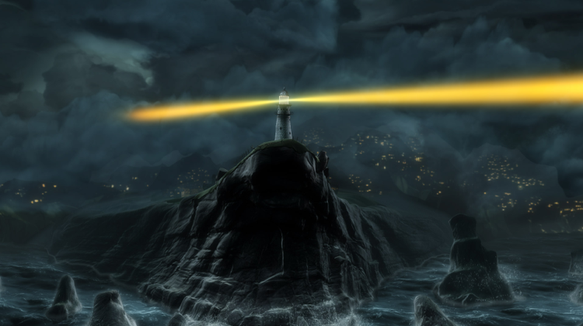**Resource 2: Miss Bourne’s story opener**

**The Lighthouse**

As night fell and the storm clouds gathered, the cliff-top village was enveloped by darkness. In the shadows below, where the land meets the sea, powerful waves battered and pounded the jagged beach boulders. The menacing water swished and churned, dragging anything in its path towards the deadly rocks.

The reassuring beams from the lighthouse cut through the blackness of the night like a sword, an essential warning to passing ships: beware of the rocks.

With his duties done, the Lighthouse Keeper settled down to his paperwork, grumpily slamming the window to shut out the chill of the night and the chatter of the villagers.

Moments later, he was startled by a crash as the light went out. The light bulb!

Hastily grabbing a lantern to guide him through the darkness, the Lighthouse Keeper darted up the spiral staircase as quickly as his tired legs would allow. Through the howling of the wind, he could just make out the sound of a ship approaching. Panic rose in his chest. He had no time to waste.

When he reached the top...

You may borrow as little or as much of my opener as you like, to start off your own version of the story.

**Resource 3: Word mat for creating atmosphere**

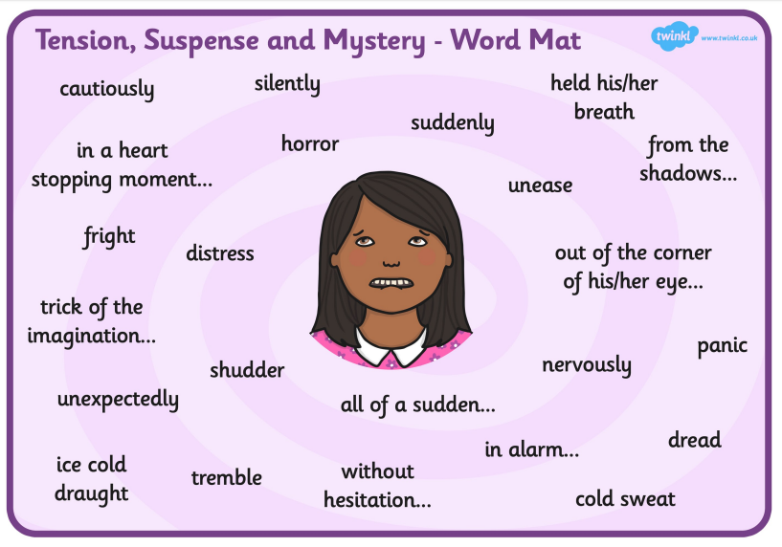

**Resource 4: The Footballers in the cave (part 1)**

A TRUE STORY

On 23rd June 2018, a boys’ junior football team cycled to the edge of their home town in northern Thailand. Their coach had organised an exciting trip: the footballers, who were aged eleven to sixteen, would be exploring the Tham Luang cave. Known for its long, winding tunnels and hidden passages, the 10km cave seemed the perfect place for an adventure.

At 7pm, when the boys did not return home, their parents became concerned. The football team’s manager hurried to the cave, discovering the boys’ bikes outside. He quickly realised what had happened: the cave entrance was flooding quickly with rain water and the boys were trapped inside.

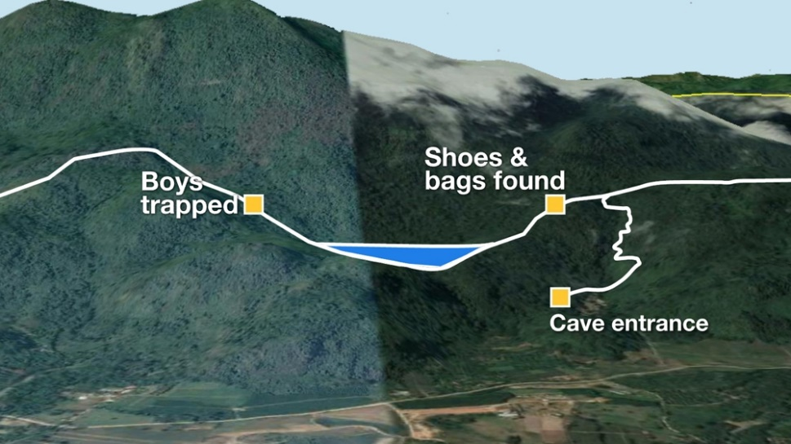Nobody knew if they were dead or alive but there was hope: some parts of the cave were not flooded and the boys might have had time to save themselves by walking further inside the cave to find an air pocket.

Cave rescue divers from around the world worked day and night but their progress was slow.

Parts of the cave were less than 30cm wide, making it impossible for divers to pass through with their oxygen containers on their backs. The men would have to stop and remove these, push them through the holes then put them on again on the other side. This used precious time.

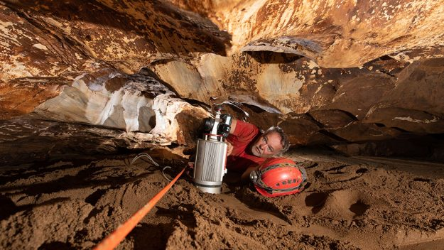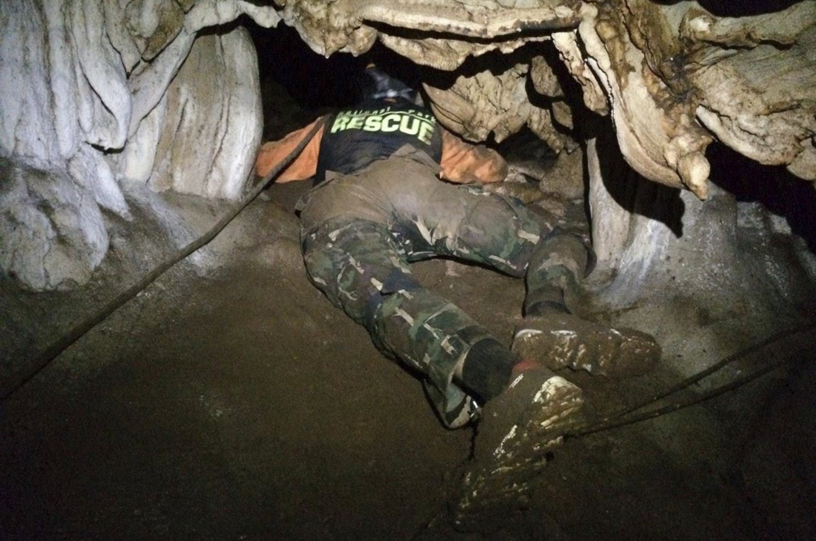Oxygen containers could only last for a short time before they ran out; this forced the divers to return to the cave entrance after a short time. A team of divers placed fresh oxygen containers along the route so that the rescuers could top up their oxygen inside the cave and travel further with each dive.

Furthermore, the water was muddy and poor visibility inside the cave made their task more challenging, even with underwater torches. The rescue team marked out the divers’ route with a long rope which they could cling on to in order to find their way out of the cave again.

Meanwhile, rain continued to fall heavily. Long pipes were used to pump as much rain water from the cave as possible but it quickly filled up again.

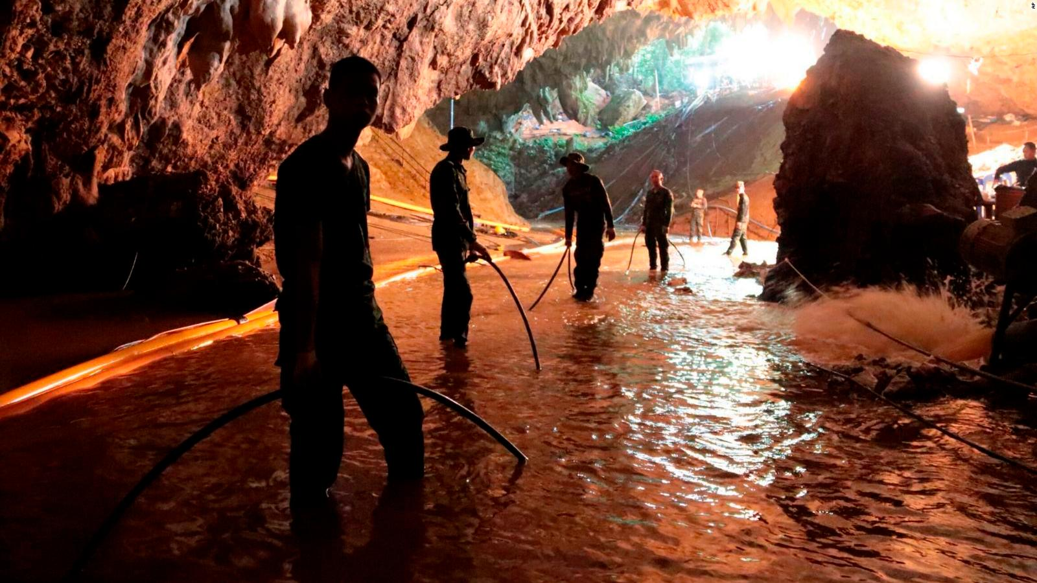

By the tenth day, the boys’ families were beginning to lose hope.

Late that night, British diving experts Richard and John decided to venture just a few metres further before turning back for the night. In the next air pocket they made the discovery everyone had been hoping for. The boys and their coach were hungry, dehydrated and exhausted but they were all alive!

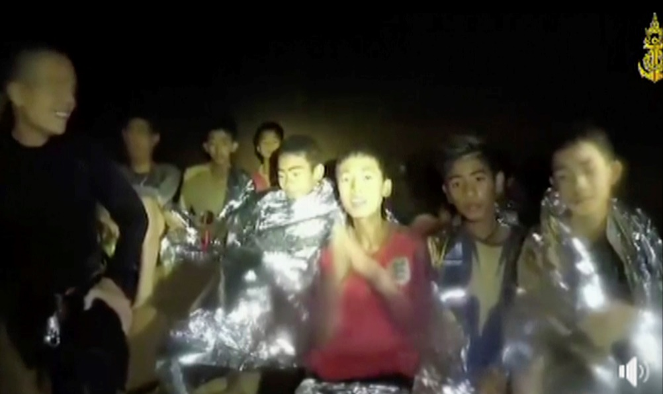

The divers retuned to the cave entrance to share the good news and fetch emergency food, water and medical supplies for the trapped boys. Now, they faced their greatest challenge: to find a way to bring the boys out safely.

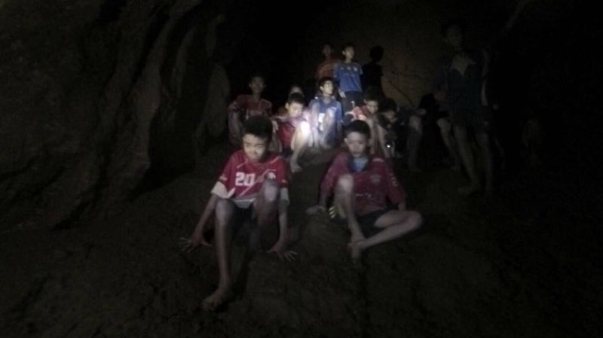

**You might also like to look at the Newsround article and video clips here:** [**https://www.bbc.co.uk/newsround/44696735**](https://www.bbc.co.uk/newsround/44696735)

**Reading response task:**

Find four difficulties faced by the rescue party. How were they overcome?

e.g.

1) Problem: Some parts of the cave were very narrow so the divers couldn’t fit through with their oxygen tanks on their backs.

Solution: Divers took off their oxygen tanks, pushed them through the narrow spaces then put them back on when they got to the other side.

**Resource 5: The Footballers in the cave (part 2)**

The boys were approximately 2.5 miles from the cave entrance and parts of their escape route were completely blocked by water. While waiting for rescue, they had tried to help themselves by using stones to dig an exit tunnel but it was no use; they were 800 feet below a mountain.

100 divers, 900 police officers and 2,000 soldiers from around the world took part in the complicated rescue, which lasted several days: it took three hours per person. Local volunteers prepared food and drinks to keep up their energy and nutrition. The divers practised their rescue plan in a swimming pool before returning to the cave.

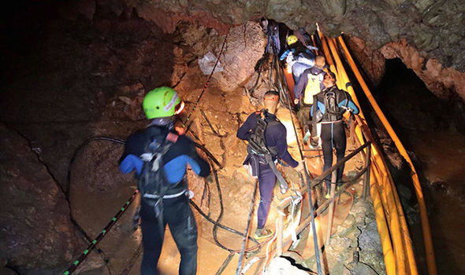

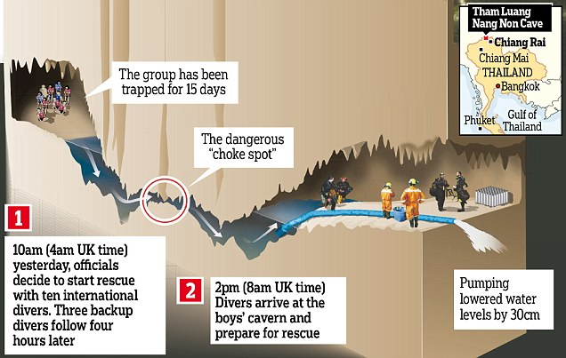

Firstly, each boy was dressed in a wetsuit, a lifejacket, a facemask and a harness. An oxygen tank was attached to his chest. An Australian doctor, who agreed to dive into the cave with the help of diving experts, gave the boys medicine to make them sleep through the rescue so that they would not panic.

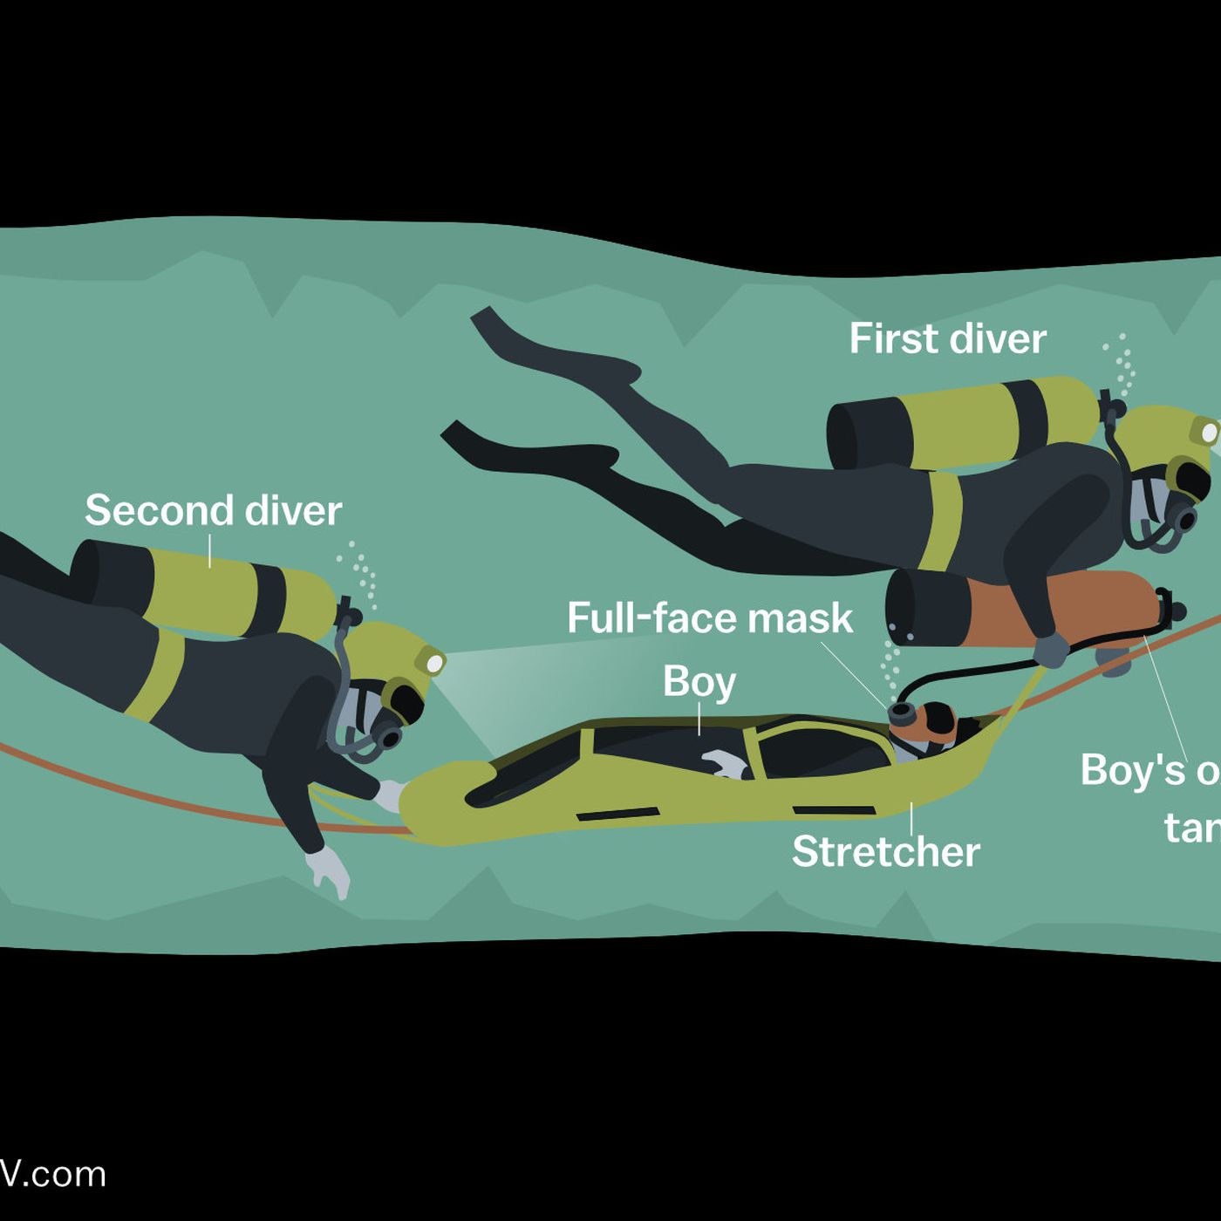

The boy being rescued was attached to a diver, who swam through the cave, following the guide rope. Divers waiting along the route changed their oxygen tanks regularly and gave the boys more medicine to keep them asleep. More divers waited along the cave to check on the boys’ health.

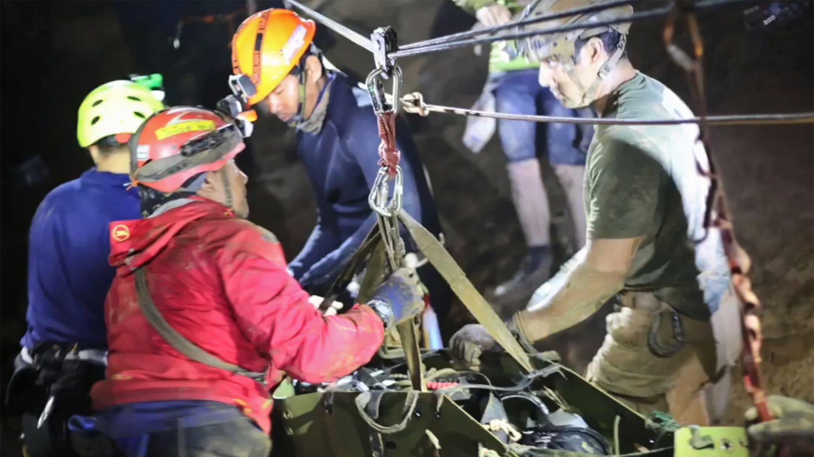

In the dry sections of the cave, the boys were put on to a stretcher and carried. In dangerous and slippery sections, climbing experts had set up ropes and zip wires. The boys were attached to these to keep them moving along the cave as quickly as possible. Meanwhile, cleaners worked to clear away as much of the mud, water and rocks as possible.

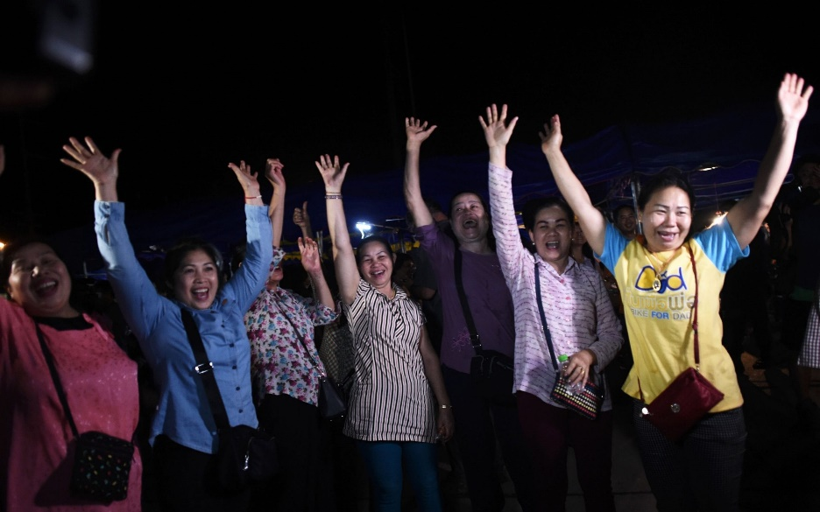

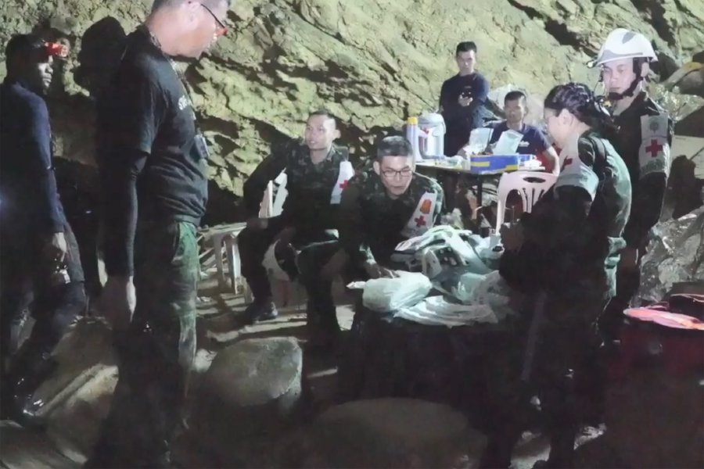By 10th July – more than two weeks after they entered the cave – all twelve boys and their coach were successfully brought out of the entrance. Delighted families cheered and ambulances waited to rush the survivors to hospital.

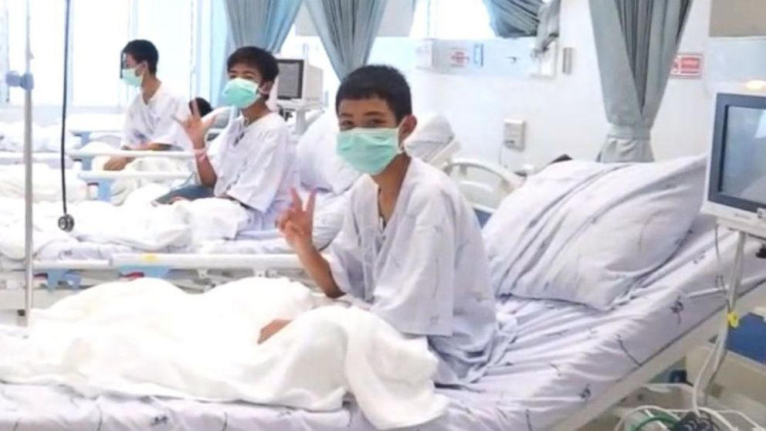For several days, the boys were quarantined in case they had caught any infectious diseases. They wore sunglasses to help their eyes to adjust to sunlight. At first, they were allowed only simple foods and water until their stomachs adjusted to digesting food again.

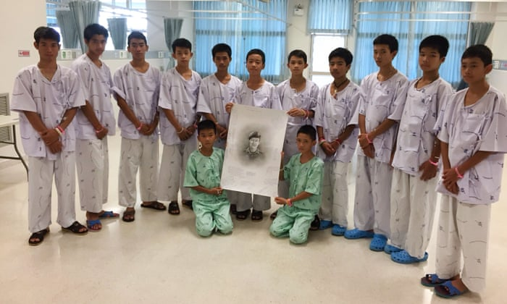Within a few weeks, the footballers had made a full recovery. They were able to return to their homes and appeared on national television, thanking the many rescuers who had worked as a team to save their lives.

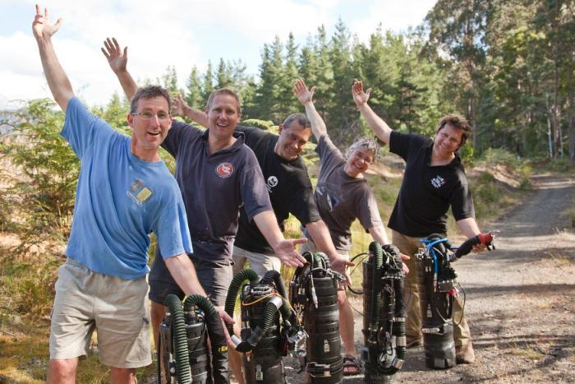Huge crowds gathered at the cave to applaud the rescue teams and celebrate their resilience and perseverance.

Answer in full sentences:

1. The footballers had attempted to save themselves before help came. What had they tried?

e.g. Before help came, the footballers had attempted to…

1. How long did it take to rescue each person?
2. What protective equipment were the footballers dressed in to be rescued?
3. What nationality was the doctor who gave the footballers medicine?
4. Why did the doctor give each footballer medicine before the rescue?
5. Why did the boys initially wear sunglasses in the hospital?
6. Which two of our learning leader attributes did the rescuers show? (final paragraph)

**Resource 6: The Woman Who Froze to Death and Lived**

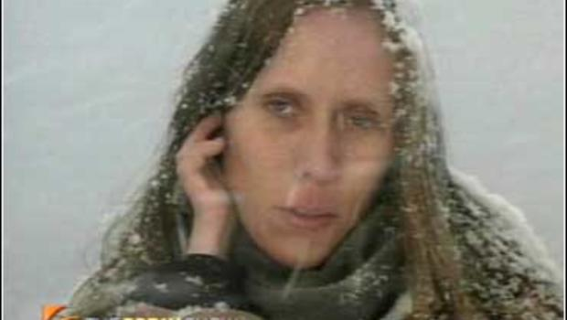Anna Bagenholm fell into danger while she was skiing on one of her favourite mountains in the beautiful Norwegian countryside. The twenty-nine-year-old doctor was enjoying herself with two friends, who were also doctors.

Suddenly, as she tried to steer a path around a waterfall, she fell head first into a fast-moving stream. The water wasn’t deep but she was trapped between thick ice and rocks, struggling to breathe.

Her friends tried to pull her free but were unable to move her. One of them battled to keep a grip on Bagenholm’s wet skis, desperate to prevent her being pulled further under, and the second called for help on her mobile. Anna was being pummelled by ice-cold water tumbling down the mountainside.

Incredibly, Bagenholm found a pocket of air beneath the ice. This stopped her from drowning, although it couldn’t protect her from the cold. As the minutes wore on and no help came, she gradually lost became unconscious. After forty minutes, her friends were left clinging to Anna’s body, believing that she must be dead.

It took a while longer for the first of two rescue teams to reach the narrow gully. A rope was attached to Bagenholm’s legs to hold her, then the rescuers began using tools to break through the eight-inch-thick ice. Using a large shovel, they were able to pull her free.

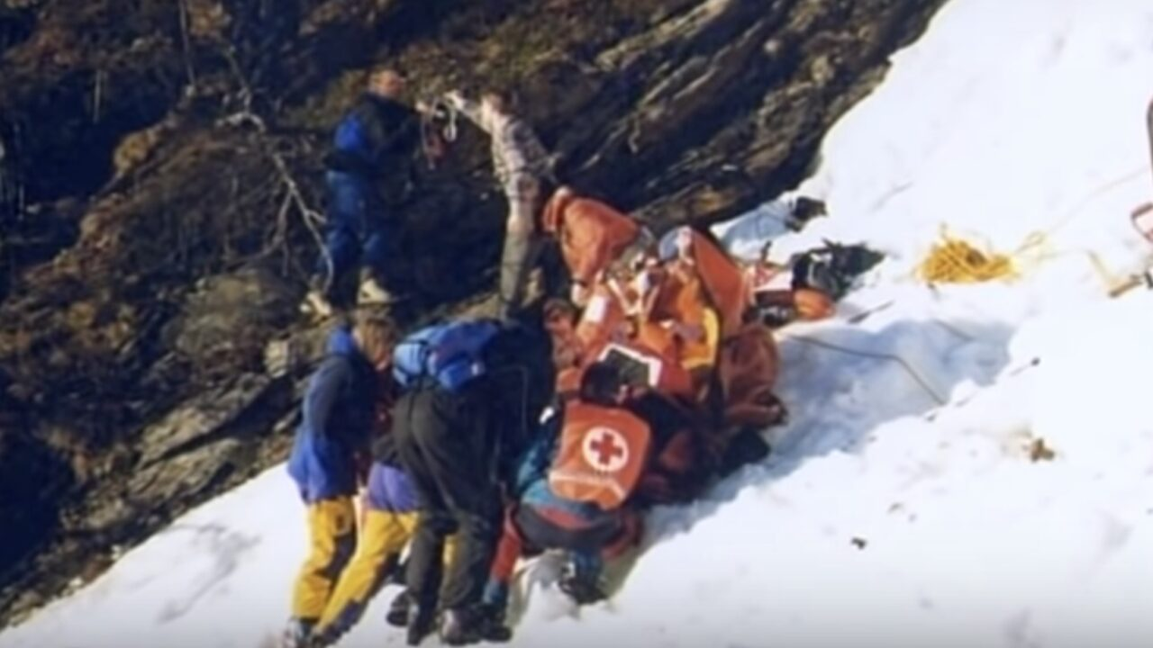

Bagenholm had been trapped under water for longer than an hour. She was flown to hospital by air ambulance with all the symptoms of hypothermia. When the body temperature drops below 30c most people lose consciousness, and at 25c the heart usually stops working.

Bagenholm’s temperature had dropped to an astonishing 13.7c. When she arrived at the hospital, the staff knew that this was no ordinary situation.

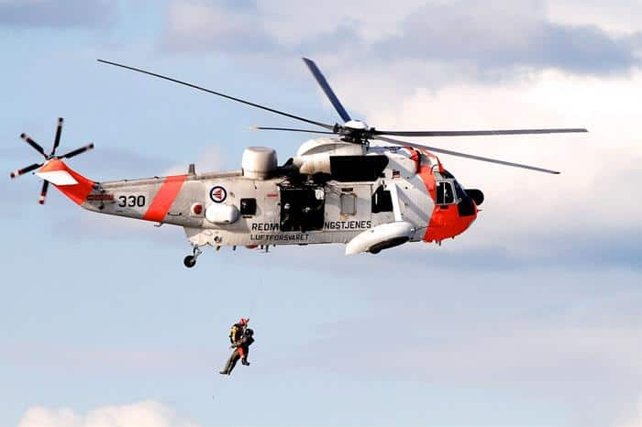

Bagenholm was hooked up to a sophisticated heart-lung machine and a video probe was inserted into her chest to monitor her heart. Amazingly, her blood was carefully drained from the veins, fed through the machine and then gently pumped back into her arteries. This clever system allowed her blood to be warmed up and returned to her body. 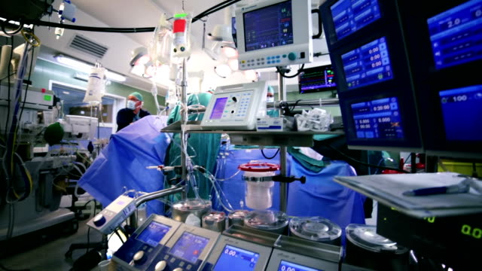

Over a period of nine hours, Bagenholm’s pulse slowly strengthened as nearly a hundred medical personnel worked to complete the process of bringing her body back up to temperature.

Miraculously, Bagenholm woke up. For two months she remained in the hospital’s intensive care unit. Hooked up to a variety of medical equipment, she needed round-the-clock specialist treatment.

Retrieve the facts from the text to answer the questions in full sentences:

1. What was Bagenholm’s profession?

*Bagenholm’s profession was…*

1. How did Bagenholm manage to breathe, even though her head was underwater?
2. What equipment was used to free Bagenholm from the ice?
3. Bagenholm was hooked up to a heart-lung machine. What did it do?
4. How many people worked to keep Bagenholm alive in the hospital?
5. For how long did Bagenholm stay in intensive care?
6. Why did Bagenholm survive such low body temperatures?

No one else has ever recovered from a body temperature as low as 13.7c. However, Bagenholm’s medical team think they might know the reason for her extraordinarily good fortune: Bagenholm’s body froze so quickly, there had not been time for it to stop working.

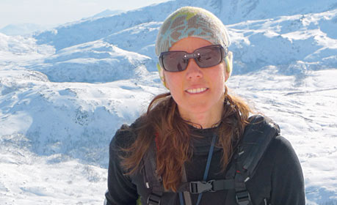With a new lease of life, Bagenholm began working with the very doctors and nurses who saved her life, and alongside one of her friends from that fateful day, who is now a member of the Tromso University helicopter emergency team. Happily, both have returned to the slopes many times and continue to enjoy skilling in some of northern Europe’s most breath-taking and unspoiled landscapes.