|  |  |  |  |  |  |
| --- | --- | --- | --- | --- | --- |
| Image result for larks classYear 5 - Larks Class  Home Learning activities to choose from  Week Commencing 4th May info@scsj.rbkc.sch.uk | | | | | |
|  | Monday | Tuesday | Wednesday | Thursday | Friday |
| Our Opening Prayer | Dear Lord  Thank you for this brand new day.  Help us to embrace opportunities for new learning.  Show us how to listen and love.  Support us and our friends.  Guide us to excellence in all that we do today.  Amen | | | | |
| Daily Events |  |  |  | The World’s Biggest Assembly  **10am**  The theme is looking after yourself. Sing along with the cast of the Lion King!  If you missed it, you can catch up here:  <https://www.youtube.com/watch?v=IR4hIxUZXmU> | **TODAY IS BANK HOLIDAY FRIDAY! ☺**  Have a well-deserved rest.  *The activities below were already planned so they have been left here in case you want to pick anything from them.* |
| P.E. | The Body Coach workout (led by Joe Wicks’ wife, Rosie, until Joe recovers from a hand injury)  **9am - 9:30am Monday - Friday**  <https://www.youtube.com/results?search_query=joe+wicks+body+coach> | | | | |
| Reading Response | Captain Tom Moore  (resource 1 below) | The Wright Brothers  (resource 3 below) | Accidental inventions  (resource 6 below) | The Tesla Story  (resource 7 below) | The Internet and the World Wide Web (resource 8 below) |
| Maths Fluency | Guardians of Mathematica:  <https://www.bbc.co.uk/bitesize/topics/zd2f7nb/articles/zn2y7nb> | Shape sorting:  <https://mathsframe.co.uk/en/resources/resource/83/sort-shapes-venn> | Division:  <https://mathszone.co.uk/number-facts-x%c3%b7/fruit-splat-sheppard-software-2/> | Telling the Time:  <https://mathsframe.co.uk/en/resources/resource/116/telling-the-time> | Alien Angles:  <https://mathsframe.co.uk/en/resources/resource/470/Angle-Alien-Attack> |
| Maths Revision | Click on the link and follow the instructions:  <https://www.youtube.com/watch?v=lWpw3iVq820> | Click on the link and follow the instructions:  <https://www.youtube.com/watch?v=ppSjFwGf3BM> | Click on the link and follow the instructions:  <https://www.youtube.com/watch?v=GuGc7VVwc-M> | Click on the link and follow the instructions:  <https://www.youtube.com/watch?v=0xh8JmMVLoc> | Click on the link and follow the instructions:  <https://www.youtube.com/watch?v=nOK2KrGLbos> |
| Times Tables  Practice | Teach someone at home to play Stickyfingers like we do at school and see if you can beat them! | Log in to your Times Tables Rockstars account. Email Miss Bourne if you need your password (address above). | Shuffle a deck of playing cards and take out the jacks and the jokers. Queen= 11 and King=12.  Split the deck into two piles and turn over the top card on each. Multiply the numbers on the cards together. You could compete with somebody else: the first person to say the answer wins a point. | Practise your times tables here:  <https://www.timestables.co.uk/multiplication-tables-check/> | Try the fast maths challenge like we do in school. You will need to draw out an 11x11 grid (or you can print the sheet at the end of this document, if you have a printer). Don’t forget your stopwatch. Can you beat our class record of 2 mins 22 seconds?  Make sure you use the numbers 1 - 12 at least once. |
| Spellings | Contractions using not:  <https://uk.ixl.com/ela/year-5/contractions-with-not> | Spellings to revise today:  attached  determined  physical  sufficient  persuade  Try writing them backwards and forwards to help you to remember the spellings. | You will need to complete Tuesday’s reading response activity before doing this.  Click on the link below. Use the ‘word bank’ option underneath the grid to help you. <https://www.learninggamesforkids.com/social_studies_games/inventor-games/wright-brothers-jigsaw.html> | Ask and adult to test you on the five spellings you learned on Tuesday and five more that you learned last week. Can you remember them? | Here’s something to help you remember what a homophone is: <https://www.youtube.com/watch?v=GJUqJyX5NSA>  Draw a simple picture to show the meaning of each of these words:  flour  flower  steel  steal  herd  heard  past  passed |
| Punctuation and Grammar | Click on the link then select ‘punctuation’:  <https://www.bbc.co.uk/games/embed/crystal-explorers?exitGameUrl=http%3A%2F%2Fbbc.com%2Fbitesize%2Farticles%2Fzbm8scw> | Future tense: <https://uk.ixl.com/ela/year-5/change-the-sentence-to-future-tense> | Using ellipses:  <https://www.bbc.co.uk/bitesize/topics/zvwwxnb/articles/zpgjy4j> | Comparing meanings:  <https://uk.ixl.com/ela/year-5/describe-the-difference-between-related-words> | Using brackets:  <https://www.bbc.co.uk/bitesize/topics/zvwwxnb/articles/zg6xb82> |
| Writing | Watch the clip below of Wallace and Gromit’s ‘Snoozatron’.  <https://www.youtube.com/watch?v=vGxRUglFFME>  Draw a comic strip or a flowchart to show how it works.  Miss Bourne has started off an exemplar flowchart (resource 2 below). | <https://www.youtube.com/watch?v=vGxRUglFFME>  Create an advertisement for the Snoozatron. Miss Bourne has written a starter.  (resource 4 below) | Watch the **first minute** of this clip of Chitty Chitty Bang Bang flying.  <https://www.youtube.com/watch?v=Wuer3mLqIxc>  Imagine that you have a flying car of your own. Where would you go? What would you see?  Write a postcard home to a friend, describing your adventure. | Choose an inventor and create your own fact file. The list used in Tuesday’s themed task may give you some ideas. | Listen to the audio story ‘Rosie Revere, engineer’ (Wednesday’s fiction choice read by Miss B.)  Write a letter to Rosie, encouraging her to persevere. |
| Themed Learning and Science | When something seems a bit useless, people often say it’s ‘like a chocolate teapot’ because a chocolate teapot would melt as soon as the water was heated in it!  Use your imagination to make a list of your own ‘useless invention’ ideas. | What is an invention?  <https://www.bbc.co.uk/teach/class-clips-video/what-is-an-invention/zrf92sg>  Inventor search: Find out one invention that was created by each of the inventors on the list (resource 5 below). | For inspiration, you might like to watch this compilation of Wallace and Gromit’s designs first: <https://www.youtube.com/watch?v=_6g8WGpMstI>  Design an invention of your own. Draw a detailed poster or make a labelled model of your design, explaining clearly what it does and how it works.  The only limit is your imagination! If you are stuck for a starting point, choose something from the list below:   * something to help a pet * something to play with * something to help an elderly person * something to help the environment | | Do you remember Scratch? Use the free features to create something you’re proud of to entertain the people in your house.  <https://scratch.mit.edu/projects/editor/?tutorial=getStarted> |
| Sing Education | Have a go at some music lessons:  <https://www.youtube.com/channel/UCr-UQ93J2M2daetW90YKoww/> | | | | |
| The Week Junior | The Week Junior Magazine for Schools | Welcome  Click on the link to catch up with the latest news:  <https://en.calameo.com/read/006188095b7f16aa02421> | | | | |
| Sharing a book with Miss Bourne | **Fiction choice:**  ***The Character Strikes back*** *- *For those who enjoy scary bits!\** The football crime writer Tom Palmer imagines what might happen if one of his baddie characters came to find him…  **Non-fiction choice:**  ***Amelia Earhart*** – The adventurer who loved to fly | **Fiction Choice:**  ***The Alchemist’s Machine*** – A poor, young girl discovers a machine with the power to grant her wishes. Should she use her wish to get money?  **Non-fiction choice:**  ***Making Wallace and Gromit*** – Creating the characters and filming the animation | **Fiction Choice:**  ***Rosie Revere, Engineer*** – A narrative poem about an aspiring young engineer who discovers that the only failure is giving up  **Non-fiction choice:**  ***Malala*** – The incredible survival story of the girl who fought for the rights of all children to get an education | **Fiction Choice: *The Naughty Snow Angel*** - What would you do with a rebellious snow angel who keeps making snowflakes with all kinds of strange features?  **Non-fiction choice: *P. T. Barnum*** – The entertainer you may know of as ‘The Greatest Showman’ | **Fiction Choice:**  ***King Arthur* –** The Legend of the King who pulled a sword from a stone  **Non-fiction choice:**  ***V. E. Day*** – Today’s bank holiday commemorates 75 years since the end of World War 2 |
| Daily reading | Read with an adult for at least 20 minutes EVERY DAY.  When you need something new to read, you could try an e-book:  <https://worldbook.kitaboo.com/reader/worldbook/index.html#!/>  [https://www.oxfordowl.co.uk/for-home/find-a-book/library-page/?view=image&query=&type=book&age_group=Age+9-11&level=&level_select=&book_type=&series=#](https://www.oxfordowl.co.uk/for-home/find-a-book/library-page/?view=image&query=&type=book&age_group=Age+9-11&level=&level_select=&book_type=&series=) | | | | |
| Suggested Brain Breaks and Relaxation | Choose a Peace Out  <https://www.youtube.com/results?search_query=peace+out> | Listen to a MindUp Brain Break (the one we use in school.) <https://mindup.org.uk/mindup-activities/> | Melting with GoNoodle  <https://family.gonoodle.com/activities/melting> | Sketch the view from your bedroom window, adding every detail you can see. | Listen to a MindUp Brain Break (the one we use in school.) <https://mindup.org.uk/mindup-activities/> |
| Suggested  Physical Activities | Challenge 1: The Step-Up challenge  <https://tlg-pe.co.uk/tlgskillsathome/> | Challenge 2: The Squat challenge  <https://tlg-pe.co.uk/tlgskillsathome/> | Challenge 3: The Jump Yourself challenge  <https://tlg-pe.co.uk/tlgskillsathome/> | Challenge 4: The Plank-King challenge  <https://tlg-pe.co.uk/tlgskillsathome/> | Challenge 5: The Tennis Step-Over challenge  <https://tlg-pe.co.uk/tlgskillsathome/> |
| A song a day to sing along with | My Lighthouse  <https://www.youtube.com/watch?v=lFBZJGSgyVQ> | Be Bold, Be Strong  <https://www.youtube.com/watch?v=OWqa4Rpq4PE> | Give Me Oil In My Lamp  <https://www.youtube.com/watch?v=21RHemxzb8U> | Our God Is A Great Big God  <https://www.youtube.com/watch?v=-424MpB_pd0> | This Is Amazing Grace  <https://www.youtube.com/watch?v=cgsbaBIaoVc> |
| Our Closing Prayer and Sung Blessing | Lord of the loving heart, may ours be loving too;  Lord of the gentle hands, may ours be gentle too;  Lord of the willing feet, may ours be willing too;  May we grow more like you in all we say and do.  Amen  May the Lord bless us and keep us;  May his power be ever beside us;  May the Lord look with favour upon us  and give us his peace. | | | | |

**Resource 1: Captain Tom Moore**

Behind every news headline, there are always positive stories of hope and love to be found. It is in times of difficulty that the courage and kindness of ordinary people have a chance to shine through.

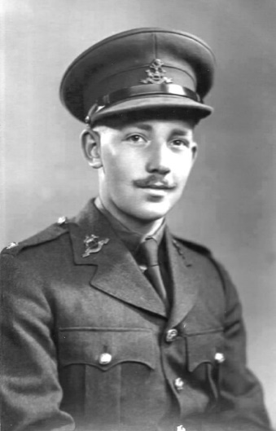If you have been following the news recently, you would probably recognise the face of Captain Tom Moore. He is a former soldier who recently became an unexpected hero for our NHS at the age of 99!

Captain Moore grew up in the North of England and enrolled in the British Army at the age of 21. By then, World War 2 was underway and Captain Moore was sent to India where he became an army tank driver. He won four war medals for his service and bravery and was promoted to ‘Captain’ in the final year of the war. Captain Moore returned to Britain and lived a very ordinary life with his wife, daughters and grandchildren.

Two years ago, Captain Moore needed operations on his hips and knees and now uses a walking frame to help him to walk. He was very grateful to the NHS staff for the care he received.

When lockdown began, Captain Moore wanted to do something to help the NHS. He set himself a challenge: to walk 100 laps of his garden in 10 days to raise £1,000 to buy new hospital equipment. As more and more people heard about his plan, money began to pour in.

He told the BBC news: “When we started off with this exercise we didn't anticipate we'd get anything near this sort of money. It's really amazing. All of them, from top to bottom, in the National Health Service, they deserve everything that we can possibly put in their place.”

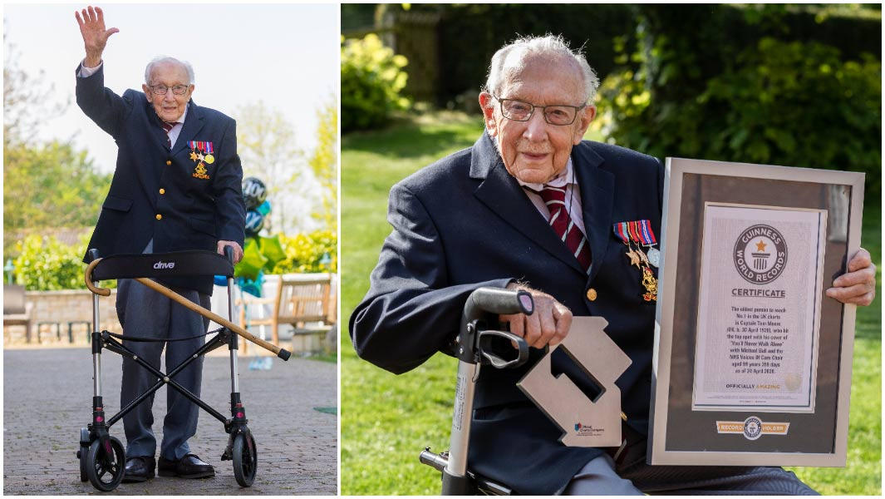By the time he completed 100 laps on 16th April, Captain Moore’s face was recognisable around the country and he had raised more than £20 million! Soldiers from his former army regiment saluted him as he completed the 100th lap.

Captain Moore was delighted with the support he received and vowed to keep walking ‘for as long as people keep giving’.

By his 100th birthday on 30th April, he had raised £30 million. Army planes were flown over his home to salute him. 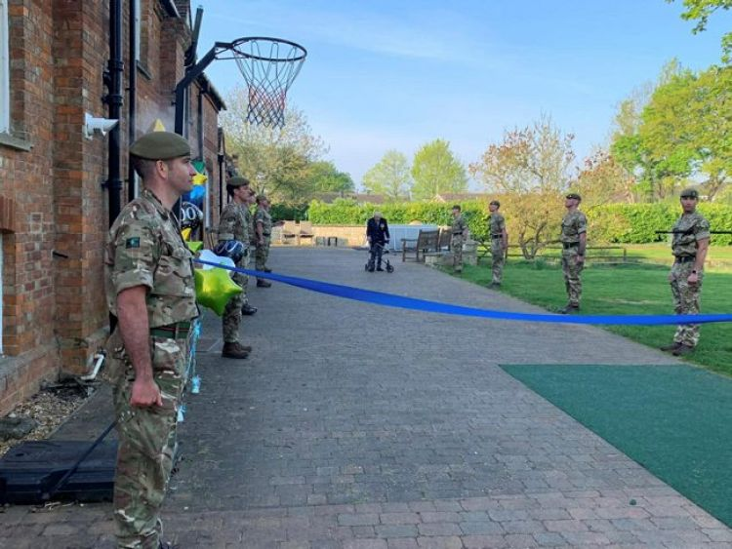He received so many birthday cards that 20 volunteers were needed to sort them. When a singer released a song with some of Captain Tom’s words included, Captain Moore set a record by becoming the oldest person ever to feature on a number 1 single!

You may thinking that you could have run around Captain Moore’s garden in a lot less time. You are probably correct. But for 100 year old legs, every lap can feel like a marathon. The speed and distance aren’t important: Captain Moore has earned respect because he has pushed himself to his personal limits and given of his best to help others.

Today (4th May), his fundraising total stands at £32,796,450 and the money is being spent on caring for NHS staff and their patients.

It just goes to show that even our NHS heroes need heroes, too. Captain Moore has reminded us to look after the people who look after us.

**Monday’s reading response task:**

Remember to give your answers in complete sentences.

1. Where did Captain Moore work with the British Army during World War 2?

*During World War 2, Captain Moore…*

1. Why did Captain Moore want to help the NHS?
2. What was done to celebrate Captain Moore’s birthday?
3. What did Captain Moore become the oldest person in the country to achieve?
4. What is the money being used for?
5. What do you admire most about Captain Moore?

**Resource 2: The Snoozatron**

Whenever you have trouble sleeping, simply pull the red lever located next to your bed.

Electronic arms will appear at each side of your bed to plump up your mattress to make it more comfortable.

An alarm will sound in your pet’s bedroom, waking him up.

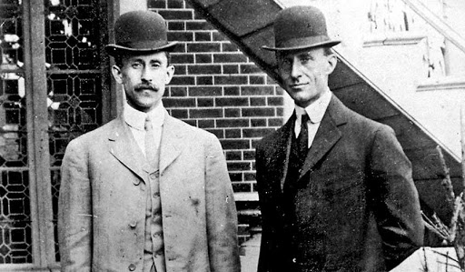**Resource 3: The Wright Brothers**

Wilbur and Orville Wright are famous for designing, testing and flying the first powered, controlled aeroplane. Their clever design has since been developed into the aeroplanes we recognise today.

The brothers grew up in Ohio, USA, in a house that was full of books. Their parents believed in education and encouraged them to learn and ask questions about anything that they found interesting. They went to high school but never to university; instead, they worked for a newspaper printing shop before opening a shop where they built and repaired bicycles.

The Wrights were fascinated by gliders (aeroplanes that had no motor) and began experimenting with building aeroplanes as a hobby. They wanted to fix the biggest problem with gliders: they could not be controlled. Therefore, they added a rudder to control the movement of the plane and wings that could be twisted and moved up and down.

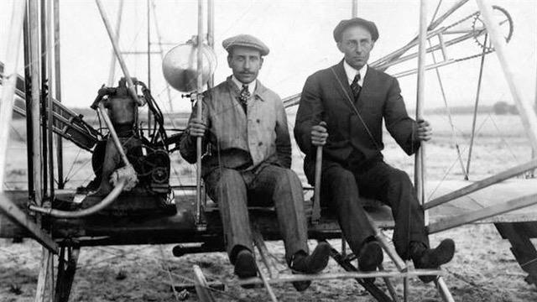For more than two years, they built and tested their model planes, experimenting with different wing shapes. They studied very closely how birds fly and aimed to use what they had learned to adapt their aeroplane wing designs.

17th December 1903 was a joyous day for the Wright brothers: they successfully flew the first powered aeroplane with an engine and propellers. They named the plane the Kitty Hawk. Their first flight was just 12 seconds, but they knew that they had proved to themselves that it could be done.

Initially, they kept their success a secret while they continued to improve on their design. They practised over a sandy beach to soften the landings!

In 1908, the secret was out. Many people could did not believe that flight was possible and the Wright brothers began doing demonstrations to showcase what they had achieved. It was now clear that the Wright brothers were on the path to developing aircraft that could be used for public transport.

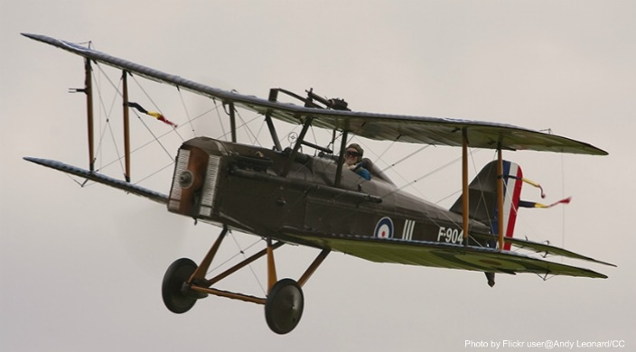Soon after, President of the USA began paying the Wright Company to make aeroplanes for the army to use. The Wright brothers made money by selling their designs to big companies that were keen to make their aeroplanes. It was not long before people were able to earn licences to fly small aircraft.

Wilbur Wright died in 1912. Two years later, a Russian mayor bought the first ever aeroplane ticket. The 23 minute flight was a huge success.

Orville carried on working in the aeroplane industry for another 36 years, advising companies on how to improve the planes. The public were so excited about the possibility of flying that more and more companies wanted to make and fly aircraft for transporting people and cargo.

Orville died in 1948, three years after witnessing the role that aircraft played in World War 2.

In the 72 years since, engineers have continued to develop the brothers’ early ideas to create the panes which we fly in today. Every year, more than 3.1 billion journeys are made by aeroplane. More than 100,000 aeroplane flights take off each day.

**Tuesday’s reading response task:**

Remember to answer the questions in full sentences, whether you are saying or writing them.

1. How did the Wright brothers’ parents encourage them to think and learn?

The Wright brothers’ parents encouraged them to think and learn by…

1. Which two jobs did the brothers have before inventing aeroplanes?
2. What was the name of the first plane that the brothers flew?
3. Many people did not believe that the brothers had created a flying machine. How did they prove to the world what they could do?
4. How long was the first ever flight with a passenger on the plane?

**Resource 4: Advertisement for the Snoozatron**

You may use as little or as much of Miss Bourne’s starter as you like, to begin your own advertisement for the Snoozatron.

Make sure you include the following:

1. Questions to get your audience thinking (see first paragraph)
2. Persuasive language
3. Information to explain how the different features of the machine (see yesterday’s flowchart)
4. The advantages of the Snoozatron
5. The cost and how to get your own machine

Here are some sentence openers which may be useful:

*The best feature is…*

*Simply pull the leaver to activate…*

*You’ll be astounded by…*

*Amazingly, the Snoozatron can also…*

*You’ll wonder how you ever lived without…*

*Lay back in comfort while…*

*There is nothing better than…*

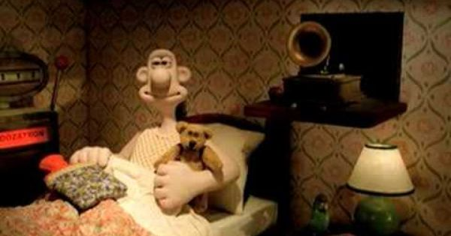

Do you struggle with getting to sleep at night? Do you toss and turn, just wishing you could drop off? Do you wake up feeling exhausted every morning?

Now you need never lose a moment’s sleep again. The Snoozatron is here to help you drift off peacefully every night. This easy-to-use contraption includes features such as…

**Resource 5: Inventor search**

|  |  |
| --- | --- |
| **Inventor** | **Invention** |
| Alexander Graham Bell | Telephone |
| Karl Benz |  |
| Ada Lovelace |  |
| Sam Panopoulos |  |
| Leonardo Da Vinci |  |
| Thomas Edison |  |
| The Lumiere brothers |  |
| Ives McGaffey |  |
| Edgar Hooley |  |
| Margaret E. Knight |  |

**Resource 6: Accidental Inventions**

In most cases, inventions take a long time to develop. Scientists and engineers spend years researching, designing, testing and perfecting their inventions.

Every now and then, while striving to create their new item, an inventor makes something successful that is completely different from what they set out to make. Furthermore, there are even strokes of luck when somebody discovers something completely by accident while they are not trying to invent anything at all! It just goes to show that inspiration is everywhere, if you look for it.

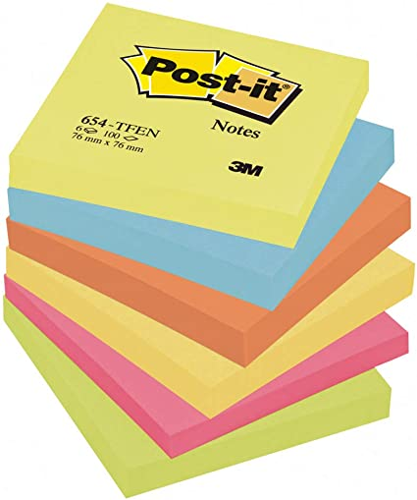These are the stories of some popular household items which were invented accidentally.

**Post-it notes**

Dr. Spencer Silver was working in a laboratory trying to develop a very strong glue. As he tried different combinations of ingredients, he accidentally created a ‘bad’ batch that was not strong at all. However, he noticed that the recipe could be useful: the glue stuck lightly enough that it could be pulled off again without causing any damage. Dr. Silver sang in a choir and used to mark the pages he needed in his song book with tiny scraps of paper. He began using his product to stop the scraps of paper from falling out. The first Post-it note had been made.

**Playdough**

Playdough was originally created to be a cleaning product. It didn’t work very well so, instead of using it to clean, people were giving it to their children to make models with. The owner of the company saw an opportunity to save his failing business. He added bright colours and a nice fragrance to the product and began selling it as a toy instead.

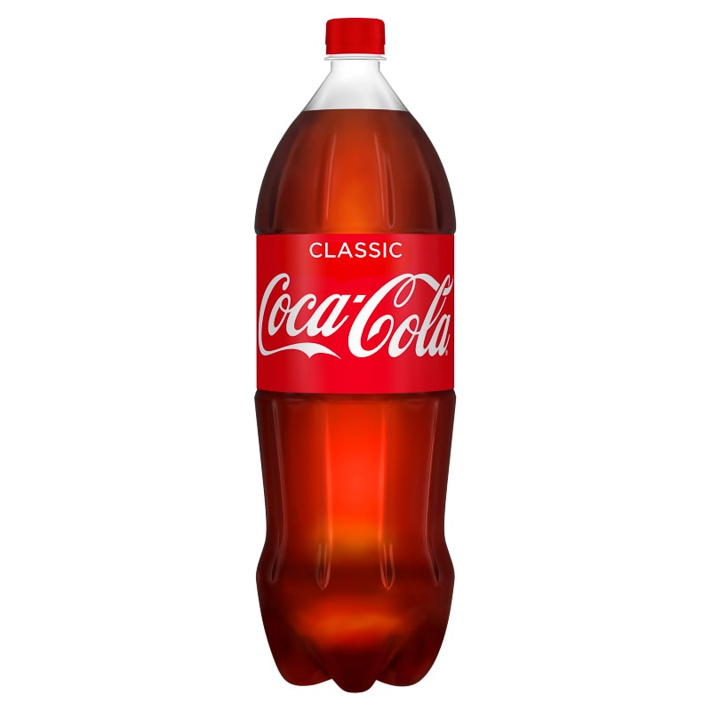**Coca-cola**

In 1886, a pharmacist by the name of Dr. John Pemberton was attempting to make a new medication. He soon found that his customers were enjoying it, not for its healing properties but because of its refreshing taste. Dr. Pemberton’s friend and business partner, Frank Robinson, suggested that he should name it after its two key ingredients: coca leaves and kola nuts. Mr. Robinson also designed the logo which is still used today.

**Superglue**

During World War 2, Dr. Harry Coover was trying to help American soldiers by making parts for weapons. The substance he created was a miserable failure: it kept sticking to everything it touched. Coover and his colleagues noticed how powerful the liquid was and began selling it as superglue.

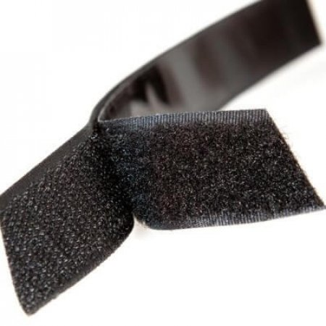**Velcro**

George de Mestral, from Switzerland, was walking his dog when he noticed the way that prickly plants stuck to his dog’s fur. When he got home, he put some of the plant material under a microscope and noticed the tiny hook shapes which caused the plants to hold fast in the dog fur. This gave him an idea and it was only a matter of time until he invented velcro. The two surfaces, one with tiny hooks and the other with tiny loops, hold fast when pressed together. Today, velcro is still used on clothing to replace buttons, laces, zips and poppers.

**Chocolate chip cookies**

Ruth Graves Wakefield was an American hotel owner who often baked for her guests. In 1938, she was baking some cookies when she decided to chop up some Nestle milk chocolate and stir the pieces into the cookie dough. She expected that they would melt into the mixture once it was heated in the oven. The results surprised her: the chocolate stayed in separate chunks dotted through the cookie.

She began selling the cookies in her hotel and soon Nestle bought her recipe in exchange for one penny and a lifetime supply of chocolate! Today, Americans spend more than 18 billion dollars per year on her tasty treat.

**Wednesday’s reading response task:**

Find the invention which was…

1. a failed cleaning product
2. inspired by a dirty dog
3. intended to be a medication
4. sold for one penny
5. invented in Switzerland
6. named after two of its ingredients
7. developed during World War 2
8. invented by Dr. Silver Spencer
9. accidentally created by a hotelier
10. inspired by a plant

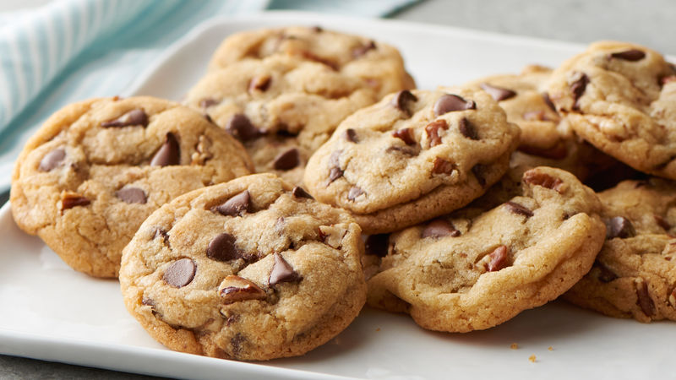

**Resource 7: The Nikola Tesla Story**

This is a longer text and you might like to share the reading with somebody else at home. You could take it in turns to read a sentence or a paragraph each.

**OR**

You can listen to Miss Bourne’s audio recording of the text (it’s in the list on our class page) and follow the words as you listen.

Nikola Tesla was a very smart boy who one day, in 1862, did something not very smart: he decided to try and fly. He climbed on to the roof of his family’s barn and jumped off, holding an open umbrella. Unsurprisingly, he fell to the ground with a thud. Fortunately, he didn’t break any bones but it took him several weeks to recover from his injuries.

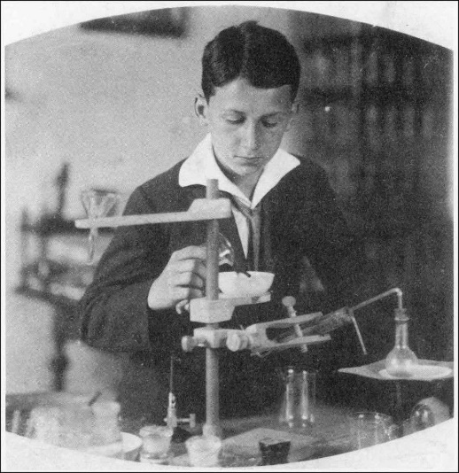Nikola was less than six years old at the time. There was no such thing as an aeroplane. He didn’t know anything about gravity or the forces that allow things to fly. The only thing he knew was that he could picture himself floating through the air with his umbrella. If he could picture something, he believed he could make it work.

Growing up on a farm in Croatia, Nikola had lots of opportunities for experimenting. His childhood inventions included a frog-catcher and a water wheel.

At school, Nikola loved science and he amazed his teachers with his ability to solve maths problems in his head. His mind raced with thousands of questions. In the evenings, he raced home to his father’s library and would stay up late into the night, reading his books by candlelight. Eventually, his father took away the candles so that he would sleep more, but Nikola simply made candles of his own.

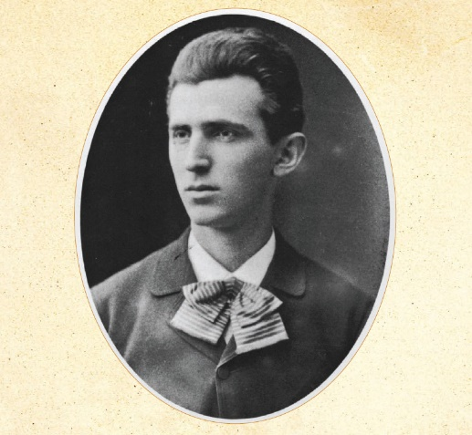When Nikola left school, he went to study engineering at university. He studied late into the night and learned about motors and machines in his spare time.

One day, a machine arrived at the university and Nikola’s teacher showed it to his class. This machine forced electricity to move in one direction. Nikola argued that it would work better if the electricity moved forwards *and* backwards. His idea was called an AC machine but nobody had yet worked out how to make one. “You will accomplish great things,” Nikola’s teacher told him, “but you will never mange *that*.”

Nikola began building complete machines in his mind, imagining them part by part. Try as he might, he just could not make it work. Perhaps his teacher was correct after all. When Nikola’s father died, he gave up university and went to work for a telephone company to earn money to help his mother.

However, his mind still raced with thoughts about how to make an AC machine. If only he could find a way to make it work, people would one day be able to have electrical items in their homes!

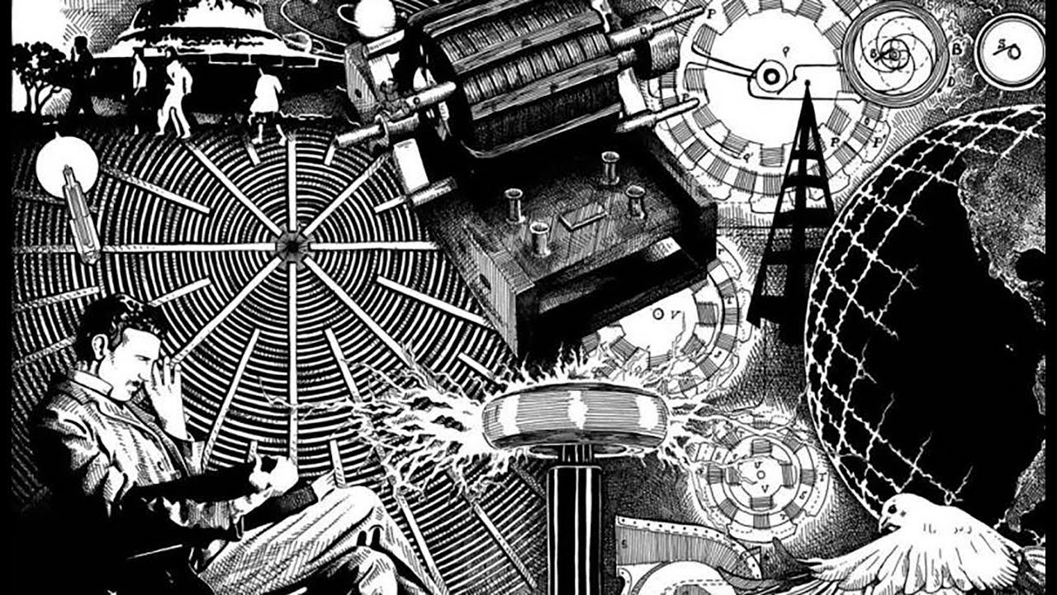

One day, he was walking in the park with a friend when an idea suddenly came to him: he could use magnets to reverse electricity! Excitedly, he picked up a stick and began drawing his ideas in the dirt.

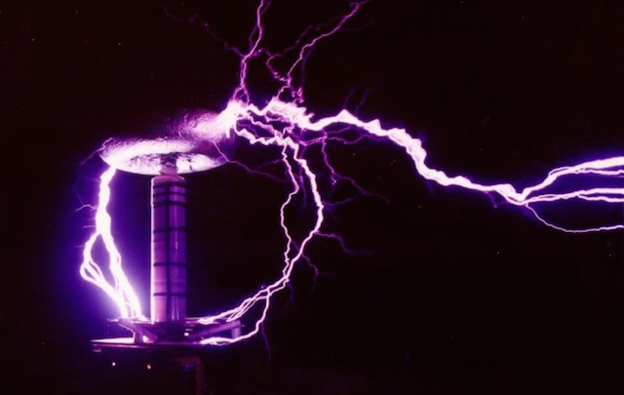Two months later, Nikola finally built the first model of the AC machine and it worked! However, Nikola could not find anyone to invest money in his plan. They just did not understand how important his invention was.

One day, Nikola’s boss was sent to work in New York with Thomas Edison, the inventor of the lightbulb. He took Nikola with him. Edison was very impressed with Nikola’s hard work and determination and gave him increasingly challenging projects. Nikola created generators to provide ships with electricity for the first time.

Despite his success, Nikola was not making enough money to buy food. His family were on the other side of the world and he felt lonely. He wondered if all his hard work had been a waste of time. He took the only job that he could find, digging ditches.

One day, his colleague overheard him talking about his AC machine idea and introduced him to an electrician called Albert Brown. Together, Nikola and Brown founded the Tesla Company.

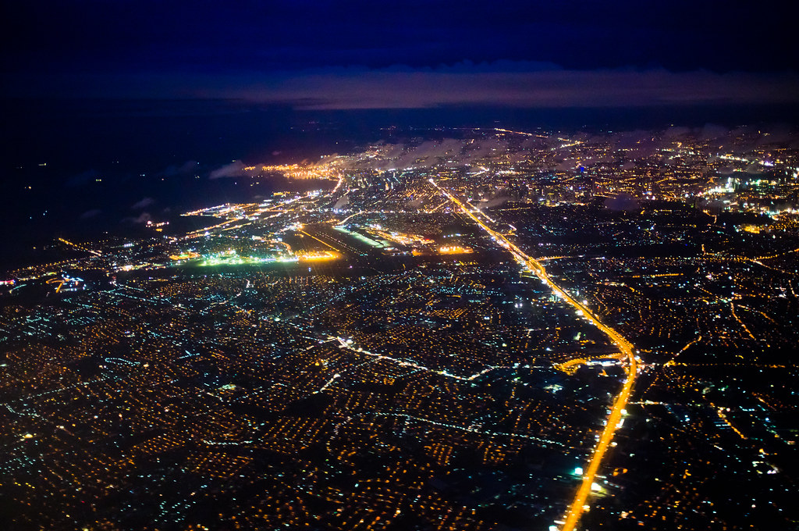

Nikola’s ideas would allow thousands of people to have electricity in their homes and suddenly major engineering companies wanted to invest. He began making large amounts of money selling his ideas. He was able to employ engineers to work for him so that he could return to his first love: inventing. Inspired by looking at the power of waterfalls, Nikola began finding ways that the force of water could be used to generate electricity. Soon, every home on the East Coast of the United States had electricity.

Nikola dedicated the rest of his life to inventing. Nobody believed him when he said that people would one day carry communication devices around in their pockets! Of course, he was correct, but mobile phones were not invented until 50 years after he died. Many modern ideas such as televisions, the internet, satellites and neon signs have been possible because of Tesla’s ideas.

Today, there is a famous company called Tesla which was named after the great engineer. Their mission is to design environmentally friendly cars which run on electricity. They are even experimenting with cars that drive themselves!

**Thursday’s reading response task:**

1. Which inventions did Nikola create while he was still a child?
2. While he was studying engineering at university, what did Nikola do in his spare time?
3. Where was Nikola when he finally thought of a way to make his AC machine work?
4. When Nikola thought his ideas would never work, what job did he do instead?
5. Name three inventions that have been possible because of Nikola’s ideas.
6. A company named their company Tesla after Nikola. What does the Tesla company make?

**Resource 8: Tim Berners Lee, the Internet and the World Wide Web**

*This text is adapted from History Heroes: Tim Berners-Lee by Damian Harvey*

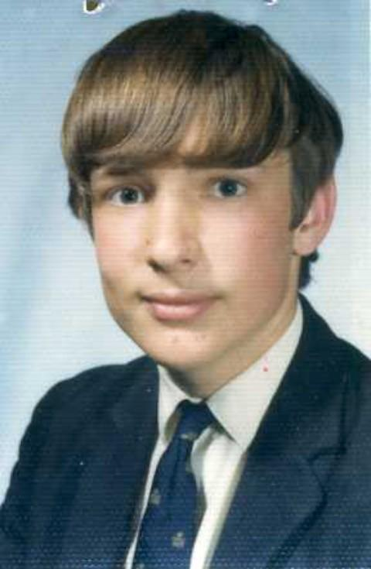When Englishman Tim Berners-Lee was born in 1955, the world was very different from the one we know today. People didn’t have computers or games consoles in their homes and televisions were in black and white with just one channel.

Berners-Lee always loved Maths and Science. Like lots of other young boys, he had a train set in his bedroom and he loved fixing and designing gadgets to make his trains work even better. His parents were computer engineers who had lots of exciting ideas about what computers might be able to do in the future. They loved sharing their ideas with their son.

One day, Berners-Lee’s father read a book about the human brain and how it connects ideas together. Mr. Berners-Lee wondered if computers could one day do the same thing and his son was fascinated.

While he was at university, Berners-Lee bought and old television and turned it into a computer in his spare time. He went to work for two computer companies before moving to Switzerland. His job was to create computer systems to help scientists who were collecting information from experiments. There was a lot of information to collect and Berners-Lee got frustrated because it was in so many different places.

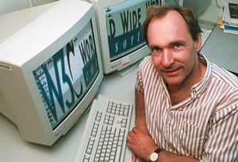He imagined a system that would allow information to be stored and shared easily. He successfully created software to move information from one computer to another but he still dreamed of finding a way that all computers could be linked together easily.

If he could find a solution, people would be able to search for information at a click of a button! It would be even better if people could keep adding to the information so that it was always new and up-to-date.

He decided to call his idea the World Wide Web. He didn’t have to do all of the work himself. There were other computer engineers around the 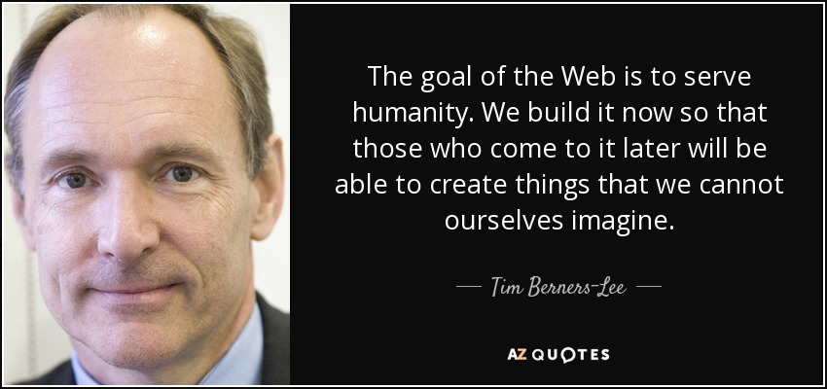world creating the internet. The internet is in fact the correct name for the email system. When you are searching online, or connecting the WiFi to use apps or play games, you are not on the internet: you are on the World Wide Web.

In 1991, Berners-Lee created the very first website. His next challenge was to get the rest of the world communicating in the same way. He made his software free for everyone to try. People soon realised that the idea was brilliant and companies began selling computers that could use the system.

Berners-Lee was amazed by how quickly his ideas spread around the world. Today, it is hard to imagine life without them! Berners-Lee has received many awards in recognition of his work.

Tim Berners-Lee is a very private person and you may not hear much about him but today, at the age of 65, he continues to work on more exciting engineering projects.

**Friday’s reading response task:**

1. How did Berners-Lee’s parents inspire him?
2. What was Berners-Lee’s job in Switzerland?
3. Why did he want to create the World Wide Web?
4. What is the difference between the Internet and the World Wide Web?
5. What event occurred in 1991?

**Fast Maths grid**

|  |  |  |  |  |  |  |  |  |  |  |
| --- | --- | --- | --- | --- | --- | --- | --- | --- | --- | --- |
|  |  |  |  |  |  |  |  |  |  |  |
|  |  |  |  |  |  |  |  |  |  |  |
|  |  |  |  |  |  |  |  |  |  |  |
|  |  |  |  |  |  |  |  |  |  |  |
|  |  |  |  |  |  |  |  |  |  |  |
|  |  |  |  |  |  |  |  |  |  |  |
|  |  |  |  |  |  |  |  |  |  |  |
|  |  |  |  |  |  |  |  |  |  |  |
|  |  |  |  |  |  |  |  |  |  |  |
|  |  |  |  |  |  |  |  |  |  |  |
|  |  |  |  |  |  |  |  |  |  |  |