2D Shapes
Properties
 | Name | Number of Sides | Number of Vertices
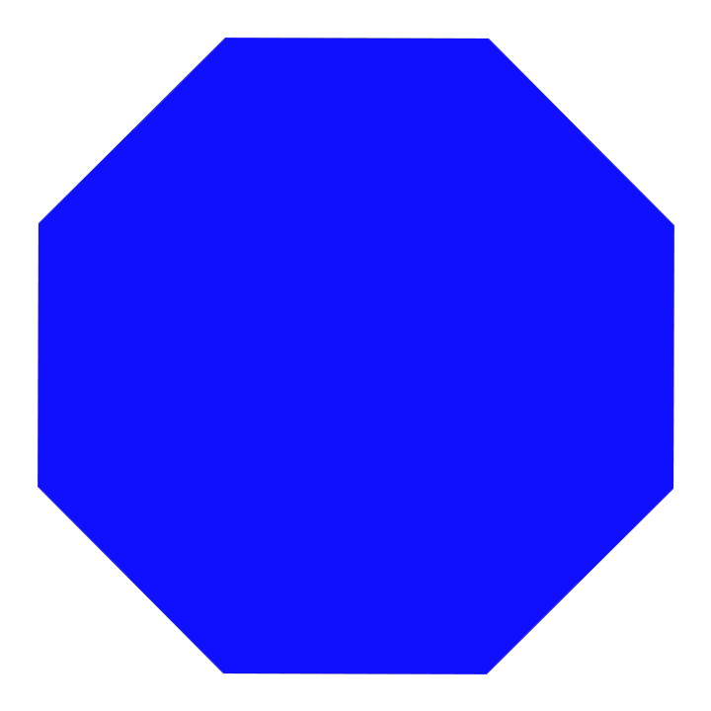

Circle Rectangle Square Triangle Octagon Pentagon Hexagon

Challenge:
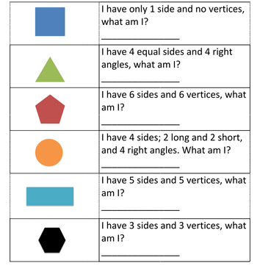

Circle Rectangle Square Triangle Pentagon Hexagon

