How you can help at home with spelling
Children need to regularly practise the key words in order to increase the number of words that they can spell from memory. Please find below a list of suggestions on how to do this at home.
- Writing the spellings in a glitter tray.
- Writing in sand/salt/flour/shaving foam.
- Using a paint brush and water bucket to write on the pavement.
- Using bath crayons at bath time.
- Making words using magnetic letters on the fridge
- Writing words on a small whiteboard in the car on long journeys
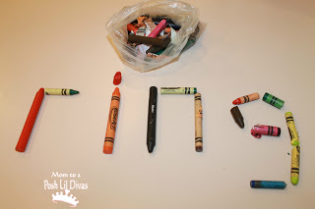
- Making words using objects such as lego, cubes, crayons, cereal etc

- Chopping words into parts or letters and putting them back together again.
- Word hangman using spellings from the table above.
- Missing letters out of the words and getting the children to fill them in.
- Using flashcards or letter cards to make the spelling word.
- Tracing spellings in different colours (rainbow writing).
- Tracing letter in the air.
- Joining the dots to make spelling words.
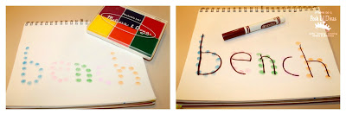
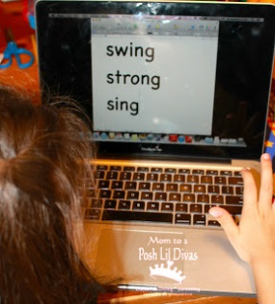

- Typing the spellings onto a Word document.

- Using the Spellosaur app to play spelling games.
- Visit the Puzzlemaker website and add your weekly words into a word search for children to find the words in.

